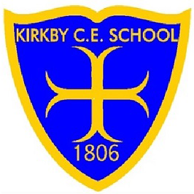
Kirkby CE Attendance Rewards

Class rewards for good attendance include:

Weekly Class Certificates
100% Attendance - Gold certificate
98% - 99.9% Attendance - Silver
96% - 97.9% Attendance - Bronze

Half Termly Class Certificates & Rewards
100% Attendance - Gold Certificate, Gold Medal & Class treat chosen by school Council
98% - 99.9% Attendance – Silver Certificate & Silver Medal
96% - 97.9% Attendance - Bronze Certificate & Bronze Medal

Pupil rewards for good and improved attendance include:
Term 1
- All children with 98-100% attendance from September - December will receive the Bronze Award (bronze certificate, bronze badge) and will be entered into a prize draw to win £10.00
- Improved attendance award - £5 voucher and certificate.
- Improved punctuality award - £ 5 voucher and certificate.
Term 2
- All children with 98%-100% attendance from January – April will receive the Bronze Award (bronze certificate, bronze badge)
- All children with 98%-100% attendance from September – April will receive the Silver Award (silver certificate, silver badge) and will be entered into a prize draw to win £20.00
- Improved attendance award - £5 voucher and certificate.
- Improved punctuality award - £ 5 voucher and certificate.
Term 3
- All children with 98%-100% attendance from May – July will receive the Bronze Award (bronze certificate, bronze badge)
- All children with 98%-100% attendance from January – July will receive the Silver Award (silver certificate, silver badge)
- All children with 98%-100% attendance from September – July will receive the Gold Award (gold certificate, gold badge) and will be invited to attend our end of year trip.
- Improved attendance award - £5 voucher and certificate.
- Improved punctuality award - £ 5 voucher and certificate.

