**Covid 19 illustrated Doing School Work at Home Social Story**

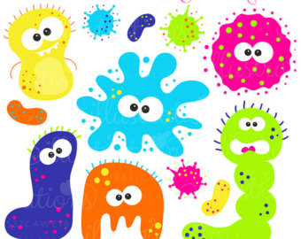

Sometimes people get sick.

People get sick when germs get into our bodies.

Germs are tiny things that live all around us.

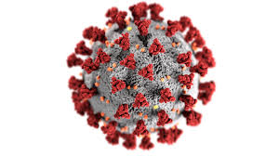

Covid 19 is a new illness.

Covid 19 can make some people very sick.

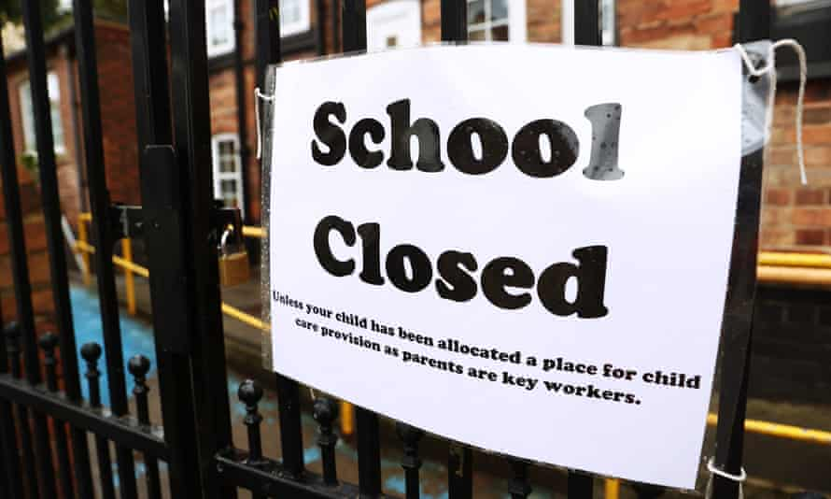

To stop Covid 19 spreading lots of places that people go to have been closed.

Schools are one of these places that have closed to stop the Covid germs speading.

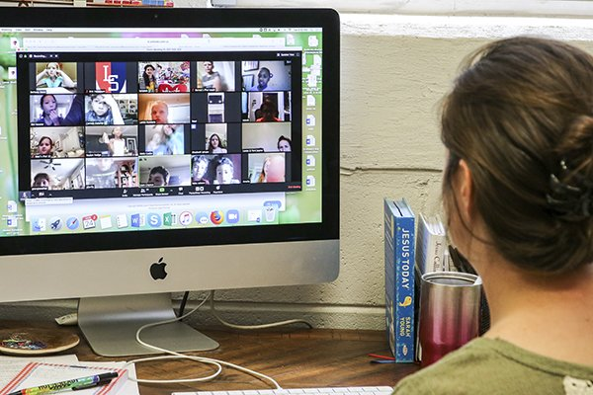

My teacher does not want me to fall behind with my work.

My teacher can teach me by using the computer.

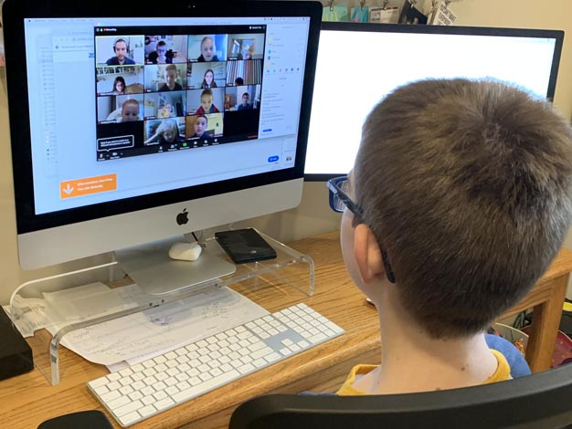

The teacher will set times for lessons on the computer.

I can log onto the computer and use a program to see my teacher and all my class.

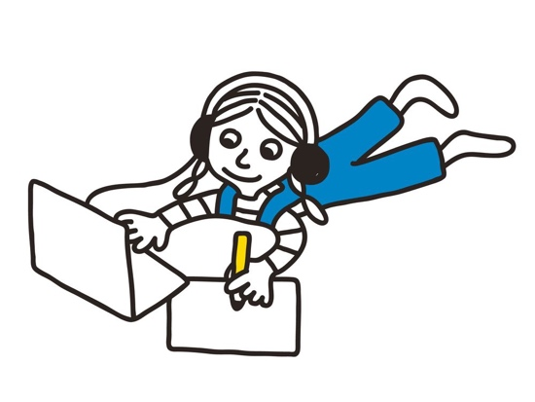

The teacher will set tasks for me to do.

It important to complete this work as this is my schoolwork.

I want to keep learning along with the rest of my class.

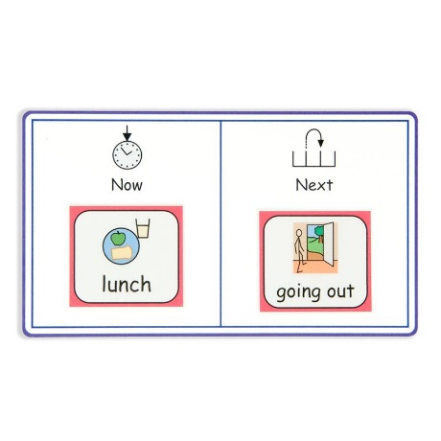

I can take regular breaks.

It is good to make a timetable with my parents and my teacher.

If I have a timetable I will know when I have to work and when I can have breaks.



If I find it hard to do the work that is OK.

If I get anything wrong that is OK.

If I am stuck I can tell my parents. They will tell the teacher so they can help me.

Having lessons at home will not be the same as having lessons in school.

My parents and my teacher will make my lessons at home different to what I am used to in school.

There will be a difference between learning at home and learning at school but that’s ok.

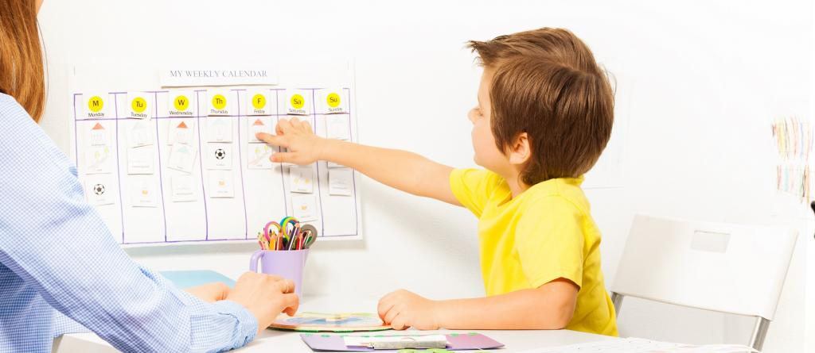

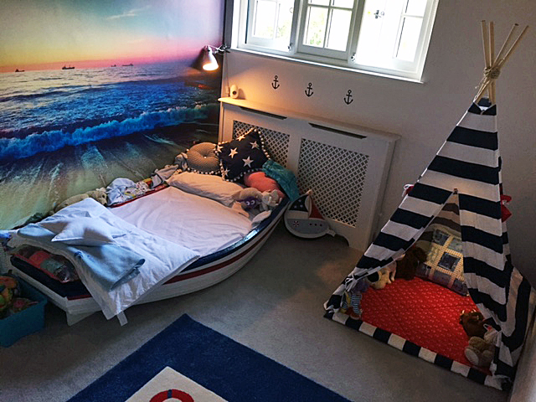

I might get upset that things are different when I learn at home than they are in school.

My parents will know ways to help me calm.

I need to tell my parents if I am getting upset so they can help me calm.

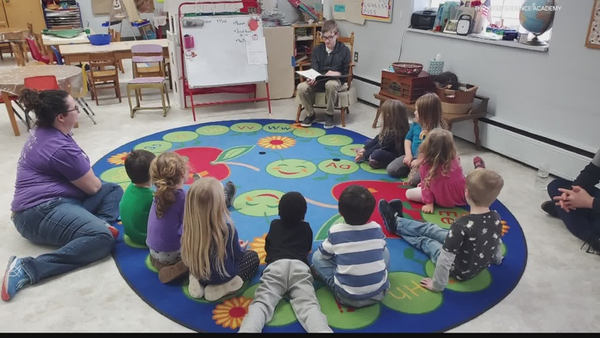

When this lockdown is over I can go back to school.

If we have to lockdown again I can follow the rules I am following now.

I will get all my school work done and be happy.