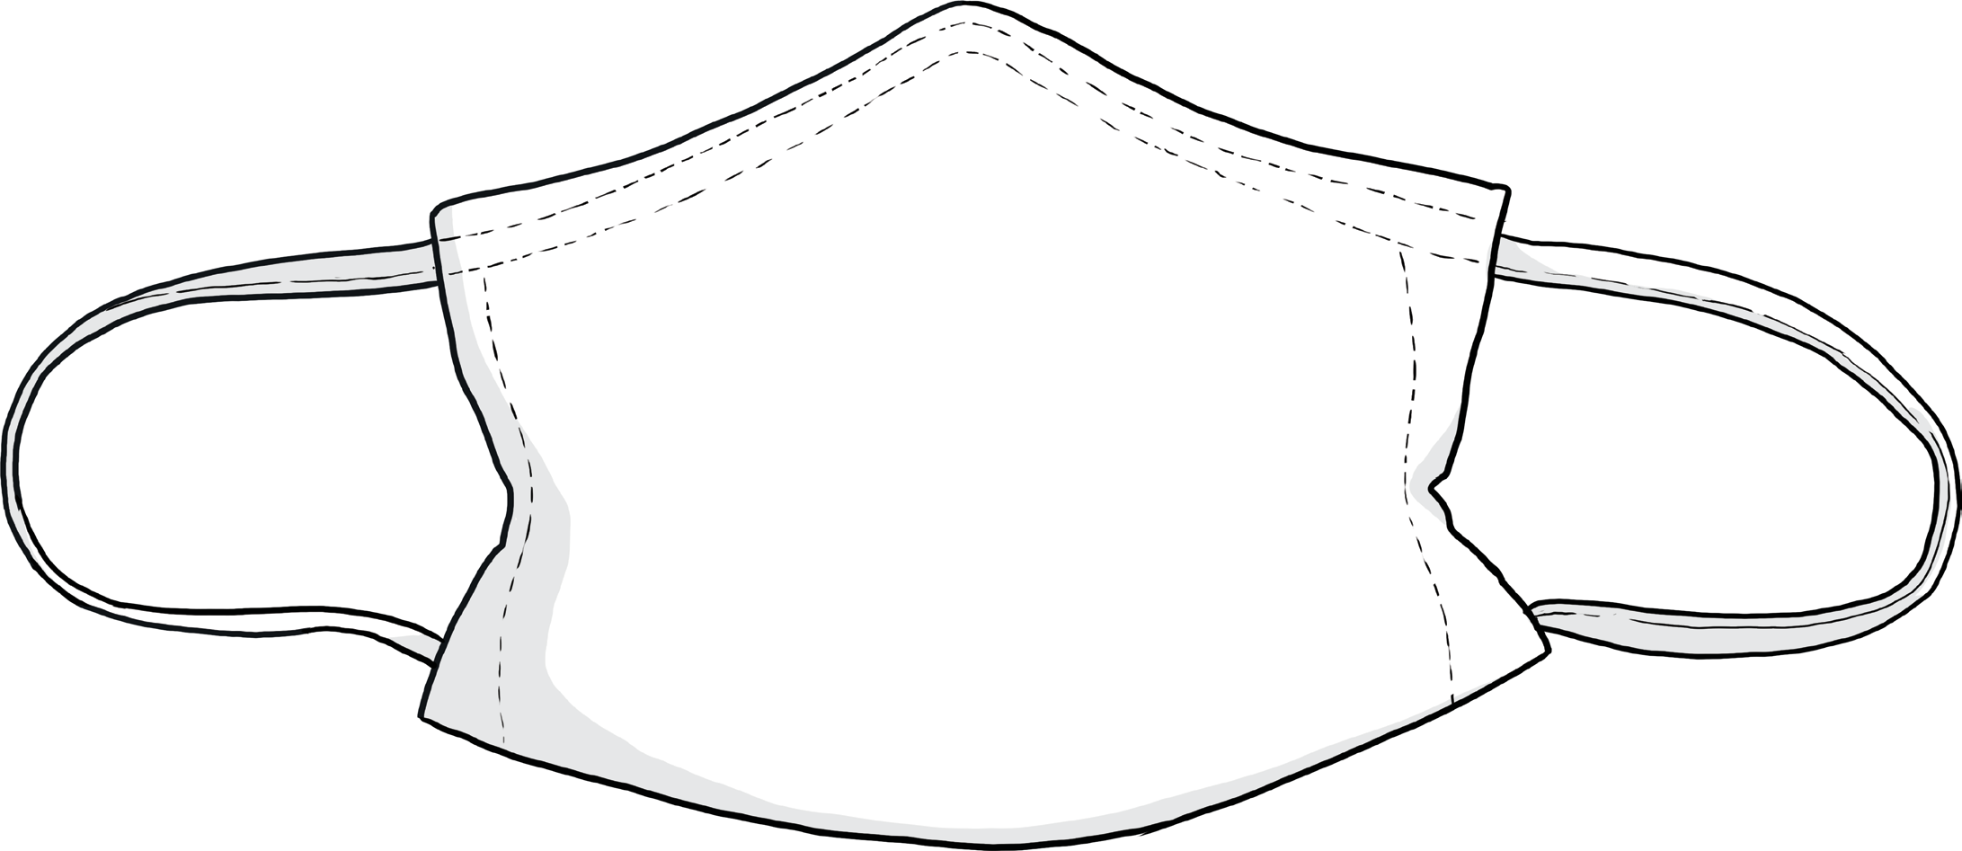

World Book Day 2021 Competition

We would like you to get creative by designing a facemask to represent one of your favourite books. This could be a picture of a character, or an illustration of your favourite part of the book. Please include the book’s title on your facemask.

There will be prizes for the winning entries.

Please email a photo of your design to [lyndsey.mccombs@kirkbyce.co.uk](mailto:lyndsey.mccombs@kirkbyce.co.uk) by Monday, 8th March.

Happy designing!