I know historical information about The Wright Brothers 11.3.21

What are their name?

What are the famous for?

The Wright Brothers First Flight

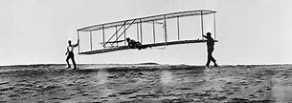

Draw and title this picture below
_________________________________________________________________________________________

