Lesson 5
Jesus is often referred to as the Messiah. What does that mean? Have you heard the word before? Who have you heard it used in relation to?
Christians believe that he was/is the Messiah. Why do you think that is?
Listen to this piece of music by a German-born English Baroque composer (below) called George Frideric Handel (1685-1759): https://youtu.be/-VX7L1WK3fg
This particular video was recorded in lockdown in April 2020 featuring members of the Royal Opera House Orchestra and Chorus at home. Have you heard it before? It is only a small part of an oratorio about the life of Jesus, called Messiah, which he wrote in 1741. An oratorio is a musical composition for an orchestra, choir and a solo singer to perform together. Performances of Handel’s Messiah are typically 2.5 – 3 hours long! The part you’ve listened to is the anthem that comes about halfway through, called the Hallelujah Chorus. Do you recognise it?
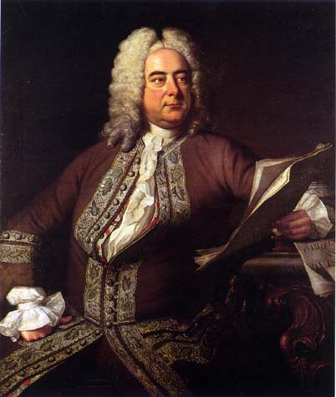

Now that we have reached the end of our unit on ‘Who Was Jesus?’, it is time to consider the answer to the question, ‘Was Jesus the Messiah?’ In this and previous units of RE lessons, we have read and discussed the ways in which the Biblical texts tell us about the birth, life, death and resurrection of Jesus. The main point of this unit has been to remind ourselves that Jesus was given many names by others during his lifetime and beyond, and that he also referred to himself as different things in order to teach others how to view him. Hopefully, you will now have a better understanding of some of the names for Jesus that appear in the Bible and in the hymns and prayers we use in school.

