**MFL**

Spanish

Los Animales (animals)

**Science**

Animals Including Humans

* identify and name a variety of common animals including fish, amphibians, reptiles, birds &mammals.
* Identify and name human body parts and match to senses.

**The Dot**

**The Word Collector**

Peter H Reynolds

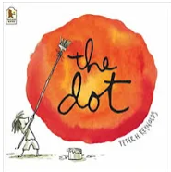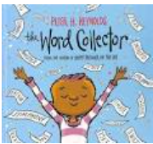

**P.S.H.E. (Jigsaw)**

Being Me in My World

* Help others feel welcome.
* Make our school a better place.
* Think about everybody’s right to learn.
* Follow the learning charter.

**PE**

Fundamentals

* Explore basic skills in isolation and in combination

Sending and Receiving

* Throwing, catching, kicking, rolling etc

**Computing (Purple Mash)**

Coding (Computer Science)

* Use code to make a computer program.
* Use an event to control an object.
* Plan a computer program.

**Art and Design Technology**

Portraits Frida Kahlo

* Create a portrait that includes key features
* Find out about a range of artists including Frida Kahlo
* Experiment with a variety of media; pencils, rubbers, crayons, pastels, felt tips, charcoal, ballpoints, chalk  in the style of Frida Kahlo.

**Phonics/Spelling**

RWI (matched to current phase)

* Recap set 1, 2 and 3 sounds
* Y1/2 Spelling Rules
* Y1/2 Common Exception Words

**Maths**

Number

* Place Value
* Addition and Subtraction

**English**

* Develop empathy with a character and make personal connections.
* Develop creative responses to a text through drama, music, dance and art.
* Explore and develop ideas through discussion.
* Write in role to explore characters and events.
* Make inferences and predictions.
* Explore a range of vocabulary.
* Write for different purposes **(Character Description, Writing in Role)**

**Geography**

Our Locality

* Know how home/school is linked with other familiar local places.
* How long will it take to walk there?

**RE**

Harvest

* Raise awareness that we harvest food all around the world and that we usually have plenty but others do not.
* Discuss what our response as Christians should be to the need of others.

**Music (Charanga)**

Hey You – Hip Hop

* Identify pulse, rhythm and pitch.
* Sing, play, improvise and compose.