**Maths**

* Shape
* Money
* Multiplication/Division

**P.S.H.E**

**Dreams and Goals**

**RE / P.S.H.E**

**Jesus Was Special**

* Know and retell stories of Jesus
* Talk about how and why Jesus was special
* Discuss friendship

Martin Jenkins

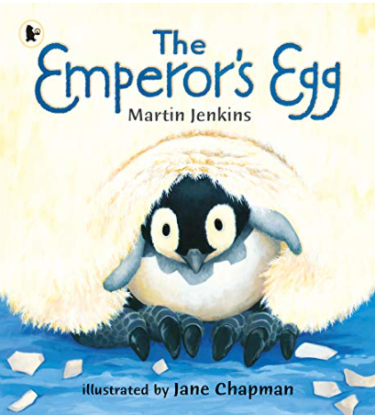

**PE**

**Dance / Yoga**

**Target Games**

**Music (Charanga)**

**In the Groove**

**Art**

**Hot and Cold Colours (Picasso- Cubism)**

* Use a variety of tools and techniques including different brush sizes and types i.e sponge, toothbrushes, nail brushes
* Mix and match colours to artefacts and objects
* Work on different scales
* Identify primary colours by name
* Mix primary shades and tones to represent ideas and convey mood

**Geography**

Hot and Cold Continents

* Name and locate 7 Continents world map
* Name and locate 5 oceans on world map.
* Use atlases, globes and world maps.
* Identify the location of hot and cold areas in relation to the equator.

**Science**

**Everyday Materials**

* Distinguish between object and material
* Identify and name a variety of materials
* Describe physical properties of materials
* Compare and group materials based on physical properties.

**Phonics/Spelling**

* RWI appropriate phase
* Year 2 Spelling Rules
* Read and Spell Y1 /Y2 Common Exception Words

**English**

**Writing**

* Explore and develop ideas through discussion
* To know where information can be found in non-fiction texts
* To know that information can be retrieved from a variety of sources
* To identify some of the features of non-fiction texts
* To use vocabulary influenced by books
* To compose and perform own poetry
* Write for different purposes (**Non-Chronological Report, Poetry)**
* Use Conjunctions
* Sort different sentence types
* Change present and past tense verbs

**Computing**

Painting

* Use technology to create, organise, store, manipulate and retrieve digital content