English

* Develop positive attitudes towards and stamina for writing by **writing in role, letter writing and instructions**.
* Make additions, revisions and corrections to own writing.
* Proof read to check for errors
* Use 4 sentence types
* Use contractions
* Use possessive apostrophe

Computing

Creating Pictures

(Information Technology)

History

Significant Individuals-Transport

* Learn about events beyond living memory.e.g.
* Transportation
* Learn about the lives of individuals who have contributed to national and international achievements. Wright Brothers, Brunel,Ford

.

Phonics/Spelling

RWI matched to current phase

* Recap set 1,2 and 3 sounds
* Y1/2 Common Exception Words
* Y1/2 Spelling Rules

PE

Dance

Striking and Fielding

Music

Charanga – Round and Round

MFL

PSHE(Jigsaw)

Healthy Me

* Make healthy choices
* Eat a balanced diet
* Be physically active
* Healthy Friendships

RE

Easter: Celebrating New Life

* Retell events of Easter week.
* Easter is a new beginning. Jesus died and was raised to a new life.
* Reflection of new life and understand bereavement.

Science

Seasonal Change Winter/Spring

* Day length variation
* Weather
* Signs of spring
* Trees and clothes changes
* Collect and record weather data

Pip Jones

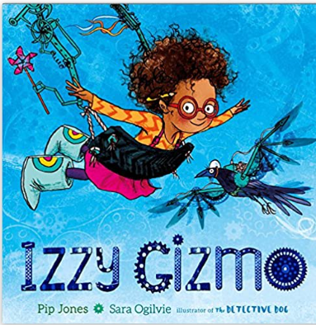

Design Technology

Transport

* Explore and use mechanisms
* Evaluate and explore a range of existing products
* Select and use a range of tools to perform practical tasks

In place of trip- Expert Visitor April 27th/28th