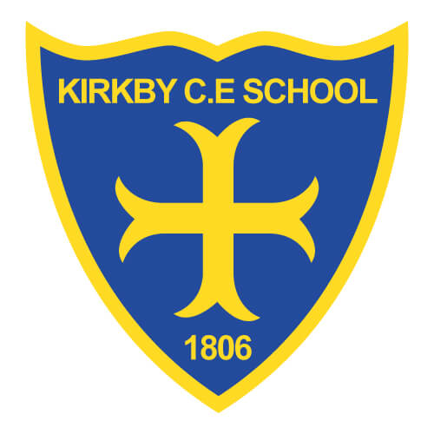Transition to School

2021

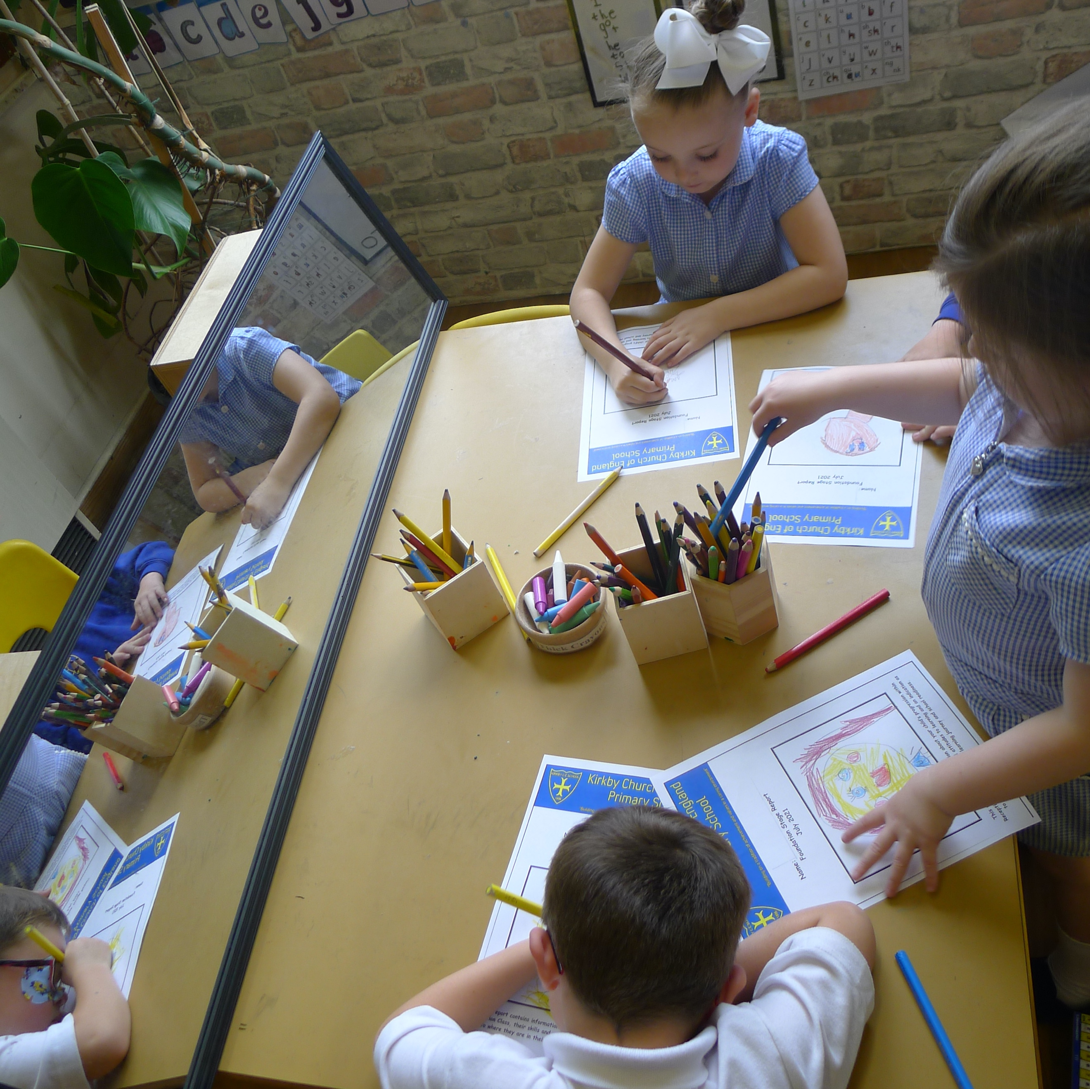

What do we do?

* In the summer term of Nursery, the daily routine becomes more in line with Reception. Allowing for a mix of large group work, independent ‘busy’ time and small group work.
* The environment is altered in correlation with the ages and stages of Reception.
* A chance to meet the Reception staff and get to know the new adults. Daily interactions at lunchtime and story times with new Teachers.
* Becoming familiar with the wider school environment. Children have chance to eat their dinner in the school hall and visit the Reception outdoor area.

At Kirkby C of E Primary School, we are dedicated to ensuring that all children have a smooth transition into school.

For children to succeed, it is crucial that they feel safe and happy in their new environment. By establishing positive relationships and promoting an exciting environment, it allows children the opportunity to develop confidence and independence.

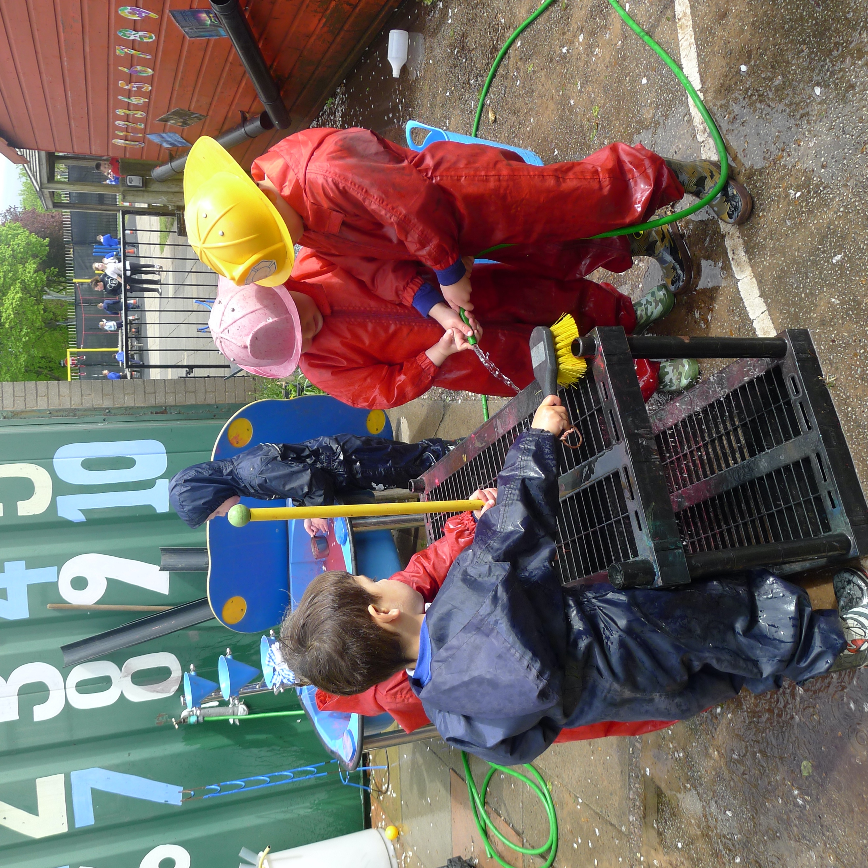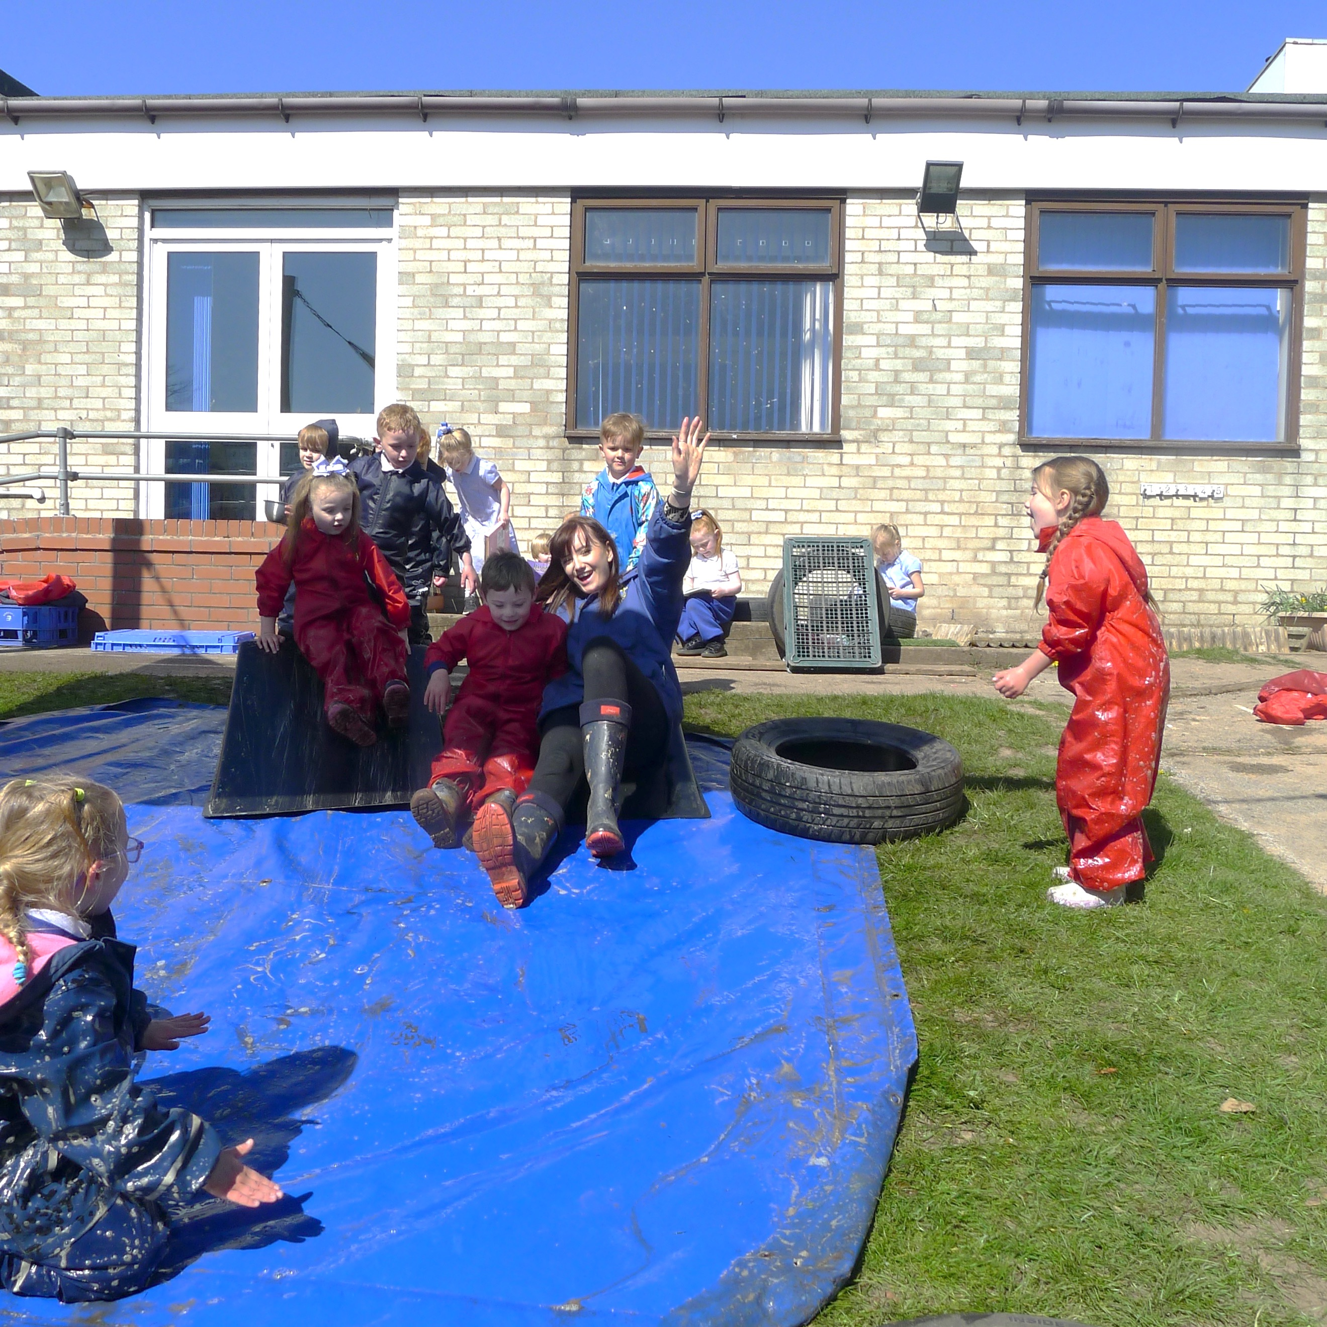

“The quality of a child’s early experience is vital for their future success”

Department for Education, 2014