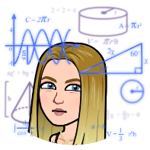
Week Commencing: Monday 20th April 2020

A1- How many adults were in the film? _____________.
A2- If you were to double the amount of adults in the film, how many adults would there be altogether? __________________.
A3- How many balls did Mrs Schumacher juggle? _______________.
A4- If Mrs. Schumacher were to juggle two times as many balls, how may would she be juggling? ______________.
A5- How long was the film in minutes and seconds? ____________ minutes __________Seconds.
A6- How many different activities were performed in total? _____________.

B1- How long was the whole film in seconds? _____________.
B2- If the toilet roll had 350 sheets, how many sheets would be in a pack of 2 toilet rolls? _________.
(Use column addition).
B3- If the toilet roll had 250 sheets, how many sheets would be in a pack of 4 toilet rolls? _________.
B4- Can you Place value this number: three hundred and fifty- four?
H | T | U
B5- Can you place value this number: six hundred and thirty- one?
H | T | U
B6- Can you add the two numbers above using column addition? ______________________

Cheeky Challenge: Can you name the song in the video? (You can ask an adult to help you with this one).

Tuesday 21st April 2020.
Number bonds.

1. 18 + 2 =_____ | 2. 6 +____ = 20 | 3. ____ + 17 =20
4. 14+ 6 =_____ | 5. 7 +____ = 20 | 6. ____ + 12 =20
7. 10 + 10 =_____ | 8. 8 +____ = 20 | 9. ____ + 13 =20
10. 13 + 7 =_____ | 11. 9 +____ = 20 | 12. ____ + 14 =20
13. 1 + 19 =_____ | 14. 10 +____ = 20 | 15. ____ + 15 =20
16. 11 + 9=_____ | 17. 1 +____ = 20 | 18. ____ + 16 =20
19. 6 + 14 =_____ | 20. 2 +____ = 20 | 21. ____ + 17 =20

Now challenge yourself.

1. 50 + 50 =_____ | 2. 30 +____ = 100 | 3. ____ + 55 =100
4. 60 + 40 =_____ | 5. 45 +____ = 100 | 6. ____ + 67 =100
7. 95 + 5 =_____ | 8. 0 +____ = 100 | 9. ____ + 13 =100
10. 85 + 15 =_____ | 11. 78 +____ = 100 | 12. ____ + 89 =100
13. 20 + 80 =_____ | 14. 75 +____ = 100 | 15. ____ + 43 =100
16. 25 + 75 =_____ | 17. 90 +____ = 100 | 18. ____ + 72 =100
19. 10 + 90 =_____ | 20. 66 +____ = 100 | 21. ____ + 29 =100

Cheeky Challenge: Now can you challenge yourself by using the Hit the button app and test yourself on your number bonds.

Wednesday 22nd April 2020
Money.

- Order the coins from smallest to largest.
- What coins are missing?
- In the film from Monday, all the adults were throwing a toilet roll. If one packet of toilet rolls cost 2 pounds and fifty pence, how much would two packets cost?
- Can you draw the amount above in a different way?
- How much does all the coins add up to all together?

- A packet of toilet paper cost the above amount of coins, what is double this amount?
- Can you draw the amount using notes?
- How many £2.50’s are in a twenty pound note?
- What is my change from a five pound note from the money above?
- How much do I need to make the next nearest pound?
- Can you make a question using the above coins?
Cheeky challenge: How many ten pence’s are in ten pounds?

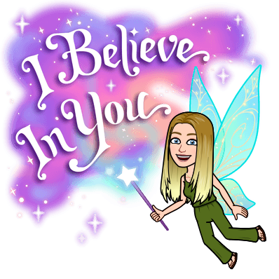

Thursday 23rd April 2020.

Column Addition

- 12  + 10 | - 35  + 10 | - 90  + 10
- 23  + 7 | - 55  + 20 | - 79  + 21
- 50  + 50 | - 13  + 17 | - 10  + 71
- 76  + 20 | - 89  + 10 | - 40  + 9
- 54  + 2 | - 51  + 11 | - 47  + 15

- 112  + 100 | - 512  + 110 | - 712  + 210
- 142  + 103 | - 142  + 140 | - 127  + 160
- 129  + 102 | - 802  + 012 | - 412  + 398
- 548  + 146 | - 745  + 145 | - 456  + 128
- 321  + 123 | - 415  + 496 | - 214  + 689
Friday 24th April 2020

Column Subtraction
12  - 10 | 35  - 10 | 90  - 10
23  - 7 | 55  - 20 | 79  - 21
50  - 50 | 13  - 6 | 71  - 10
76  - 20 | 89  - 10 | 40  - 9
54  - 12 | 51  - 11 | 47  - 15

560  - 60 | 423  - 23 | 190  - 90
700  - 300 | 345  - 45 | 863  - 60
567  - 45 | 138  - 24 | 799  - 67
769  - 59 | 890  - 180 | 420  - 120
548  - 332 | 452  - 321 | 470  - 150

