Watch the Kirkby CE staff video on school website and then write a review about it.
Think about the following things:
What was your favourite part?
Who surprised you with their hidden talent?
Who do you think should win an Oscar?
What did you think about the messages at the start and the end?
How did you feel watching the video?
What message would you have written?

REMEMBER TO WRITE IN FULL SENTENCES AND JUSTIFY ALL OF YOUR ANSWERS!!!
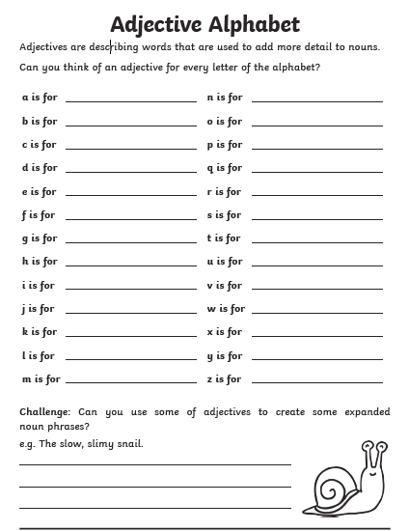
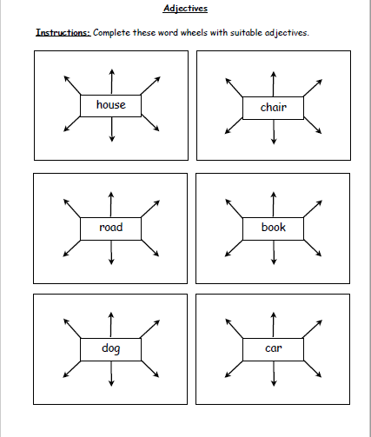
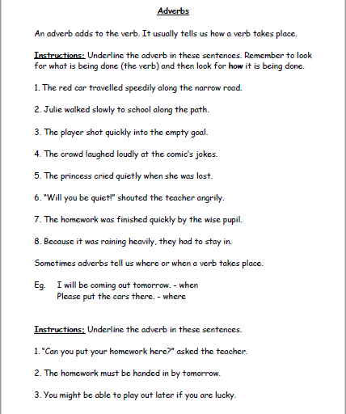
Write a description of a setting
We have done this activity in class and it is a fantastic way of showing off all of your fantastic vocabulary and sentence structure.
Imagine you are one of the two people in the picture below.
Write in 1st person (I, my etc.) to describe all of the things you can see, hear, smell and feel. Remember feelings can be both internal (scared, nervous etc.) and external (wind racing through my hair).
Use some of the Alan Peat sentences we have covered in class. I have listed a few examples below:
If I had just listened to Mr Mawson, if I had just trusted the league table, if I had just opened my eyes, then I wouldn’t be an Evertonian
All I could see was darkness. Darkness was quickly becoming my enemy.
Enjoy

