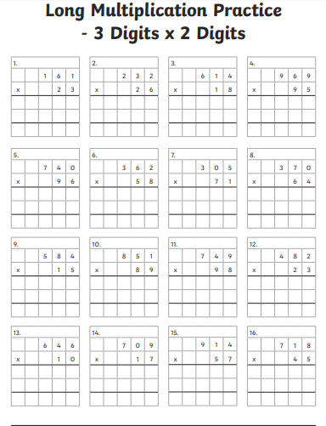

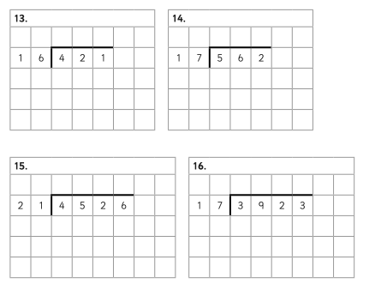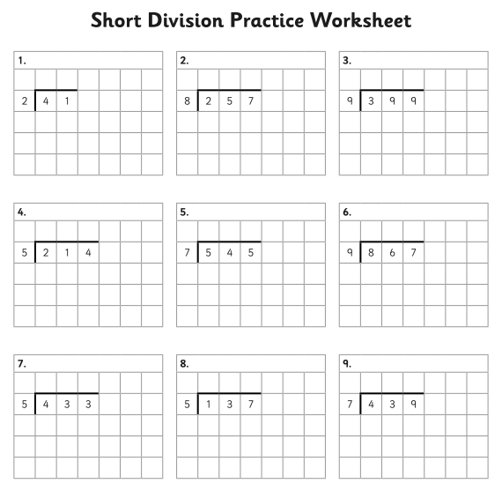

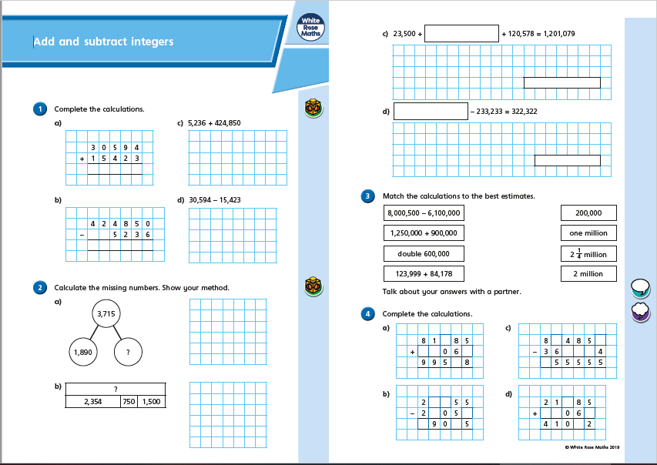

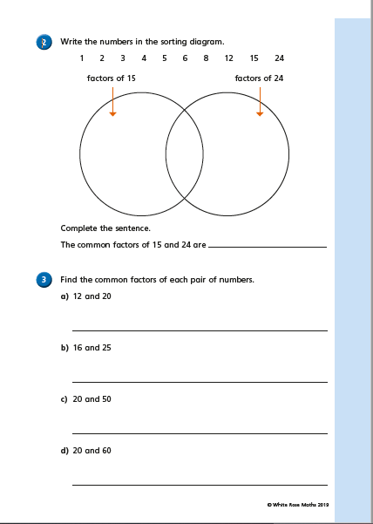

|  |  |
| --- | --- |
| 1. The first year we had a school fete we raised £312. We raised ten times as much money this year. How much did we raise? | http://www.caskwidge.com/shop/images/thermometer.gif**2.** The coldest temperature recorded on the school thermometer this year was –6 degrees Centigrade. The highest temperature was 25 degrees Centigrade. What is the difference between the two temperatures? |
| 1. 5639 people attended a football match. The previous week 7564 people attended a match. What is the difference in attendance figures for the two weeks? | 4. A netball team is made up of 7 players. If 212 children turn up to a netball tournament, how many full teams could you make? |
| 1. 3 friends agree to split the cost of a meal. They each pay £12.68. How much was the meal? | 1. I buy a £10 phonecard, I already have £2.65 credit on my phone. I make a call costing £1.83, how much credit have I got now? |
| 1. To make a litre of light blue paint you need 2 tins of blue paint and 3 tins of white paint. If I need 9 litres of light blue paint, how many tins of blue paint and how many tins of white paint do I need? | 1. Mum’s favourite chocolates in the selection box are truffles. For every 2 truffles in a box there are 4 toffees. If the box contains 24 toffees, how many truffles will there be? |