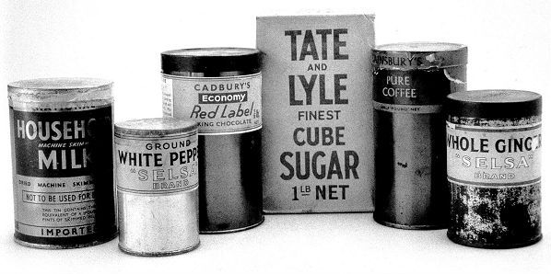
Rationing during The Second World War

During the War (and after it too!) people weren’t allowed as much food as they wanted (even if they could afford lots of it!) Each person had a ‘ration’ of food for each week. This was how much food they were allowed from the shop. The table shows the amount of some items an adult was allowed.
Can you complete the table to show what a child’s ration would be? The first two have been done for you.
Food/drink | Adult ration | Child’s ration
Milk | 3 pints | 1½ pints
Sugar | 8 oz (ounces) | 4 oz
Tea | 2 oz
Butter | 2 oz
Margarine | 4 oz
Lard | 3 oz
Cheese | 3 oz
Bacon | 4 oz
Sweets | 2 oz
Jam | 2 oz
Eggs | 1

Look at the family in the photograph (It looks like the father might have gone away to war). How much of each would they get altogether per week?
Food/drink | Total amount per family per week. | 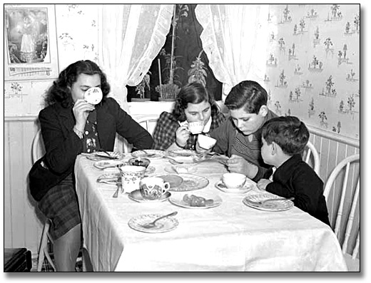
Milk | 7½ pints
Sugar | _____ oz
Tea | _____ oz
Butter | _____ oz
Margarine | _____ oz
Lard | _____ oz
Cheese | _____ oz
Bacon | _____ oz
Sweets | _____ oz
Jam | _____ oz
Eggs | _____ eggs
Challenge: Work out how much of each YOUR family would get each week.

