If you have any questions, please email us at,  L McPhllips (Early Years Lead)  lisa.mcphillips@kirkbyce.co.uk  E O’Nions (Teacher)  emma.o’nions@kirkbyce.co.uk  A Nieman (Teacher)  anne.nieman@kirkbyce.co.uk  Contact Us  Kirkby C of E Primary School  Hall Lane,  Kirkby,  L 32 1TZ  Phone: 0151 4778510  “Building on a tradition of achievment and values in a caring environment”  Hall Lane,  Kirkby,  L 32 1TZ |  |  | Kirkby C of E Primary School  2021-2022  “Building on a tradition of achievment and values in a caring environment”

Contents  Mission Statement 1  Welcome 2  Introduction 2  Our Priorities 2  Settling into School 3  Make It Your Own 4  Our Early Years Team 4  Contact us 5  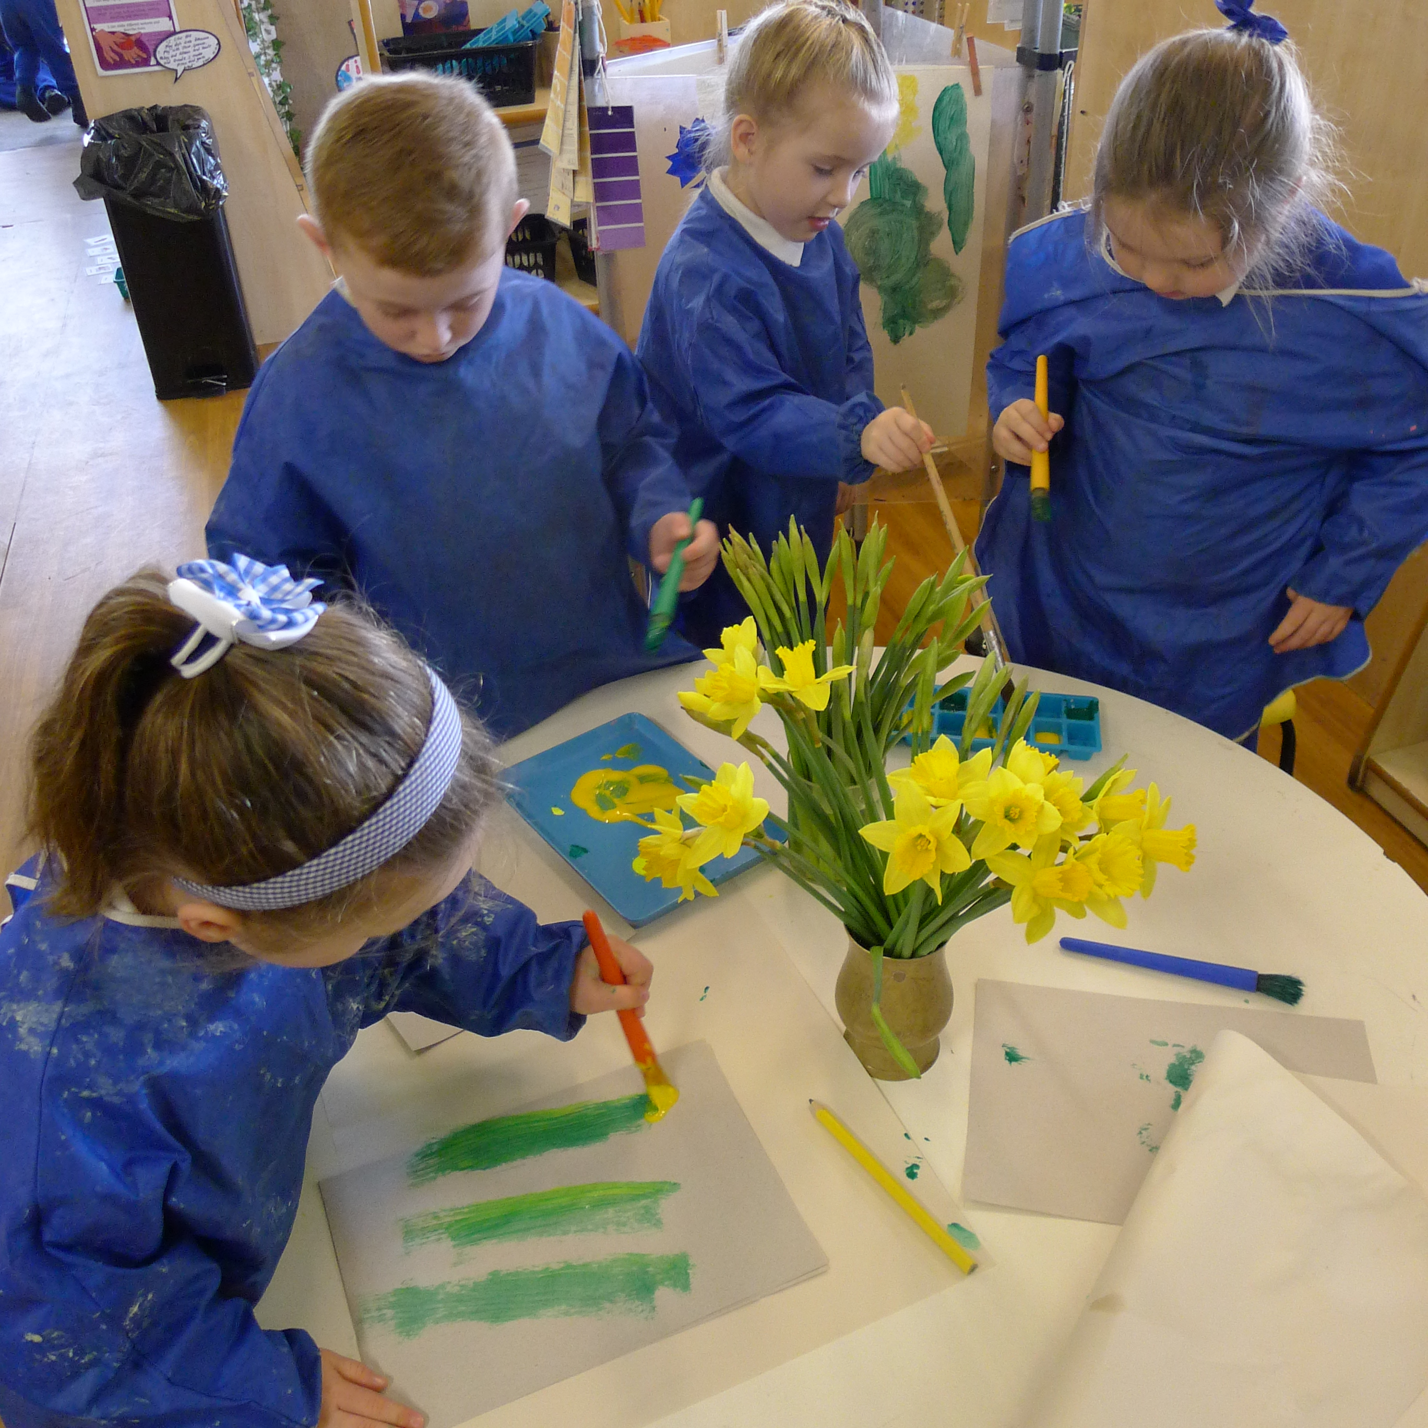 |  |  | 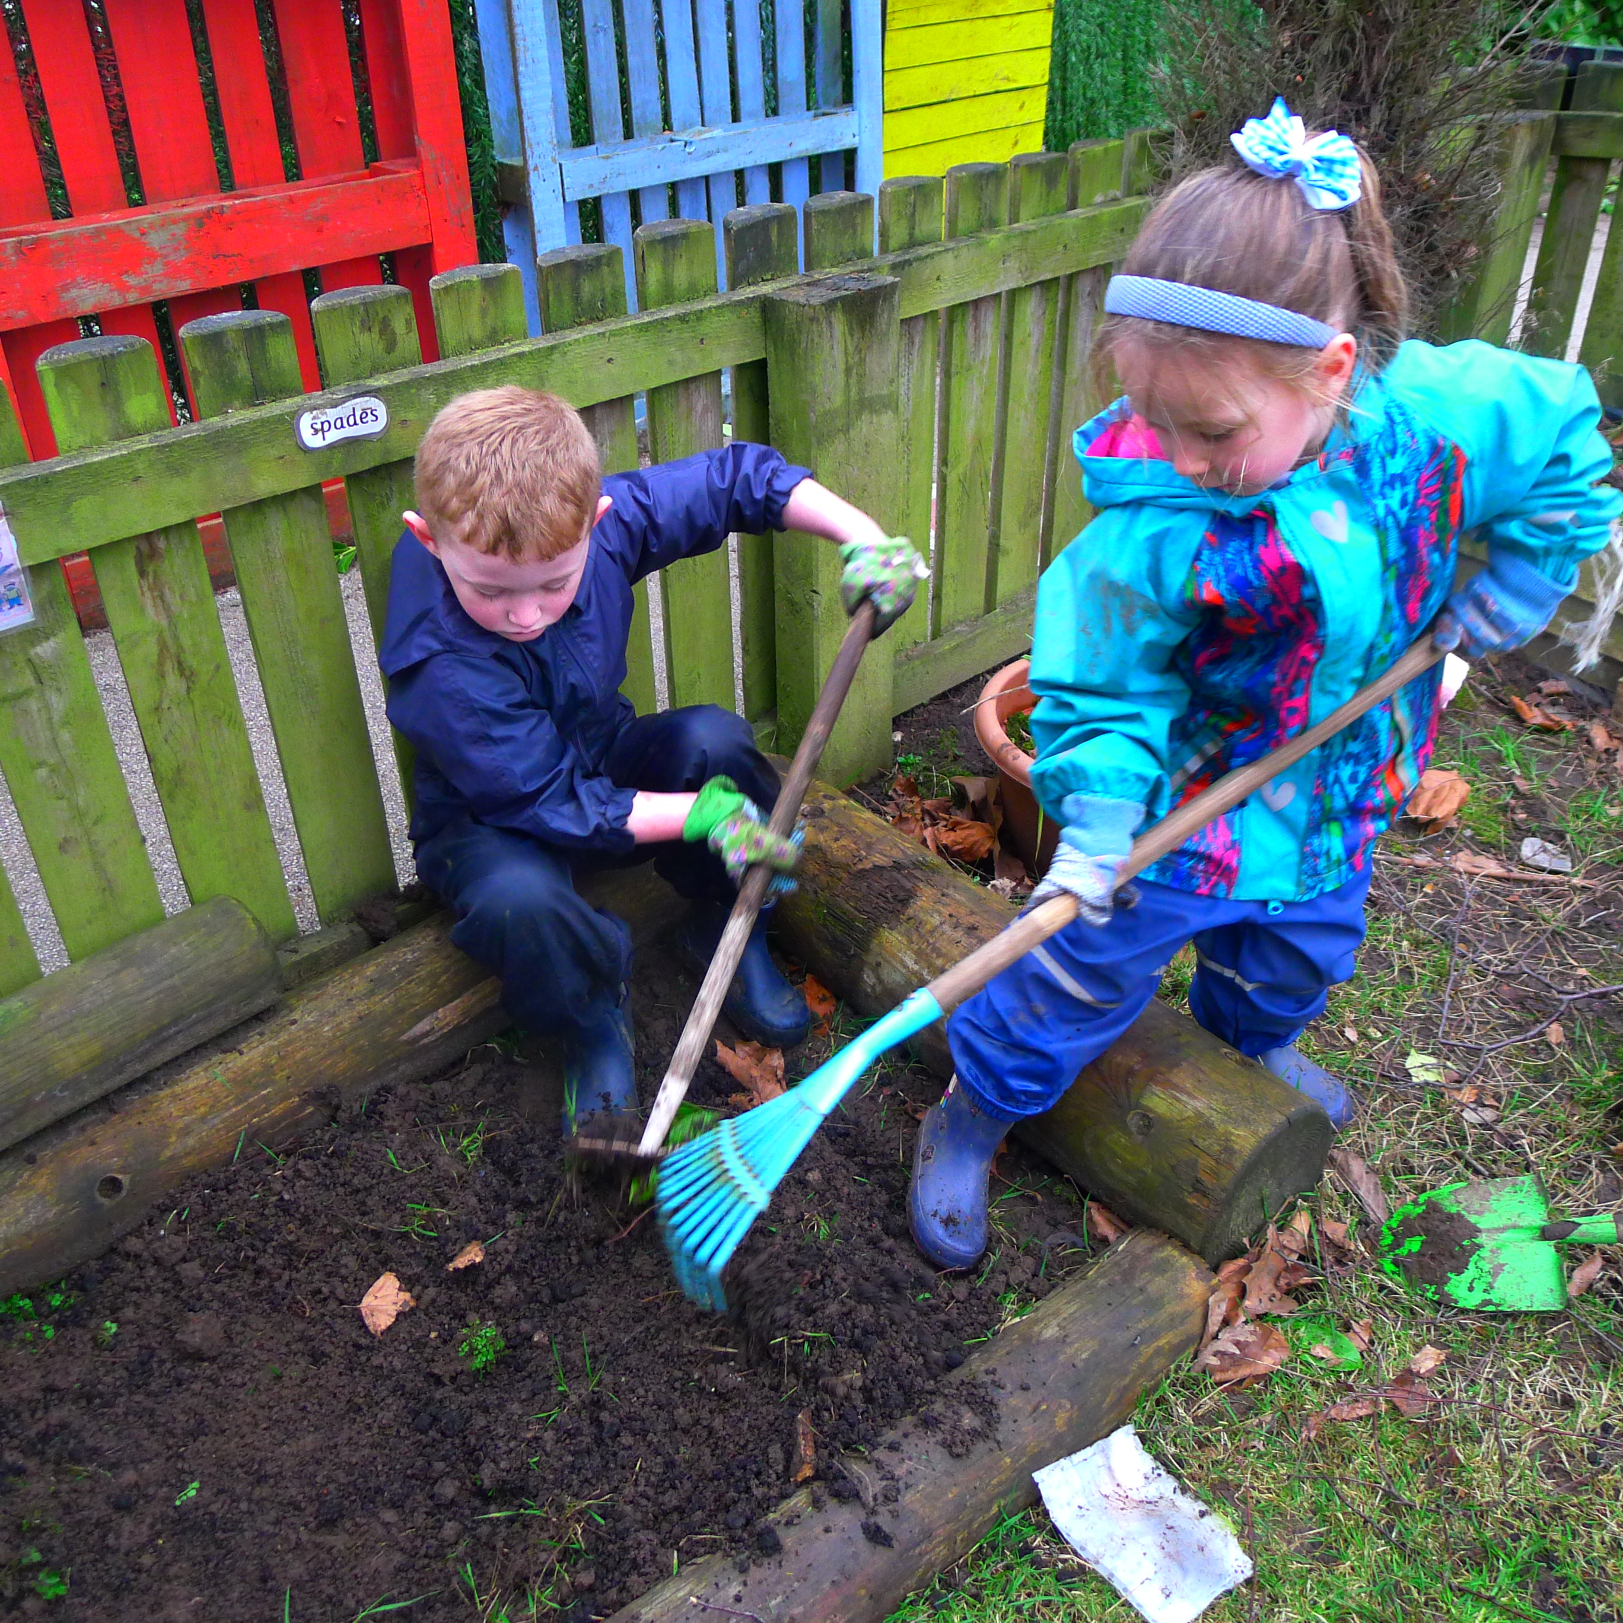  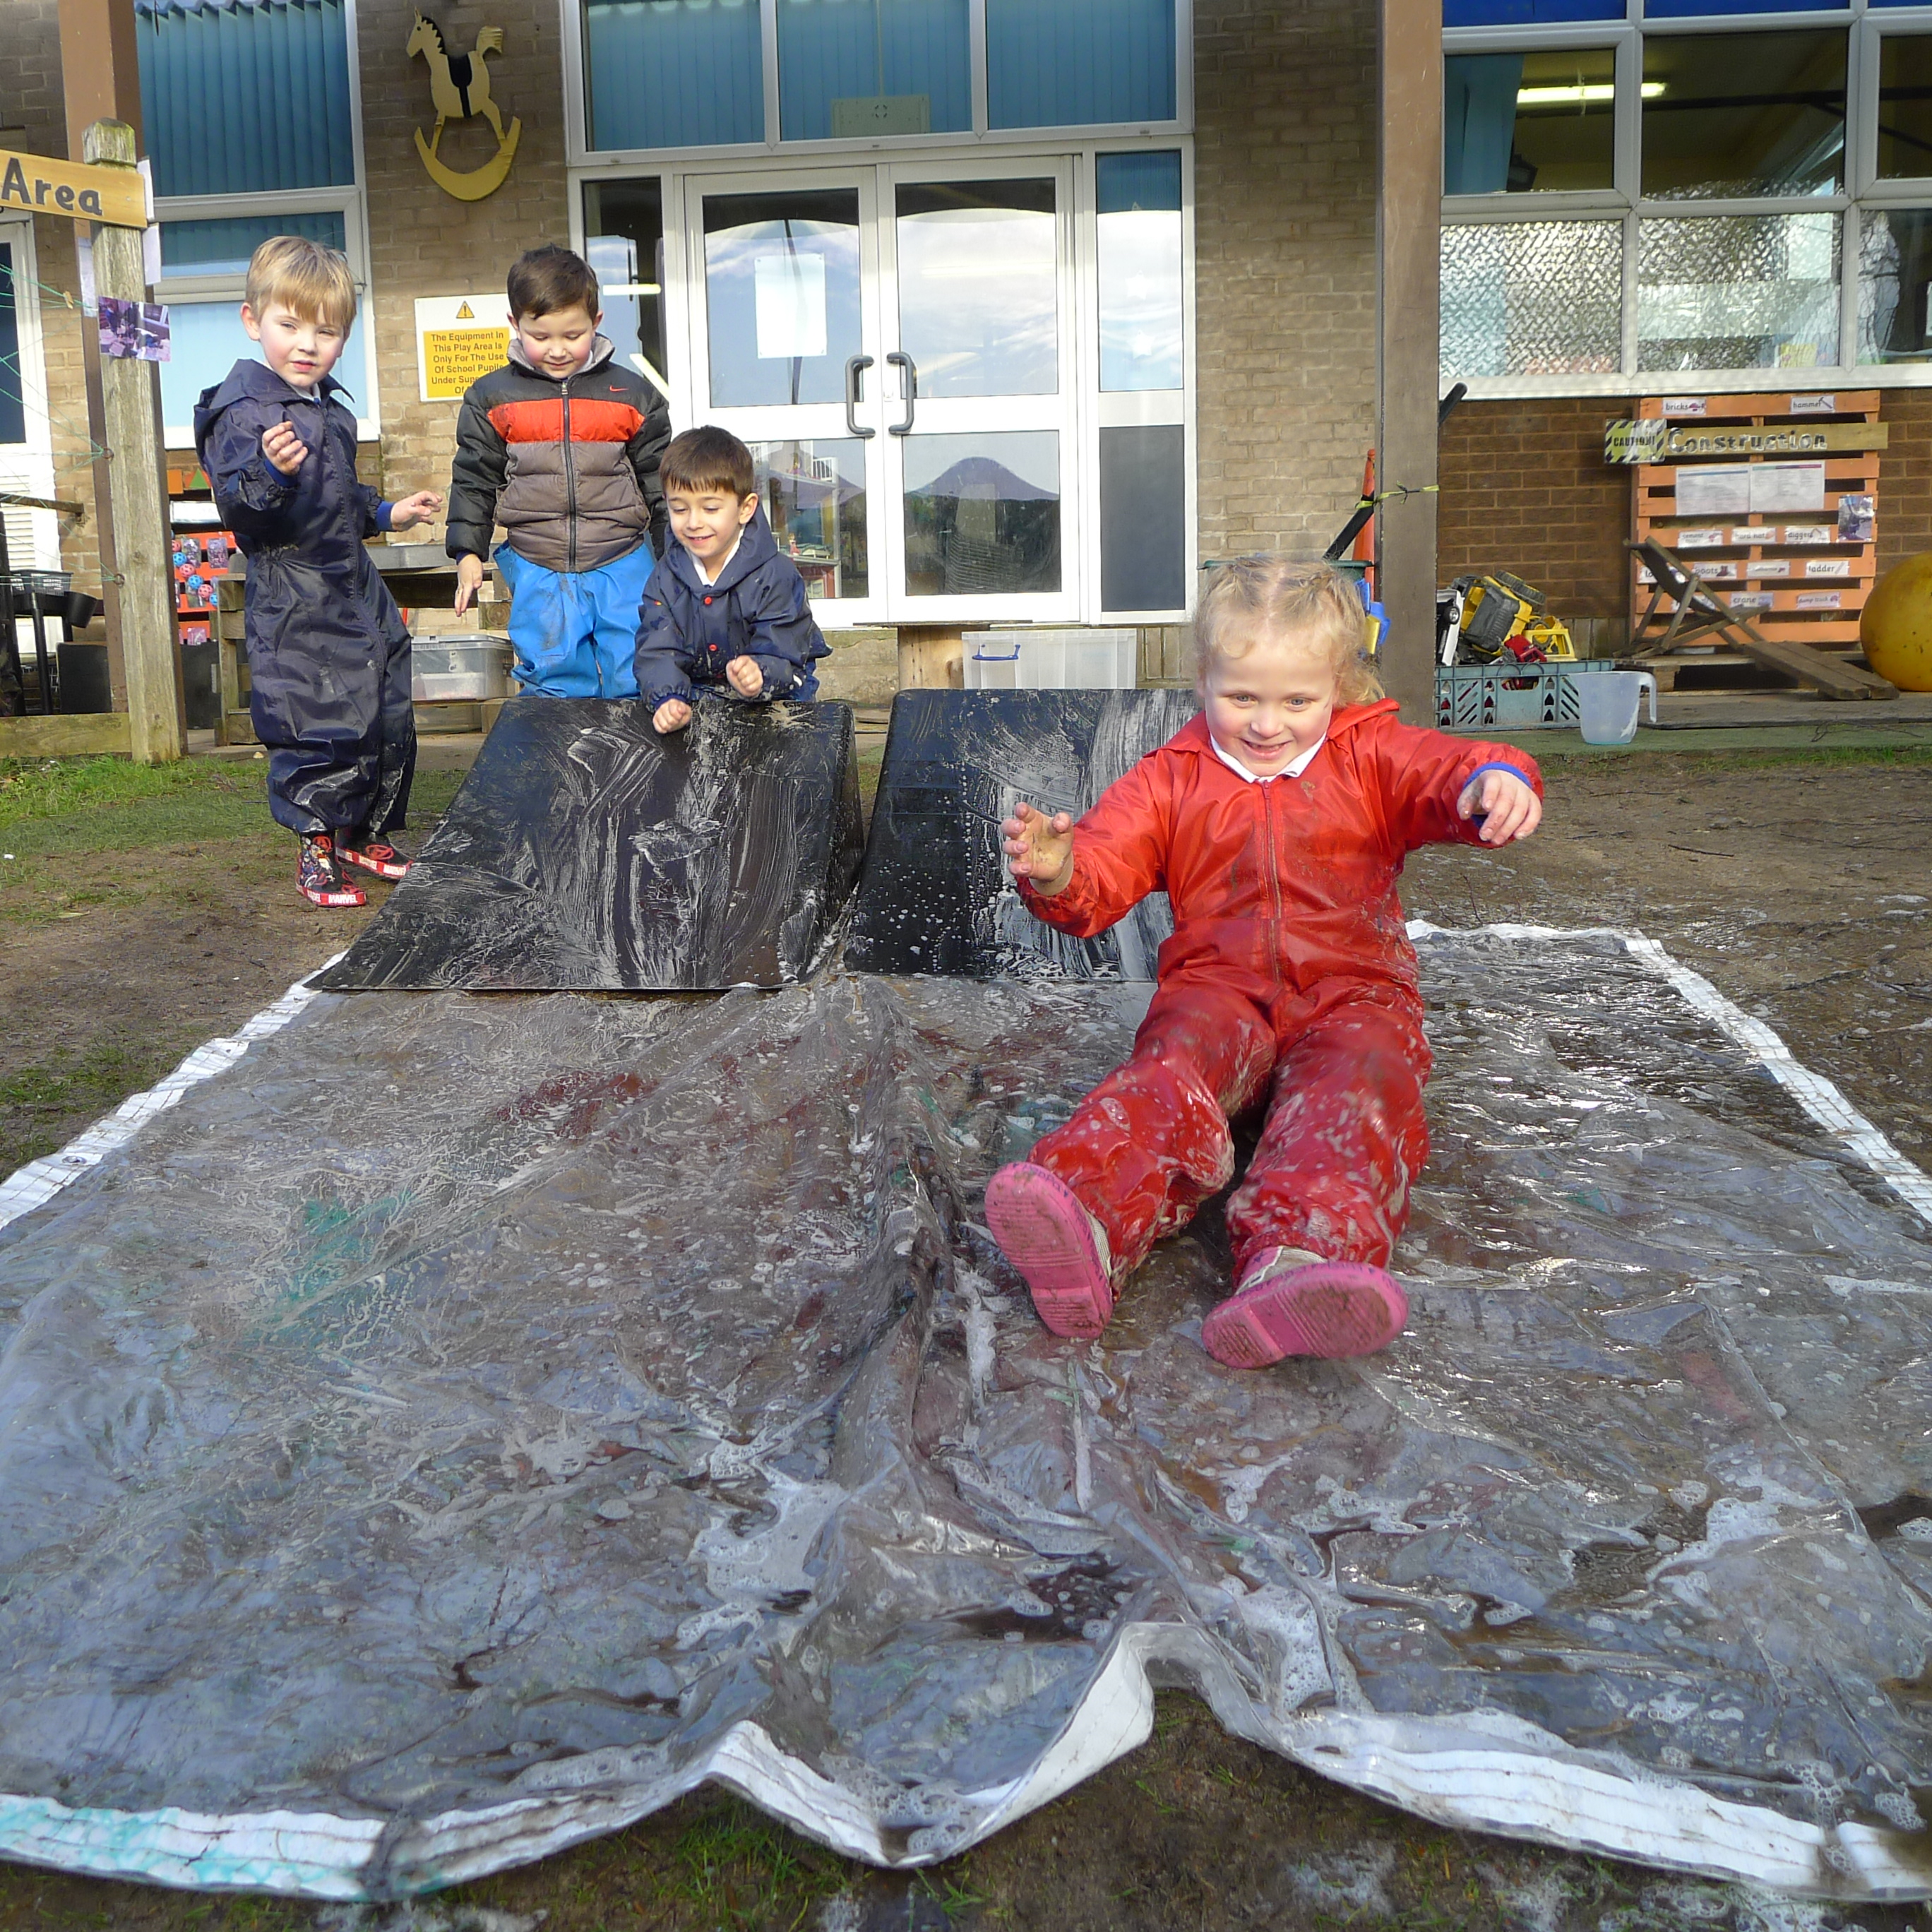  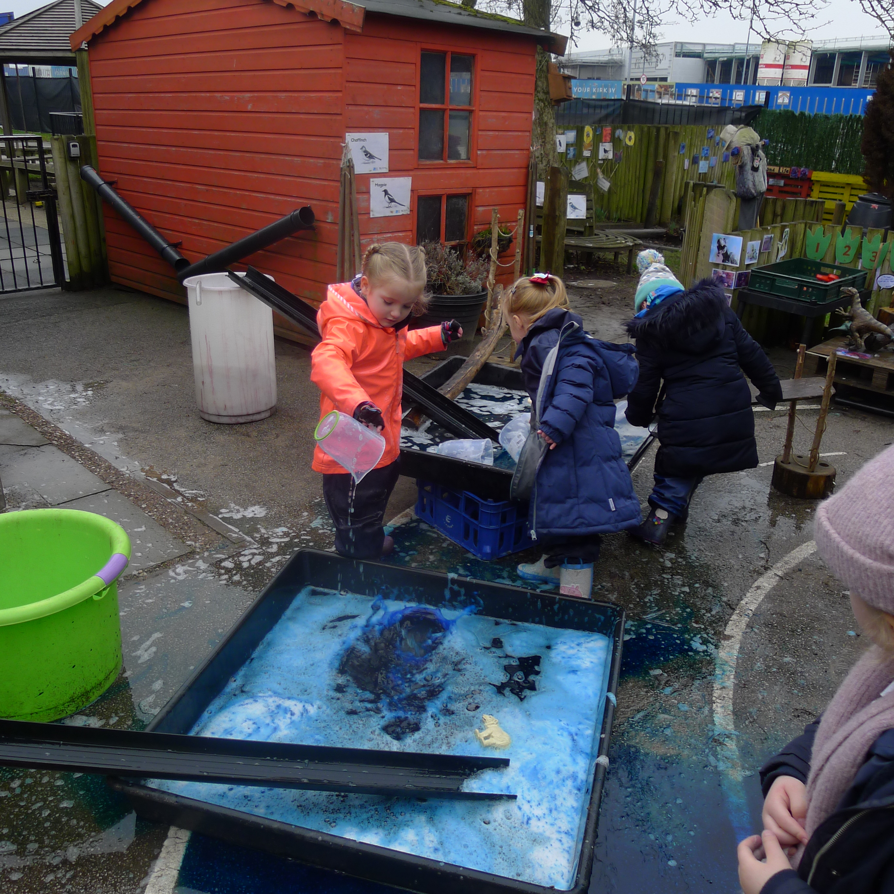
 |  |  | 5

Our Early Years Team  Mrs L McPhillips – Early Years Lead and Teacher  Miss E O’Nions – Teacher  Miss A Nieman – Teacher  Mrs A Schumacher – Teaching Assistant  Mrs N Vella – Teaching Assistant  Miss K Dunphy – Teaching Assistant  Miss K Noonan – Teaching Assistant  All staff work with both Nursery and Reception children.  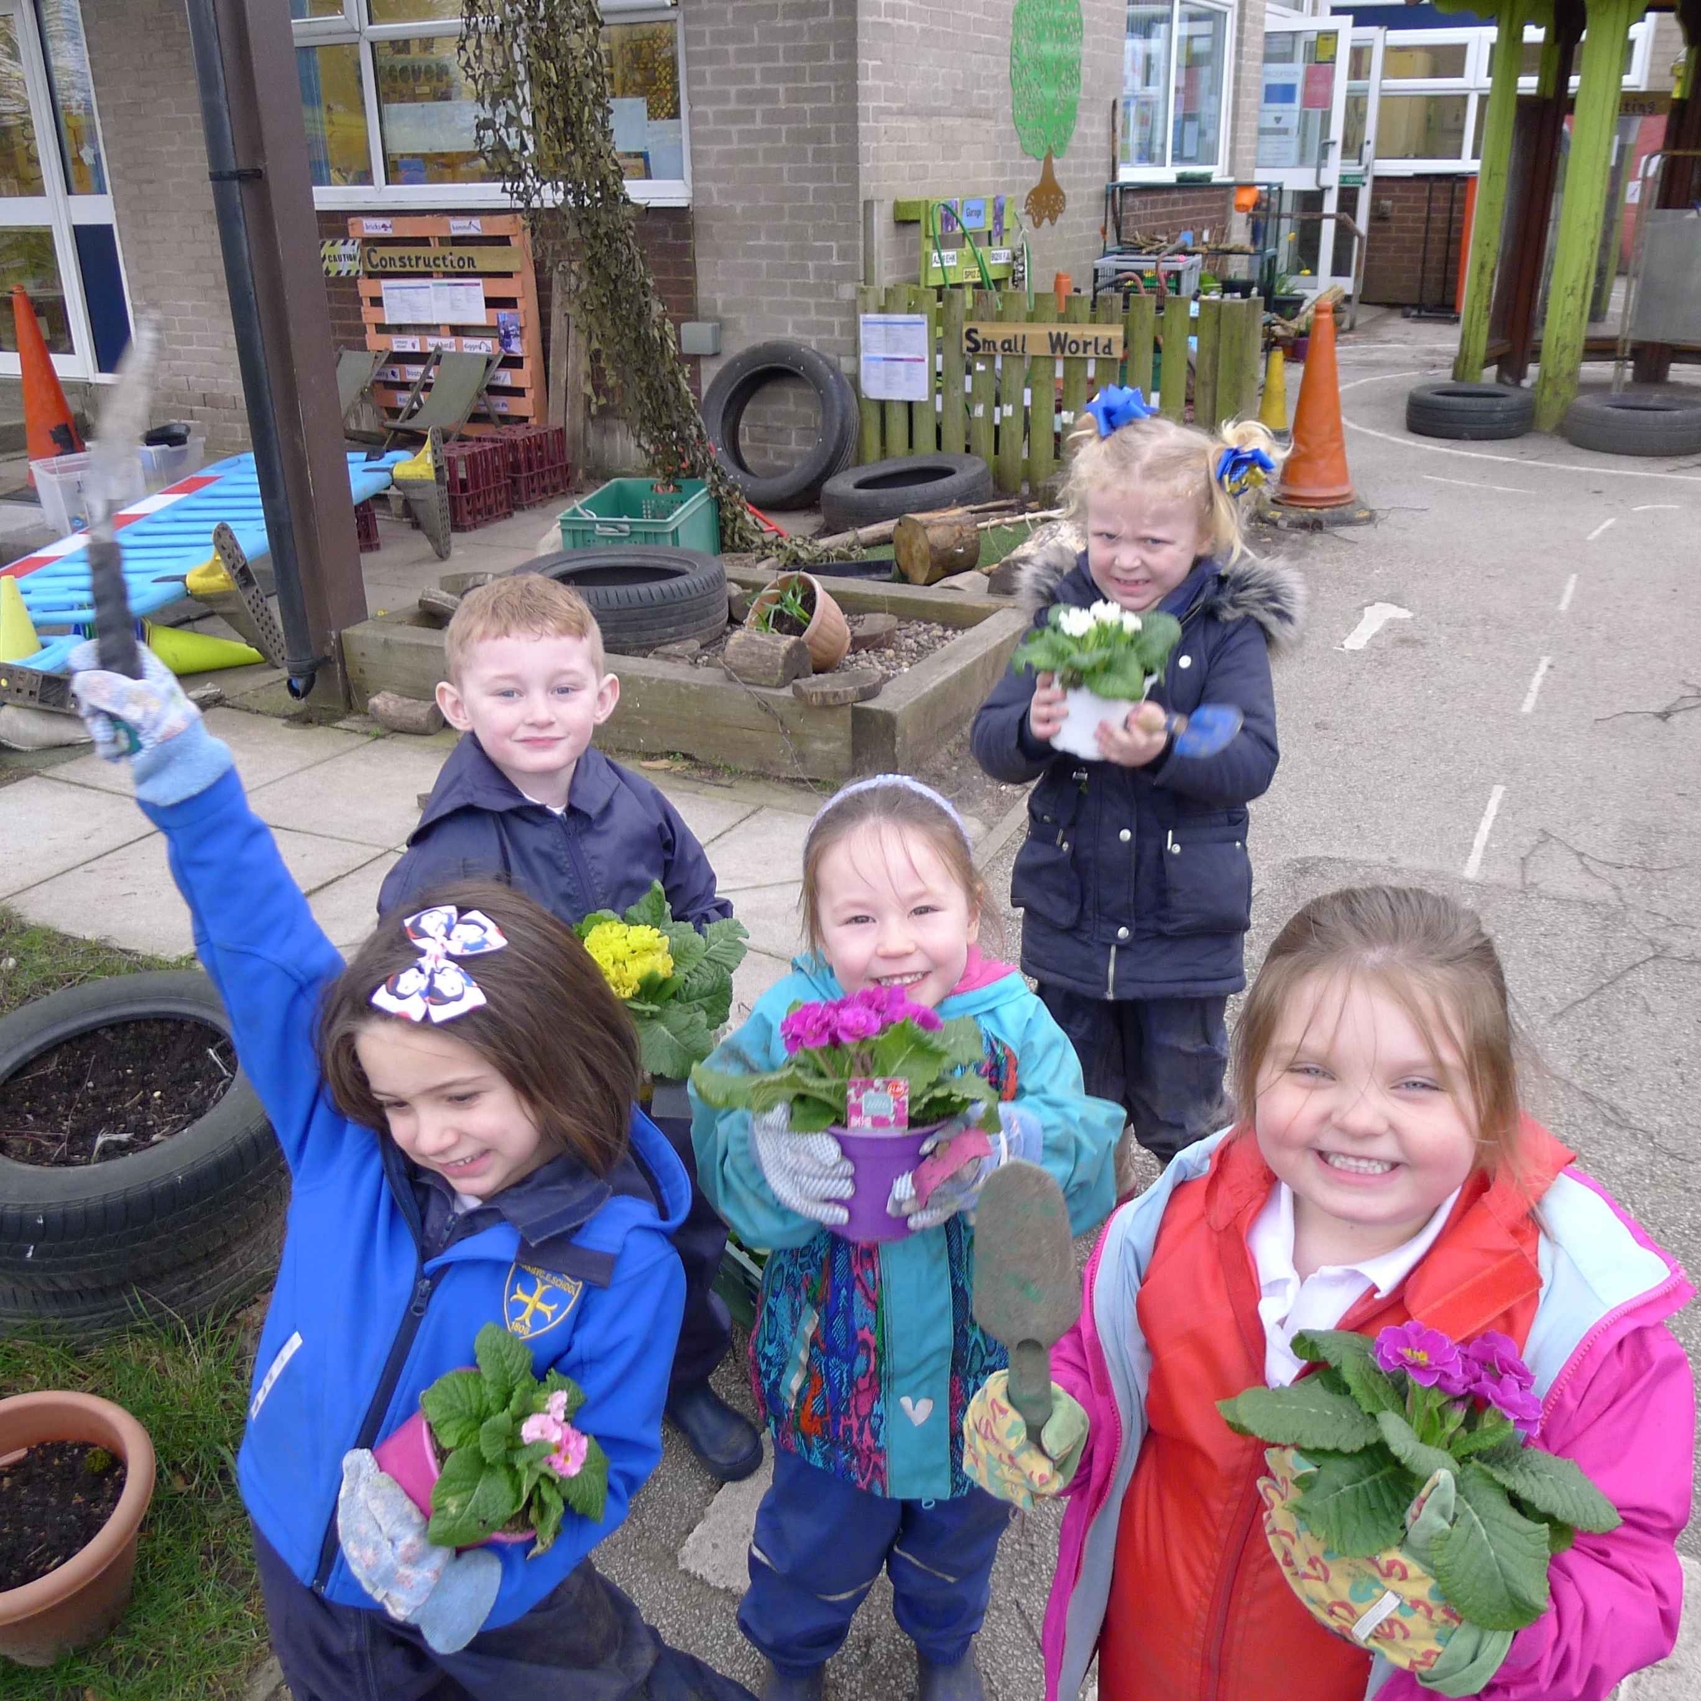  ‘As a new family to the school, the support we have had from staff just confirms that I have made the right choice for my child and I know she is very happy there’ – Parent 2021  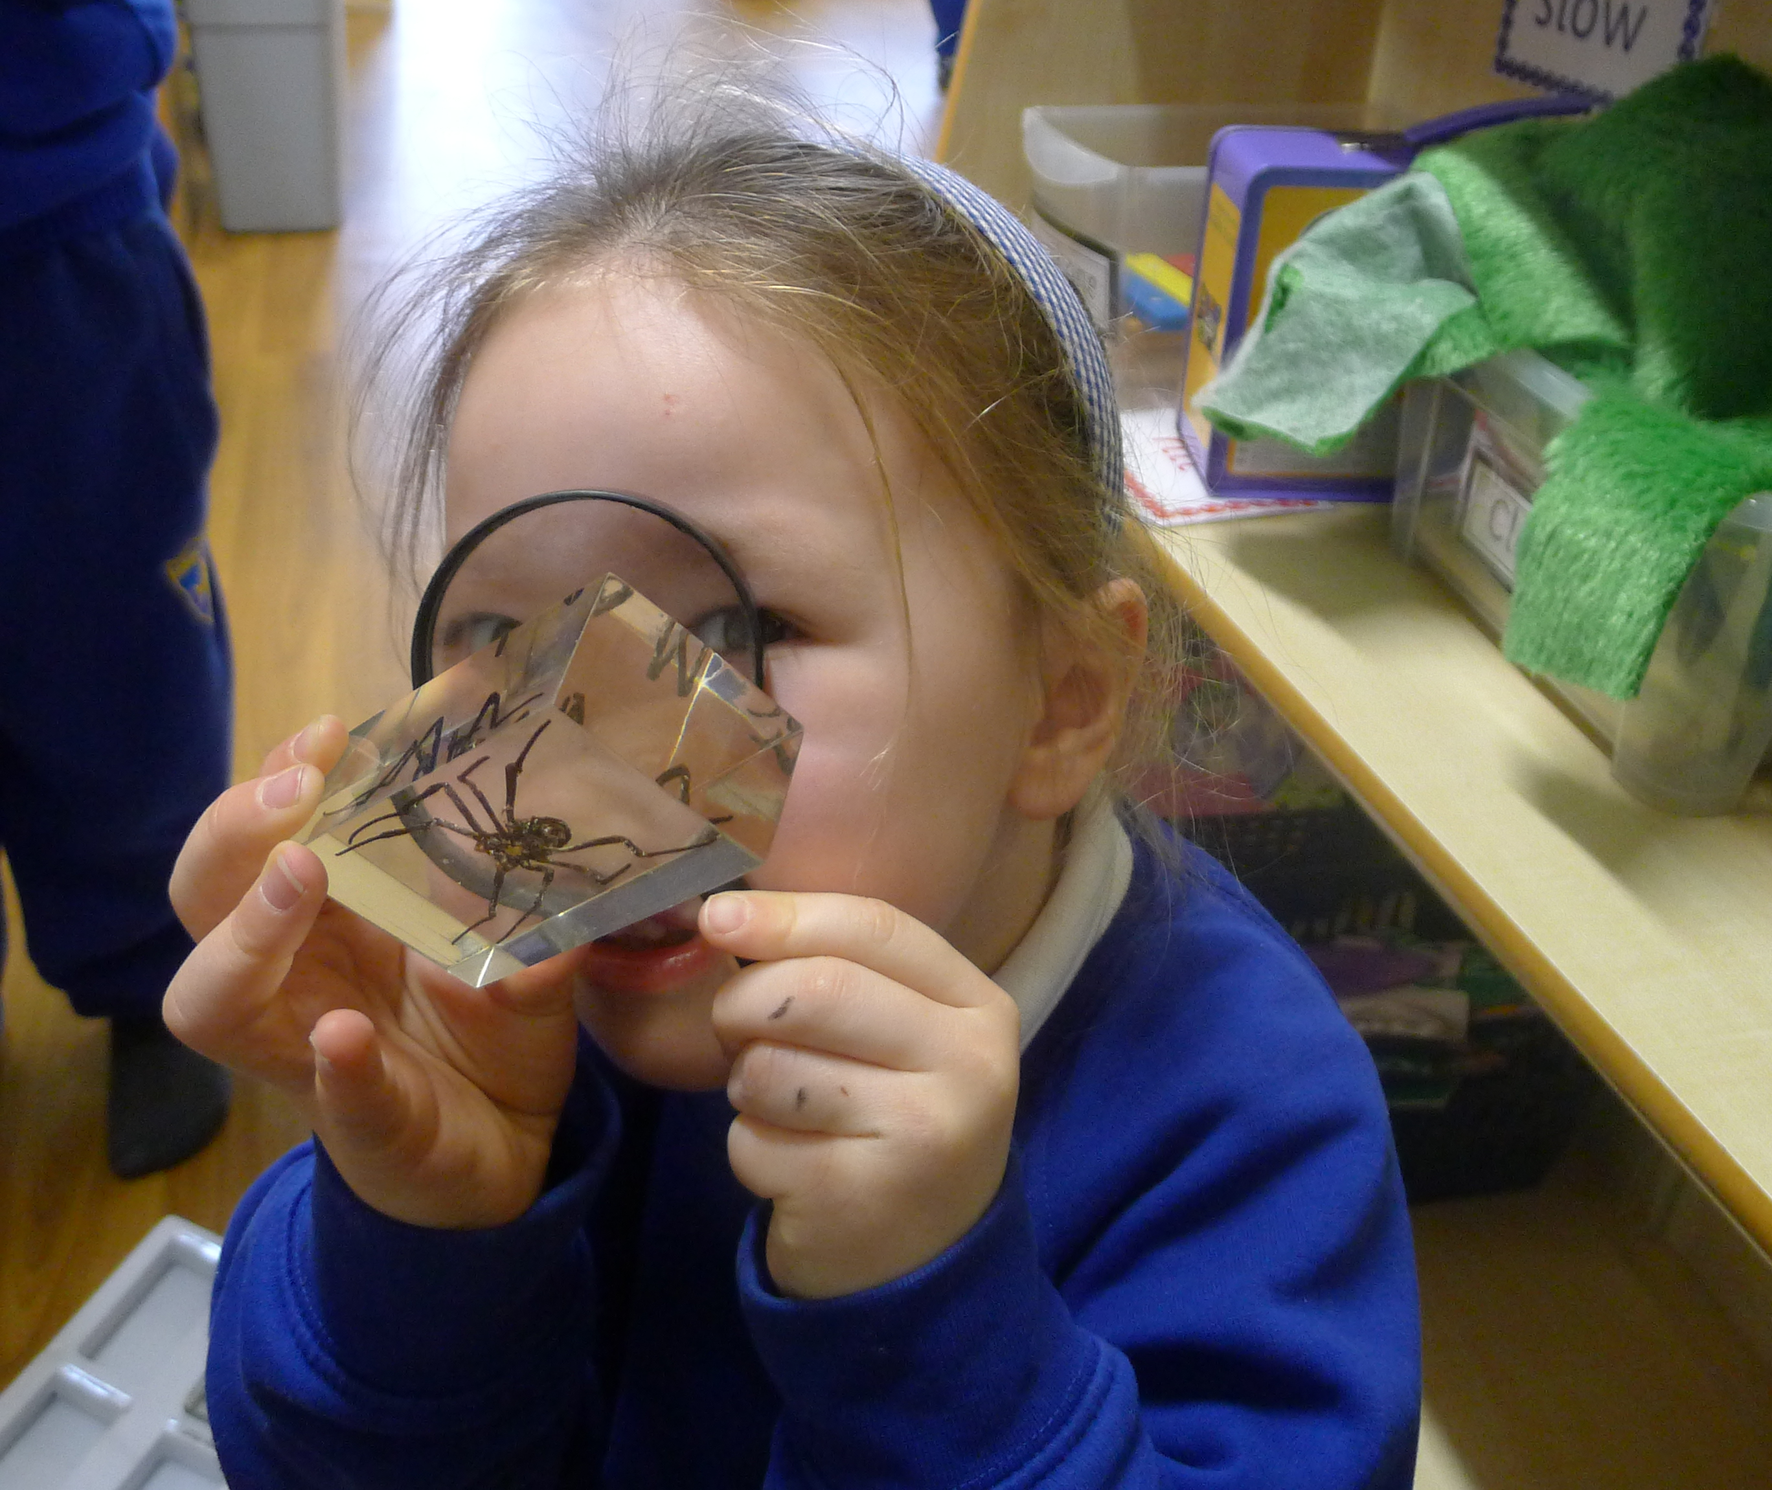 |  |  | Mission Statement  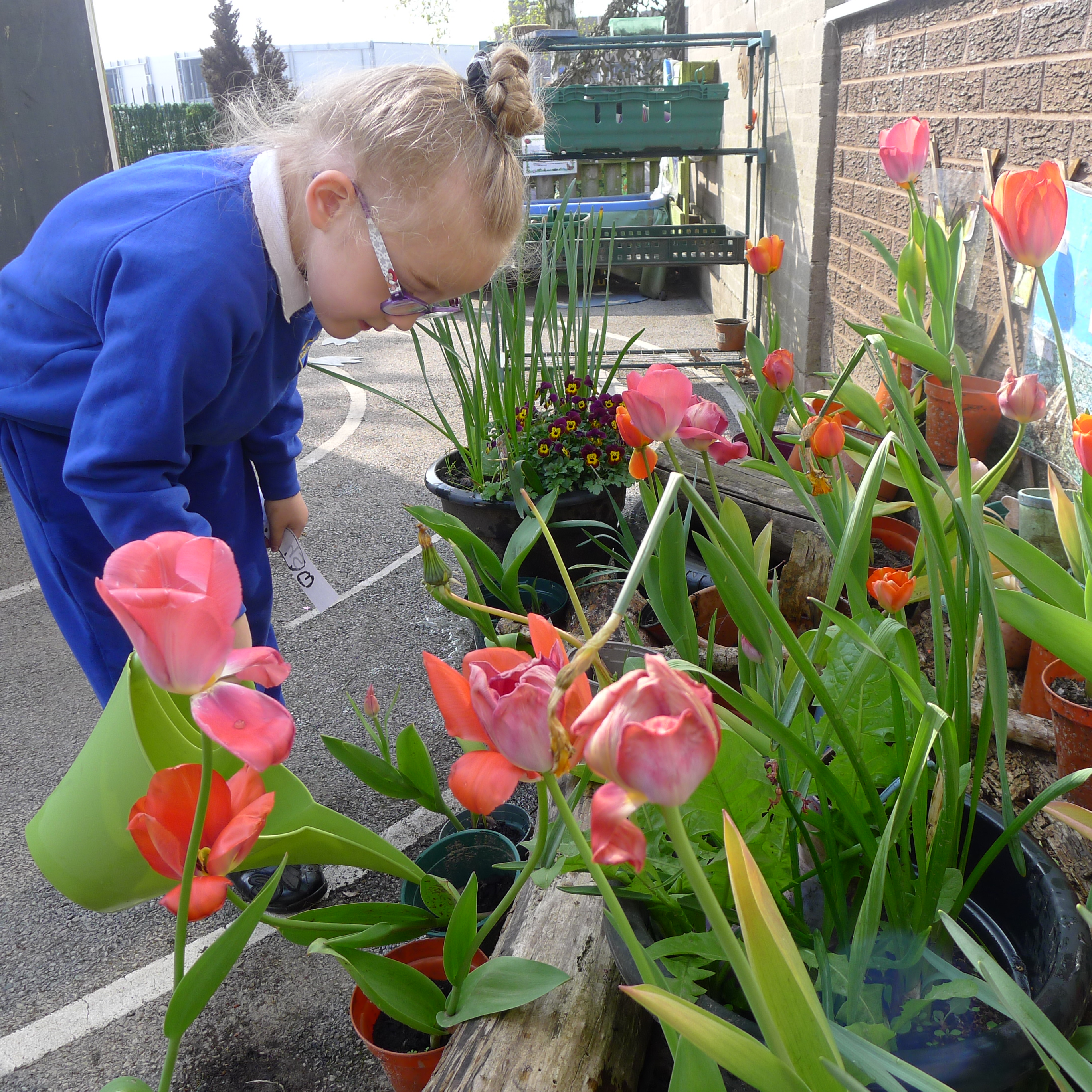  We value every child and aim to nurture each one in a respectful Christian environment. We encourage all their qualities and celebrate individuality. By working with partners alongside families we aim to maximize each child’s spiritual, academic and social potential through building solid foundations for a fulfilling future.  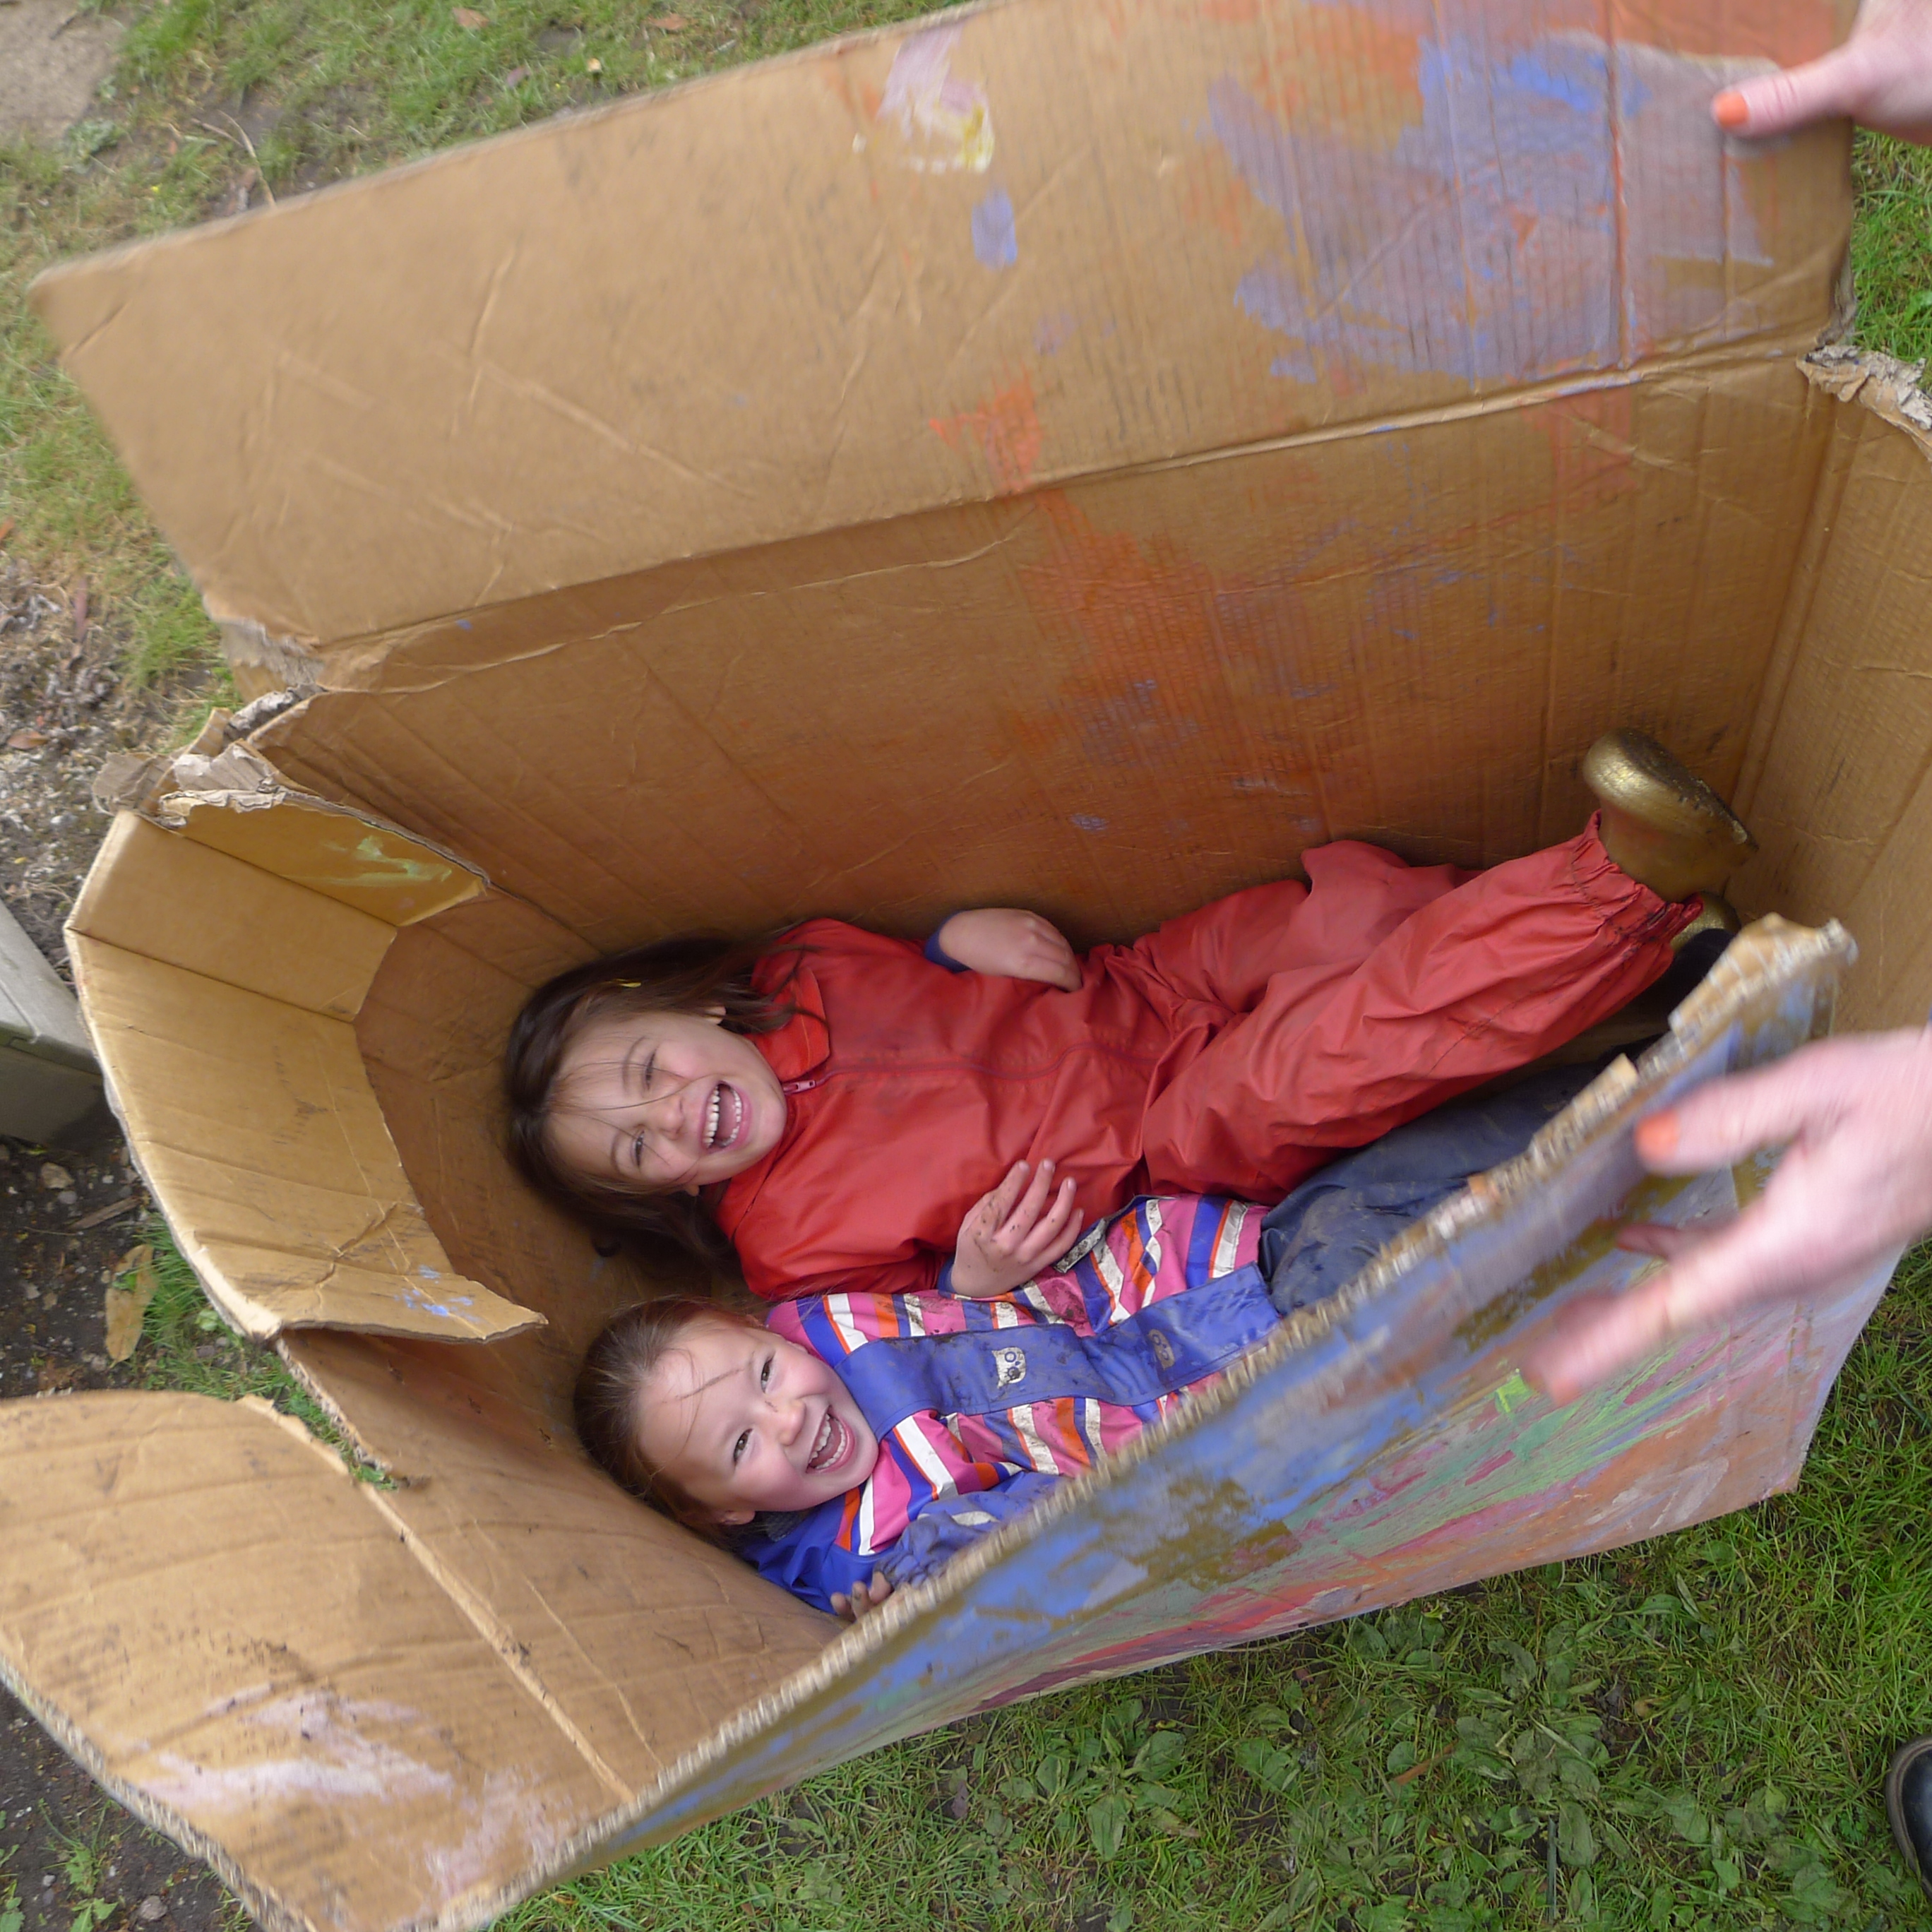
4 |  |  | 1

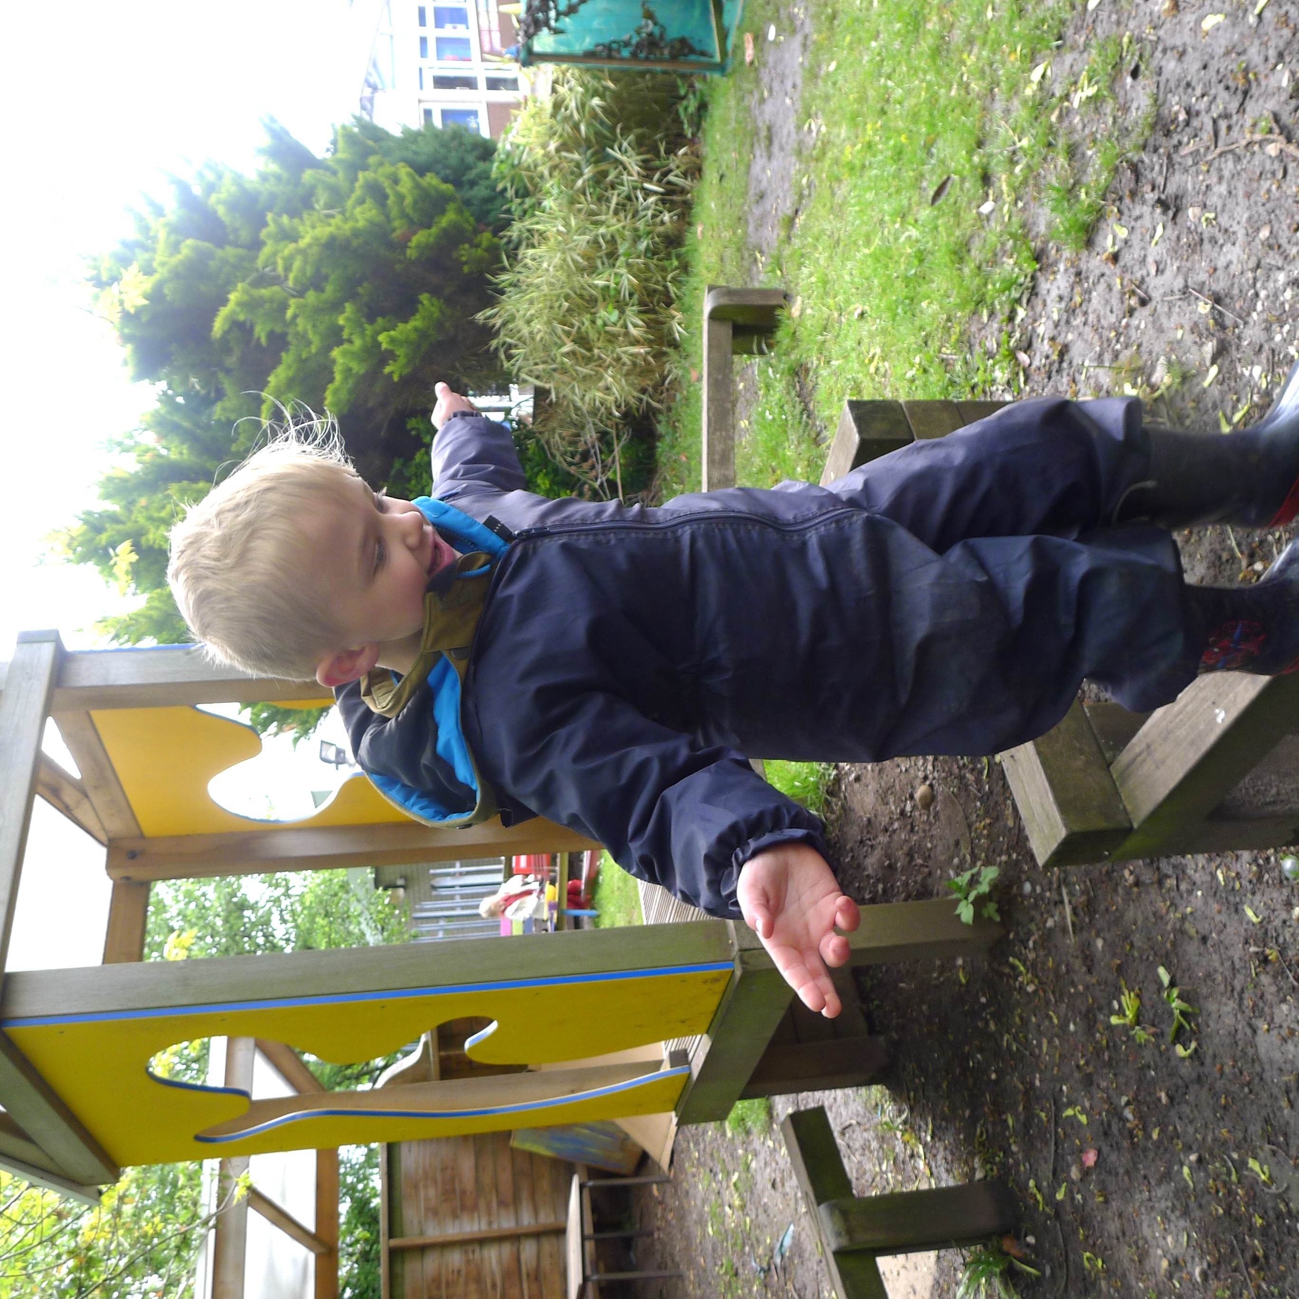  Welcome  Introduction  We welcome you and your child to Kirkby Church of England Primary School and we hope that your time with us will be a happy experience for both you and your child.  ‘Play is the work of childhood’ – Jean Piaget (Child development psychologist)  Our Priorities  Our first priority is for your child to be happy and for him/her to develop their full potential. We recognise that every pupil is an individual with their own personal talents and needs.  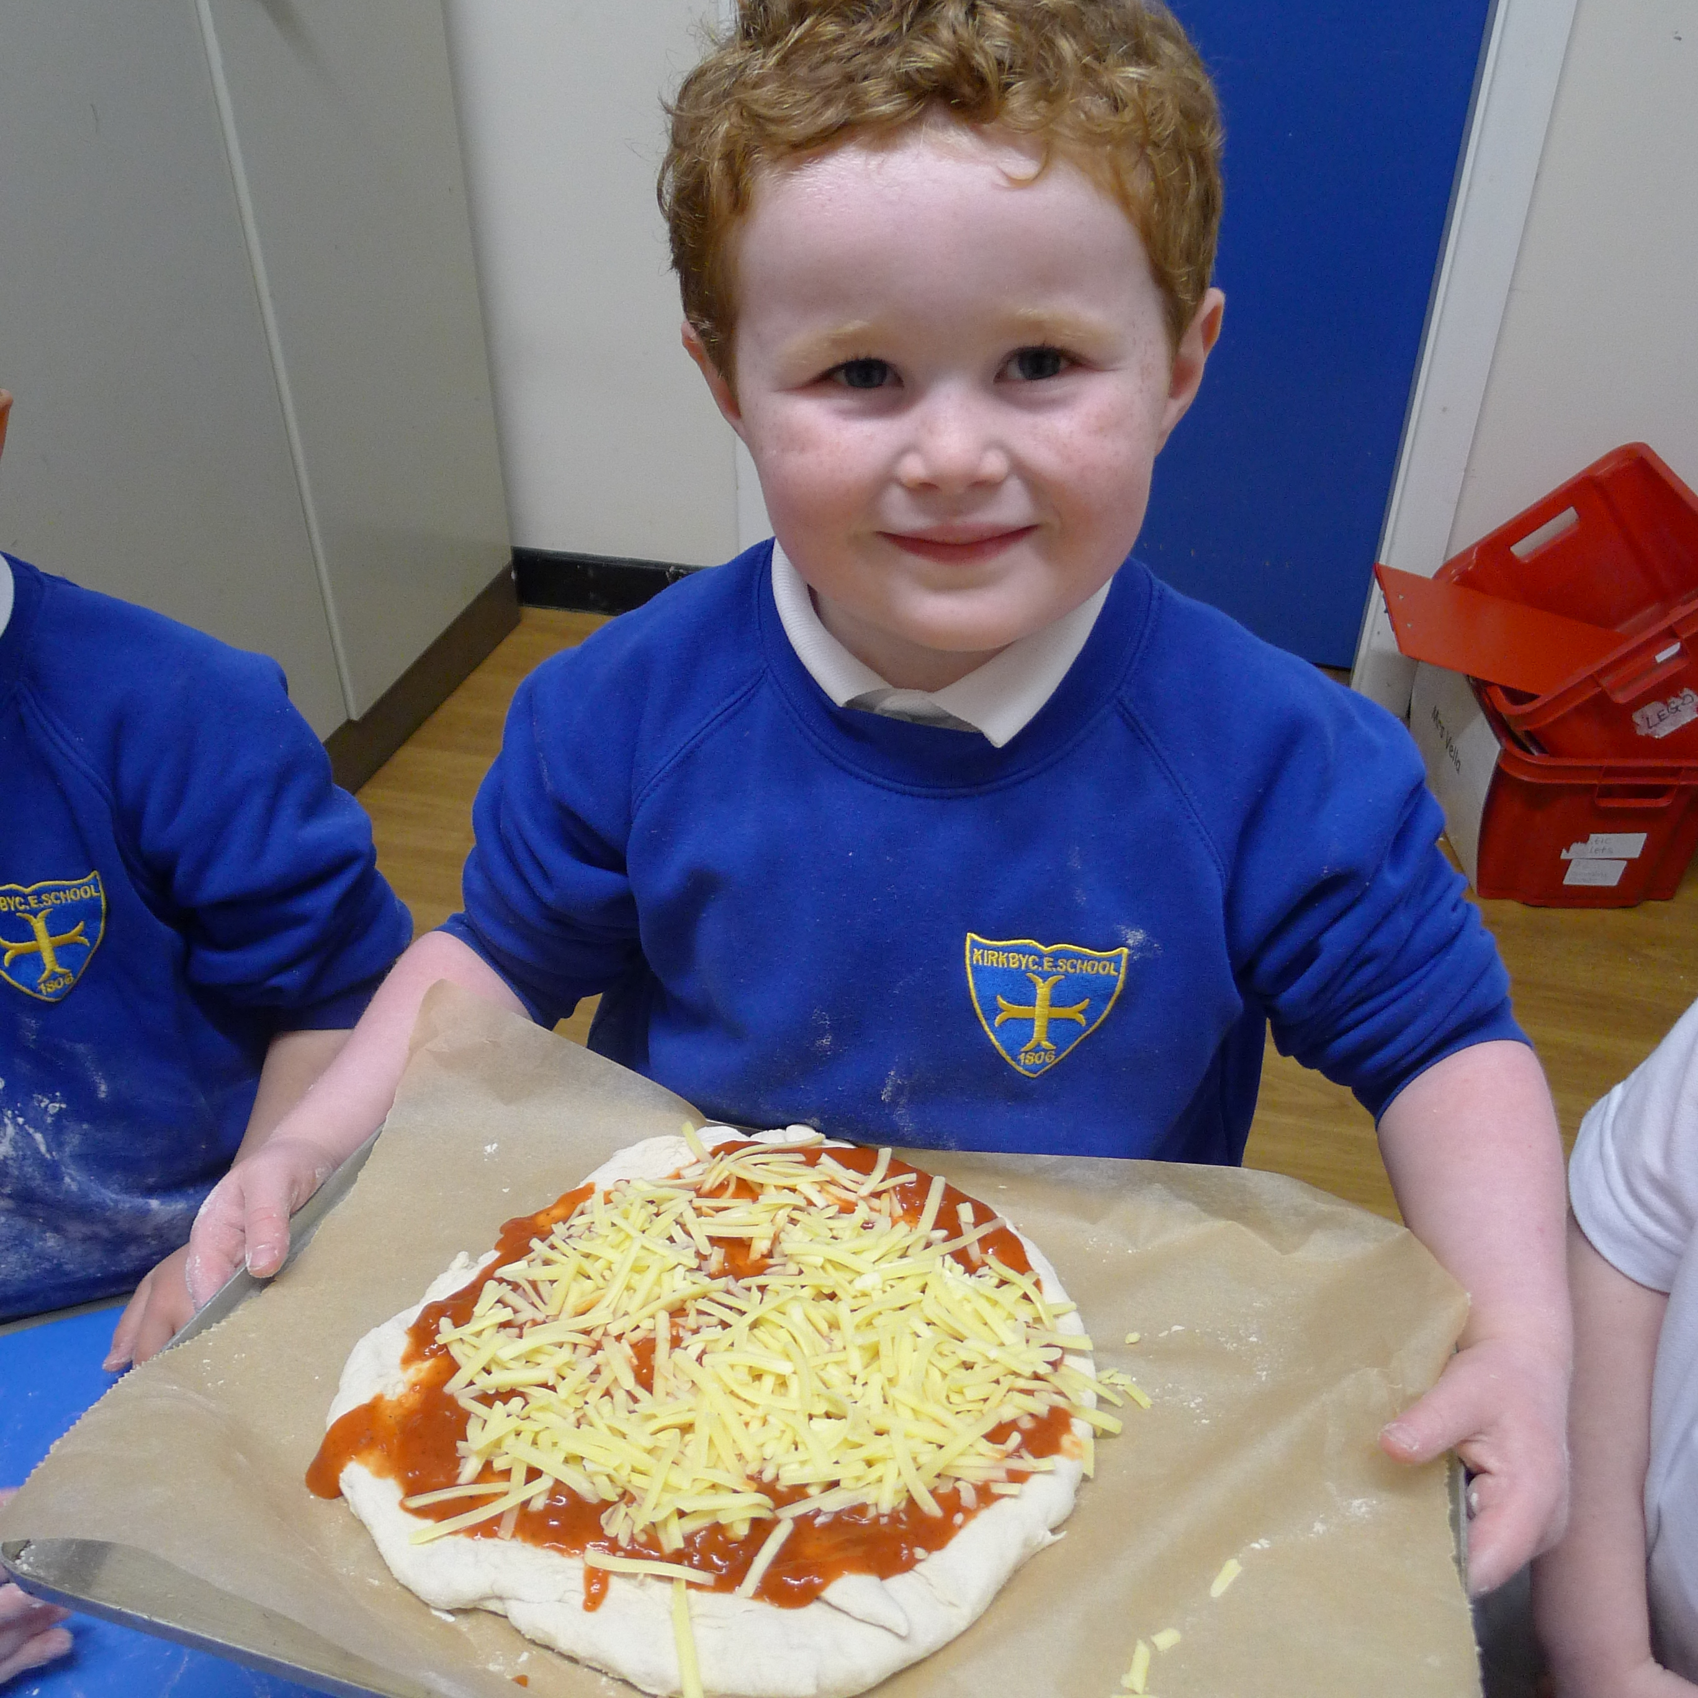  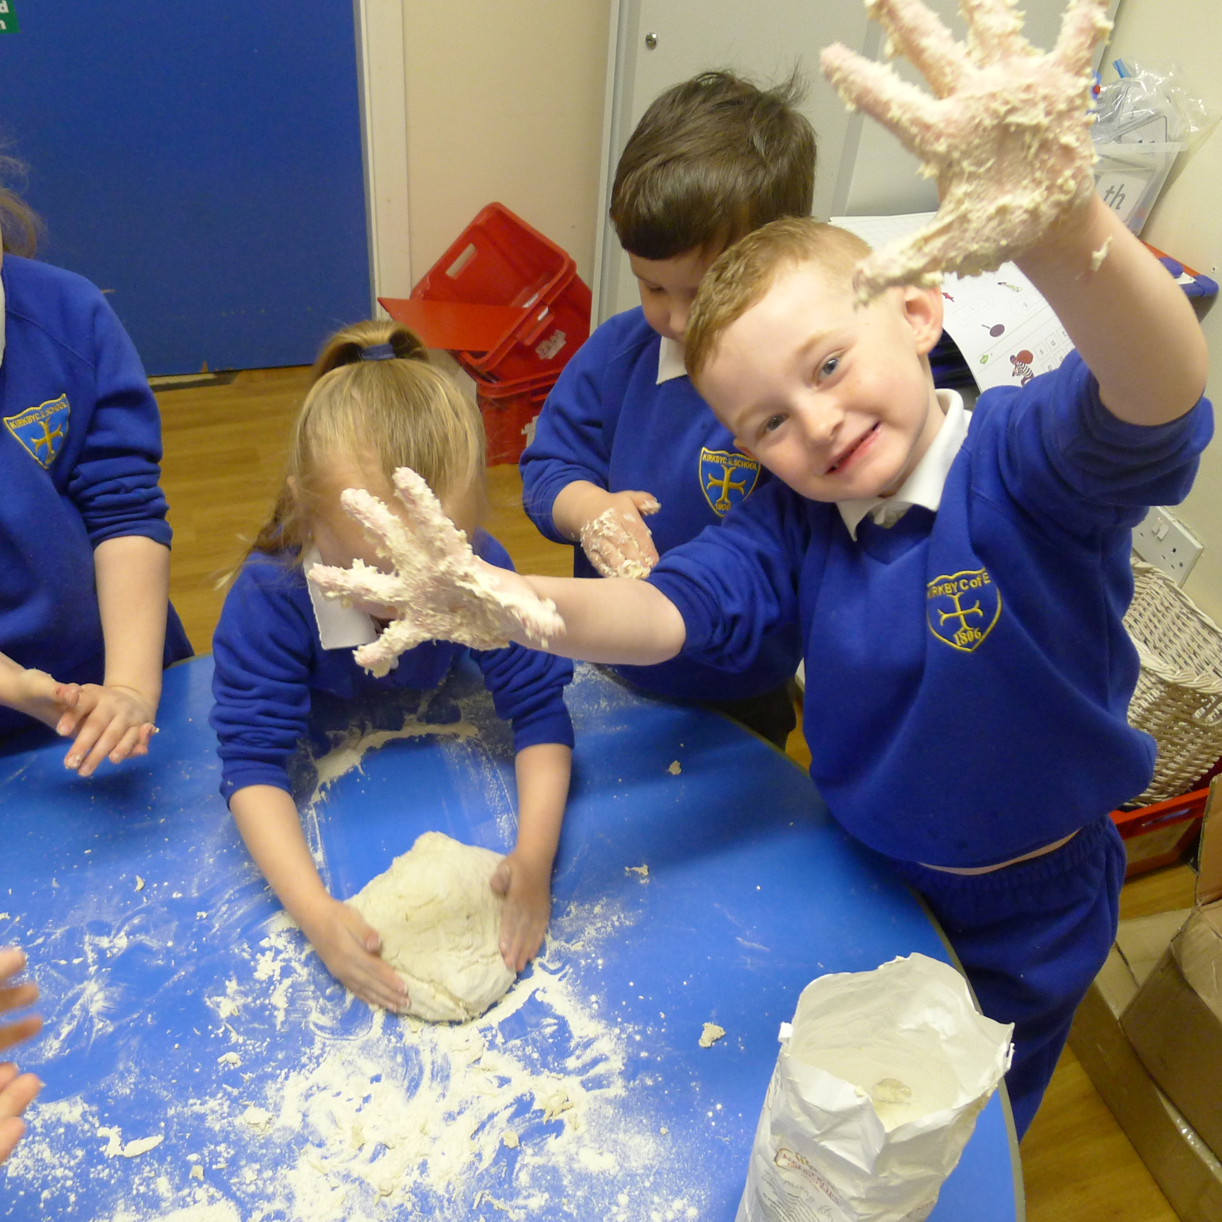  We are an ‘open’ door school in which we can discuss what is best for the children and resolve any problems if they arise. From experience, we find that if we all keep in touch, then these problems can always be resolved. |  |  | Settling in to School  Don’t worry if, after all the trouble you have taken to prepare your child for school he/she cries on the first day or even on the first few days. Some children settle immediately and with some it takes a little longer to become accustomed to this new step in their life.  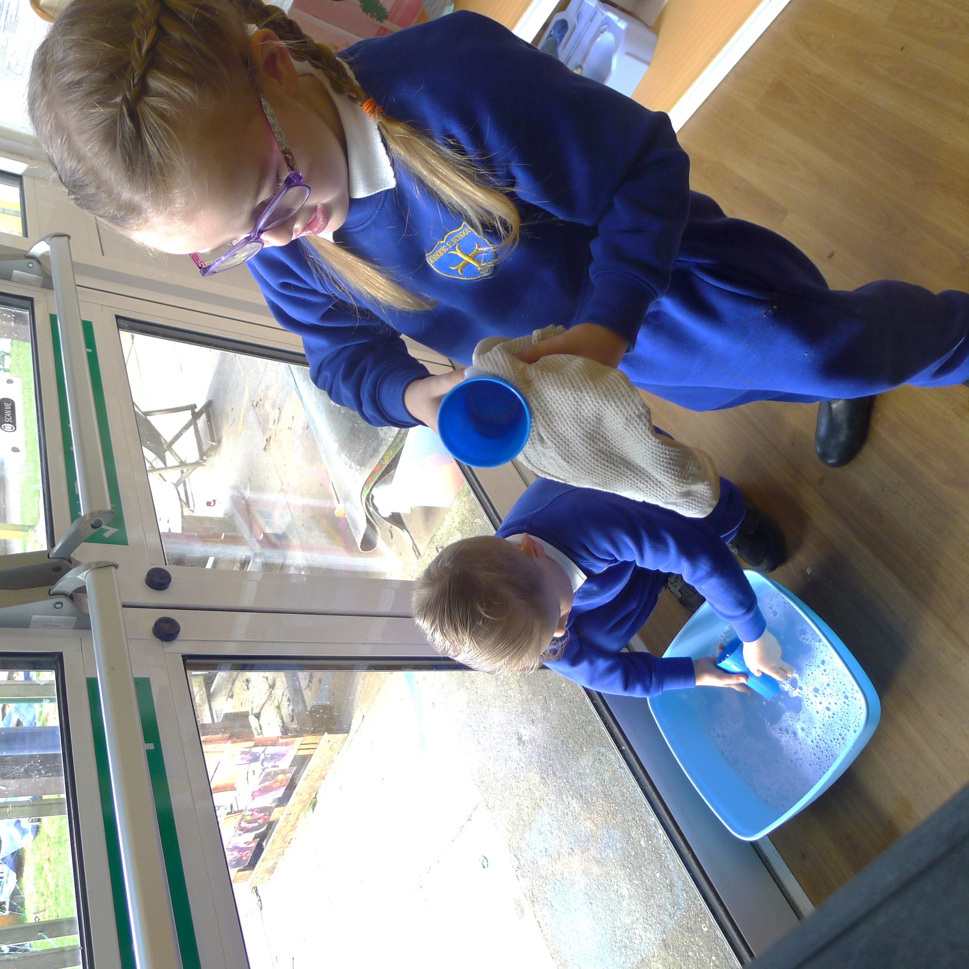  We know it can be distressing seeing your child upset however, please be assured that it is much better to leave quickly and more often than not the child settles within a few minutes. You can either call the office or we can call you to put your mind at ease. If you have any concerns, please do not hesitate to speak to a member of the Early Years team.  School hours and timetable  8:50am – Registration. If your child is late then he/she should be brought to school via the main entrance.  Snack – Children are offered milk and fruit each morning.  11:30am – 12:30pm - Lunchtime. Free school meals are provided for children in EYFS and Key Stage 1. Packed lunches should be in a names lunch box. No fizzy drinks, glass bottles or sweets.  3:00pm – Home time. Please notify us of who is collecting your child in the morning.
2 |  |  | 3

