2022 - Issue 2

If you have been forwarded this email and would like to subscribe, please fill out your details here.

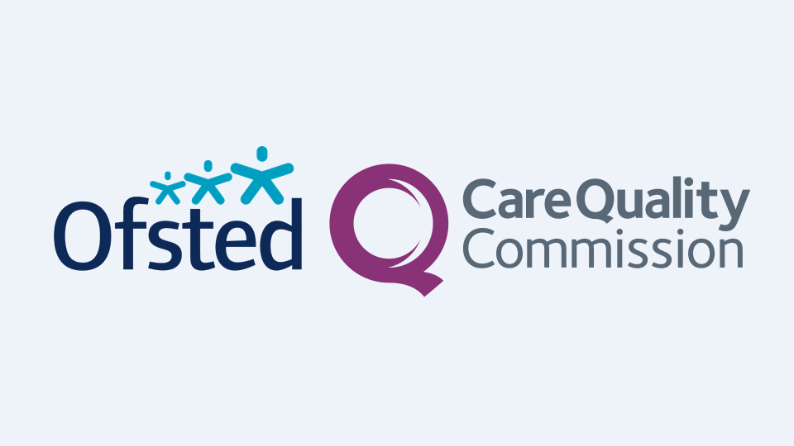

SEND Local Area Inspection
OFSTED and the CQC will be conducting a joint Local Area Inspection of our Special Educational Needs and / or Disabilities (SEND) services.

The two week inspection commences on 7th March 2022 and inspectors will review how well we identify, assess and meet the needs of children and young people with SEND across all of our local area services such as schools, early years, health, social care, education, inclusion and commissioned services.
During this time, the team will consider how well we fulfil our duties set out in the Children and Families Act 2014 and associated SEND Regulations and the SEND Code of Practice 2015. It will consider the quality of practice and how well we work together as partners in line with the graduated approach and principles of assess, plan, do and review.
What we have been doing
Over the last three years, we have been preparing for the inspection through: -
- Strengthening the relationship with our Parent Carer Forum (KPCV)
- Implementing our co-produced SEND Strategy 2018-2021 (extended for a further year due to COVID)
- A management restructure to increase oversight of the quality of our work – the restructure concluded in September 2021
- Restructure of the SEND Team and associated Inclusion Services
- Co-produced a SEND Assurance Learning Framework (ALF) to ensure consistency of our practice as well as improvement in practice.
- Delivered significant workforce development to council services and partner agencies
- Increasing special school sufficiency locally
- Creating a range of early intervention services for schools to access
- Improved governance through SEND Core Leadership and Partnership Board
And much more.
What we still need to do
Whilst we have achieved lots over the last few years we still understand there is lots to do. We know we need to;
- Enhance our Short Breaks offer through newly commissioned services
- Work towards Fullerton Grove re opening and expand our respite offer locally
- Improve how children transition from children’s services to adult services
- Work better with children, parents, carers, and each other to jointly commission services to meet needs
- Increase our special school provision locally
Inspectors will spend the first week off-site, analysing our performance data and management information. During the second week, Inspectors will be meeting with parents, carers, children, and professionals across a variety of field work activity such as 1:1’s, group sessions, surveys and focus groups.
This is the first ever SEND Local Area Inspection Knowsley has had and it will provide us with a platform to share our achievements as well as providing valuable learning for us.
There are several ways in which children, young people, parents and carers from your provision can engage with the inspection process and contribute their views:
- The inspection will include a survey of parents and carers. The survey will be open from noon on 07 March 2022 until 11:59pm on 15 March 2022. Parents and carers who would like to take part in this survey can follow this link: https://www.smartsurvey.co.uk/s/KnowsleyMetropolitanBoroughCouncilLASENDInspection/
- Parents and carers can email their contributions to Lasend.support@ofsted.gov.uk.
Ofsted and CQC carry out inspections in line with the Local area special educational needs and disabilities inspection framework and Local area special educational needs and disabilities inspection handbook for inspectors.

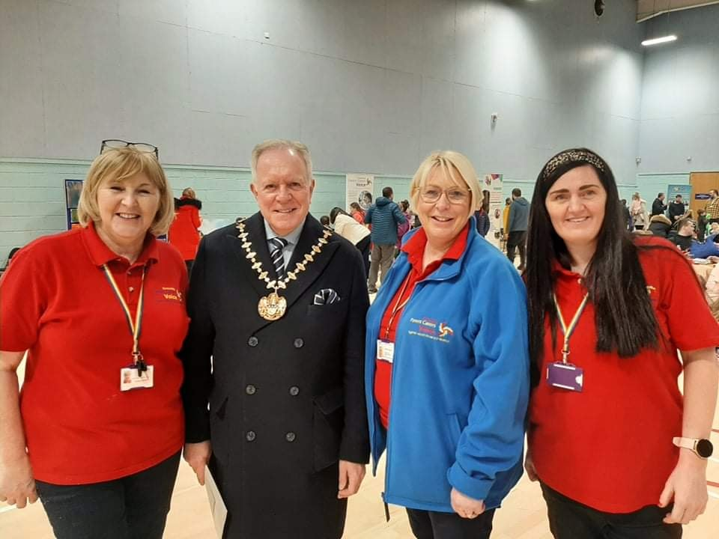

KPCV SEND Family Event
Knowsley Parent Carers Voice would like to thank you for attending the SEND Family Event on Monday 21st February 2022.
The SEND events are a fantastic opportunity for Knowsley Children & Young People and their families, where they can have a catch up with other parents, get information and advice, meet officers from the Local Authority and Health services and local disability service providers.
The entertainment was outstanding, fabulous buffet from Foodiez who always go the extra mile for KPCV.
Special thanks to; Knowsley Mayor for attending and spending time with the families.
Thank you to the following services and entertainment providers .
- ADDvanced Solutions Community Network
- Community massage therapy
- Knowsley Disability Concern
- Knowsley Police
- Knowsley Family Information Service
- Knowsley SEND Team
- Mersey Care NHS Foundation Trust
- Party Central Wildlife Experience Ltd
- Liverpool and Knowsley Sendiass
- StedyChefs Learning Centre
- The Sensory Hive
- 12 Million Minds
- Young Adult Respite Service C.I.C
- Al Russo
- Alma Wills and
- team.
- Cewe School
- Lily community crystals
- Qwell
- Shield Team
- Unique & Able Art
Our next event will be on Friday 26th August 2022 between 12-3 pm at Kirkby Leisure Centre and will be our 9th SEND Family Fun Event!

KPCV are looking for volunteers
Looking for a new challenge? Do you have 10 hours a month free?
KPCV always welcome volunteers to join the team. If you have a passion to make a difference for children/young people with SEND 0-25 or just want to help at a coffee morning or SEND event then please email KPCV for further details.

Follow KPCV!

Updates from Knowsley Inclusion Service

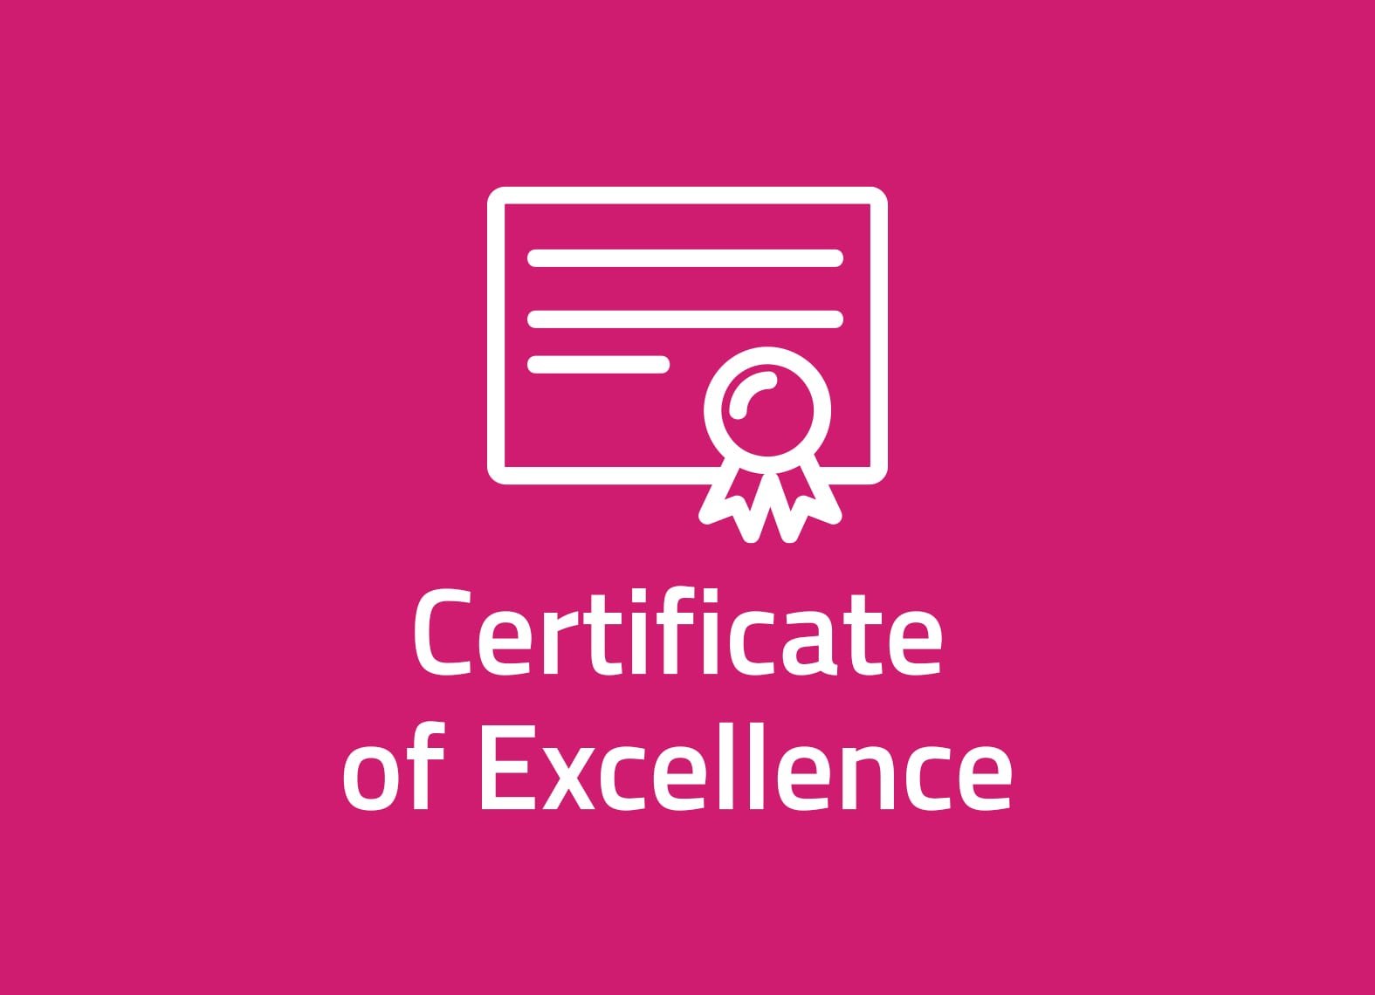

Knowsley Council recognised for improvements to Education Health Care Plans
Knowsley Council has been awarded an iESE Certificate of Excellence for implementing the Invision360 EHCP Audit Tool, leading to improved quality of Education Health Care Plans (EHCP).
The tool enables the Council to audit the quality and consistency of EHCPs against recognised standards, providing data and evidence to target improvements and improve outcomes.
The online tool provides auditors with a simple online step-by-step process with includes built-in checklists and key tips around what to include in each section. They system also increases objectivity and consistency.
The Certificate of Excellence has been awarded as part of the iESE Public Transformation Awards, recognising public sector organisations for their efforts in improving and transforming local public services. This year’s awards attracted over 300 entries, so the Certificate of Excellence is recognition of the excellent work being undertaken by the Council to improve EHCPs for children and young people.
The Council is using Invision360 to improve practice, create a more joined-up approach to Education Health Care planning and, most importantly, improve outcomes for children and young people with Special Education Needs and Disabilities.
The judges heard how the Council has made sustained improvements in the quality of EHCPs. One of the most significant improvements has been around the auditing of health and social care sections of the plan. Before introducing Invision360, just 31% of plans had sufficient health or social care sections audited as ‘Good’, however just 12 months in, this percentage now stands at 86%.
Cllr Margaret Harvey, Cabinet Member for Children’s Services, said “I’m delighted that we have been recognised for our work to improve our Education Health Care planning process. We will continue to build on the improvements we have made to ensure the best possible outcomes for our children and young people.”

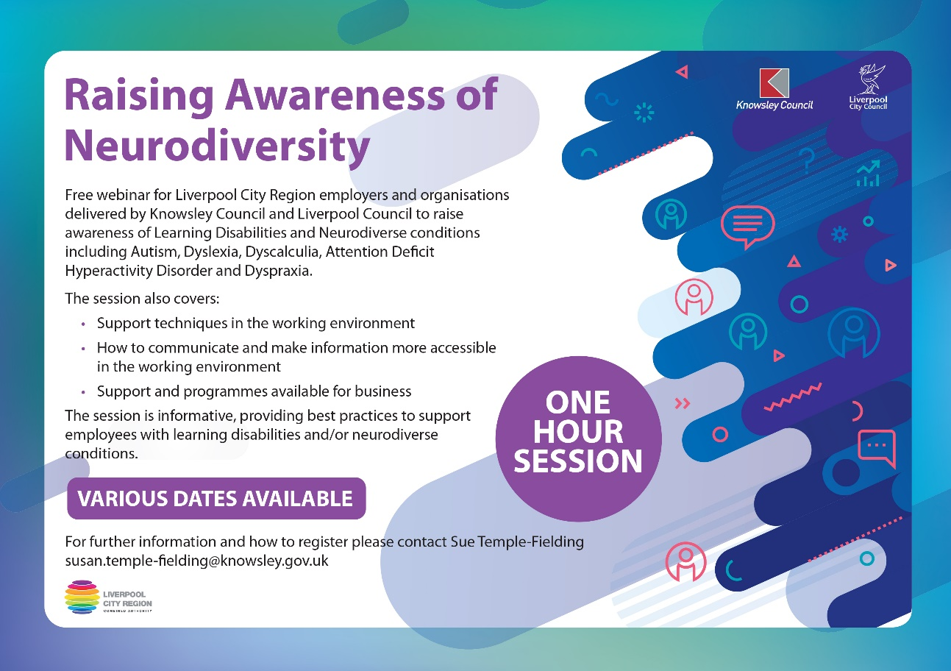

Access & Inclusion
We are offering a free one hour webinar for Liverpool City Region employers and organisations delivered by Knowsley Council and Liverpool Council to raise awareness of Learning Disabilities and Neurodiverse conditions including Autism, Dyslexia, Dyscalculia, Attention Deficit Hyperactivity Disorder and Dyspraxia.
YOU MUST REGISTER IN ADVANCE TO SECURE YOUR PLACE IF YOU WISH TO ATTEND ONE OF THE WEBINARS BELOW
There are 60 places available which will be allocated on a first come / first served basis to those who register in advance.
Click here to register for Raising Awareness of Neurodiversity 15th March 2022 (start time 11am - end time 12pm)
Click here to register for Raising Awareness of Neurodiversity 26th April 2022 (start time 11am - end time 12pm)
On the day of the webinar, please join 5 minutes early to allow for a prompt 11am start
After registering, you will receive a confirmation email containing information about joining the webinar.
Please see Privacy Policy for this event: Knowsley Council Privacy Statement
Please inform us in advance if you have any access requirements.
We look forward to you joining us.

English as an Additional Language (EAL)
The EAL Team are continuing to support those EAL learners who require our support.
We are pleased to say that two academies have bought into our service and we hope this encourages others. More information and resources are accessible to all via the EAL page on the Knowsley Local Offer site.
We now have four schools who have shown interest in the School of Sanctuary Award. We are waiting for them to sign their organisation pledge.
Merseyside Police are running a Black History Art Competition for primary school children. This is a competition that was run last year across all the boroughs. Each borough had their own winner and the winning entry was posted on Police vans in the area. Knowsley’s winner was a Year 4 boy from St Ann’s Primary. As part of the prize the winning boy’s class had a free trip to the maritime museum.
Merseyside Police are prepared to go into schools and do an assembly on this. So far six schools have requested this and want to take part in the competition.

SEND Team
As part of our on-going commitment to improving our services, we are introducing surveys for those Children, Young People and Families who receive SEN support and another survey specifically for those Children and Young People who have an EHCP.
We would kindly ask for any children, young people and parents who receive SEN support in Knowsley to complete the surveys below:
- SEN Support Survey - Children & Young People
- SEN Support Survey - Parents & Carers
There are also surveys that will be issued alongside a new EHCP and as part of the annual review process both of which have now been embedded into the correspondence, we send out alongside a new EHCP.
We want to know how helpful the support you and your child/young person receives is to you, to help improve things for you and your child/young person who need support.
The answers may be used by the Knowsley SEND Team and you have the option of keeping your answers anonymous or providing your contact details if you wish to discuss any issues with a member of the team.
The answers will be used to help improve the way that we provide EHCP and SEN support for all Knowsley Children & Young People who require them.
Your voice matters and will make a big difference to how Knowsley Council can help you and your family in future.

Meet our new Team Manager!
We are pleased to announce the recent hiring of Amanda Avery to the position of SEND Team Manager. Amanda comes with a wealth and breadth of knowledge within Education and SEND and she joins us from Warrington, where for the past five years, she distinguished herself as Education Quality Manager for the Virtual School followed by the Quality Assurance Manager for SEND. Prior to this, Amanda was a Classroom Teacher in both Secondary and Primary Schools. She'll be reporting to Inclusion Manager Kelly Carey.
Amanda is an avid footballer and plays for her local Vets team whilst promoting football for all. She also has a passion for drama and theatre, and can often be found on stage!
She would love to meet you over the forthcoming months so that she can better encourage and train her team, so that she can provide you with the best service possible.

Follow Knowsley SEND Team

Sensory Impairment Service
The Sensory Impairment Service has a new piece of art for the office wall (a tea towel in a frame is art to teachers!!). Luke Christian is a deaf fashion designer who has been commissioned to produce a design to feature on a range of items for comic relief’s fundraising activities this year.
Luke, who was born deaf, owns DEAF IDENTITY a fashion brand aiming to break down barriers and stigmas surrounding deafness. In his blog Luke says, “I aim to show that deafness is a spectrum, there’s no right or wrong way of being deaf and that deaf people can do anything they want.”
In a world where diversity and equality is being highlighted and spoken about, it is important to remember that many deaf children and young people have a very personal deaf identity, often different from what is seen on TV and this is an aspect the service focuses on with them through our Audiology Curriculum.
Luke’s designs for TKMaxx show the British Sign Language sign for ‘love’ signed by a figure with a stylised hearing aid. Money raised through Comic Relief supports a range of projects offering services to deaf babies, children, young people and their families.

Source: https://www.google.co.uk/bsl (sign for love)
You can show your support by learning the BSL sign -placing your hands flat across your chest as you say ‘love’.

Updates from our Young Reporters

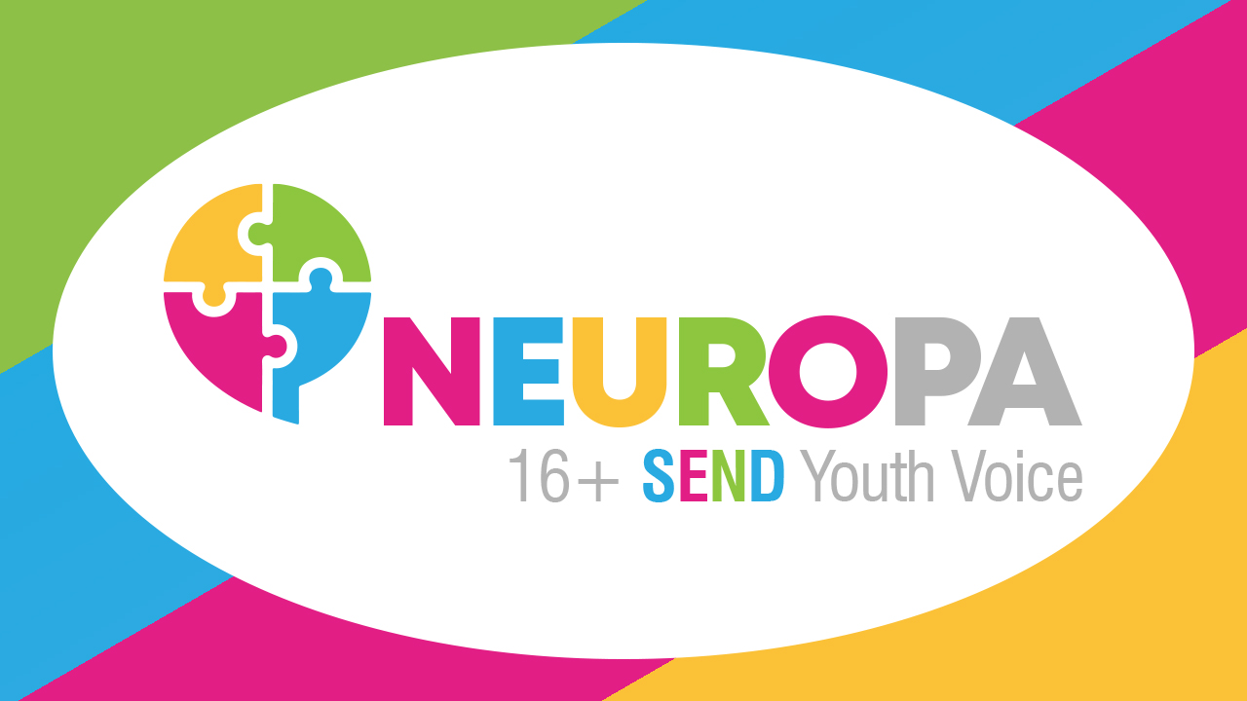

What Youth Voice Means to us
This article was written by members of NEUROPA Youth Voice.
I was initially interested in joining a youth voice forum to have a platform to be able to talk about issues that young people with SEND across Knowsley face. I have since be able to be involved in other opportunities such as representing young people on the SEND Partnership Board, sitting on the board of the small grants applications and attending Knowsley Youth Cabinet. I enjoy attending because everyone is nice and welcoming, and I enjoy the topical discussions that I have with other members of the group.
The group allows me to talk about topics that I wouldn’t normally talk to other people about such as politics, mental health and SEND issues. Being apart of the group makes it easy to talk openly about these issues because there are people who understand and have common interests. Since being a part of the group, I feel more confident and given me the ability to express myself openly.
I was initially attracted to the group due to the diverse nature of the sessions and that Adam likes to explore topics using different technologies. We have worked on a video and I have produced a poster for both NEUROPA and AMPLIFY. I found out about the group through a worker at VIBE who explained what youth voice is and that it may be a good opportunity for me to get involved. Since joining I feel more confident and excited to be a part of more sessions and projects in the future.
Youth Voice can provide some form of support for people given that the group is a collective of people from different backgrounds and experiences who can offer advice or can be someone to talk to etc. Youth Voice is important because it gives young people a voice in a world where they often don't get listened to, Youth Voice can also bring about change within the local authority, our forum can amplify this further as the SEND Partnership Board Representative is in our group, give any ideas you have to them!
Please spread the word far and wide about NEUROPA and AMPLIFY so more young people have access to these amazing groups and to make the voices of children and young people with SEND louder than ever!

Our SEND Youth Voice forums are a safe hub for young people with SEND across Knowsley to meet and discuss their thoughts and feelings and to explore opportunities to engage in the ongoing discussion around SEND.
AMPLIFY is a group specifically for under 16's across Knowsley that meets twice a month on a Thursday between 5pm - 6:00pm.
NEUROPA is a 16+ which also meets every other fortnight on a Thursday between 5pm - 6:00pm.
Our 16+ group are hard at work scripting a series of videos that will help to explain the EHCP process to children & young people. We also plan to work on several creative and engaging projects such as recording podcasts, hosting game nights, creating a group of young reporters and more. No experience is necessary and there will be no expectations from any young person to commit to anything.

If you have anybody in mind for either group or would just like more information please contact get in touch.
Feel free to share the video below to any young people.

Updates from local services

ADDvanced Solutions Community Network’s Spring term programme
ADDvanced Solutions Community Network’s Spring term programme includes a range of virtual and face-to-face activities and learning opportunities for families, including a new, ‘Supporting Behaviours that Challenge Learning Programme’. Over four workshops, these sessions will help parents and carers understand and develop skills around behaviours that challenge to enable them to support their child. A diagnosis is not necessary to attend this course.
Find out how you can join this and other events and activities here.

An update from Kooth and Qwell
Kooth.com & Qwell.io are online mental health support services available in Knowsley. Kooth is for ages 11-18 and Qwell is there for those aged 19+. Both services are free, safe & anonymous. They offer online counselling, self-help resources and peer to peer support. Our online practitioners are available to speak to every day of the year, between 12-10pm weekdays and 6-10pm weekends.
You can order promotional materials and/or arrange staff training sessions to help signpost to Kooth/Qwell. For more info, contact Holly at hcook@kooth.com

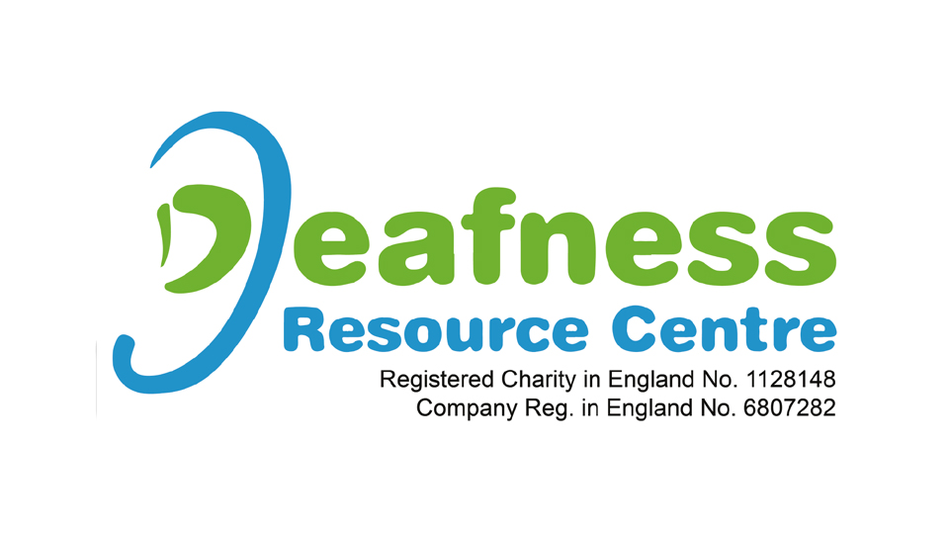

New sessions on offer from the Deafness Resource Centre
Deafness Resource Centre have just announced new plans on a Wednesday, their “Wonderful Wednesday” sessions offer children and young people a variety of opportunities to get involved and their meet peers.
As part of these session, there is also a new sports session starting at the Deafness Resource centre on the 16th March, it will be an opportunity for young people to increase their confidence and make new friends.
All sessions are inclusive for all in the D/deaf community, CODA’s and hearing.
If families would like to book they child onto any session they can email or text Tanya McGibbon on 07541995844.

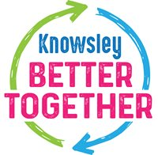
If you have any feedback on the services you are receiving, please tell us. You can email sendadmin@knowsley.gov.uk
The Knowsley Parent Carer Voice – KPCV – can be contacted via email at infokpcv@gmail.com
Parents / carers and children / young people with SEND can contact SEND IASS for impartial information, advice and support via telephone on 0800 012 9066 (option 2 for Knowsley) or via email at liverpoolandknowsleysend@wired.me.uk
SEND IASS also have their own newsletter, if you would like to sign up and subscribe you can do so by emailing iasmanager@wired.me.uk

Share this newsletter!
Share Tweet Forward Share

