English Task - Week Beginning 11.5.20
Hello Class 9,
One of the KS2 Reading targets is to ‘be able to predict what may happen from details stated and implied. So, this can be as simple as asking the question, ‘What do you think is going to happen next? Followed by ‘Why?’
Look at the picture below and predict what you think will happen next and why. There are some questions for you to consider underneath the picture to help guide your predictions.
Feel free to send any of your predictions to me via email at dale.mawson@kirkbyce.co.uk
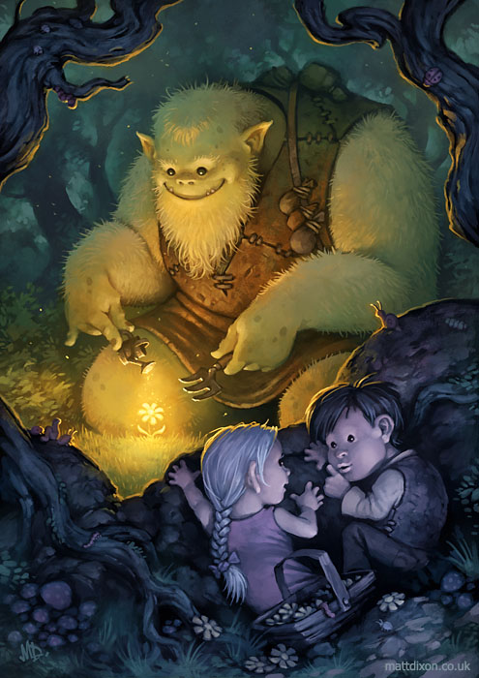

What is the ogre doing? Why?
Why is there a glowing light over the flower? Where is it coming from?
What do you think is in the pouches on the ogre’s bag strap?
Why were the children in the woods?
Does he know that they are watching him?
Do the children want him to know that they’re there?
What is going to happen next?

