Ordering fractions
Hello Class 9,
This week we are going to be focusing on ordering fractions.

In order to do this, we sometimes may find it easier to convert our fractions so that they have the same denominator (bottom number) as it then becomes easier when ordering them or finding out which fraction is the smallest or largest.

I have attached a PowerPoint that you may wish to look at if you feel like this would help you and there is also a useful video link.
https://www.bbc.co.uk/bitesize/clips/zvvgkqt
Any problems let me know!
Mr Mawson
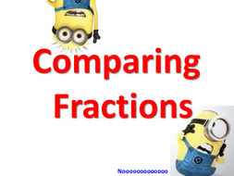

Colour in the circles to represent each fraction and then use the symbols <, = or > to complete the following:

