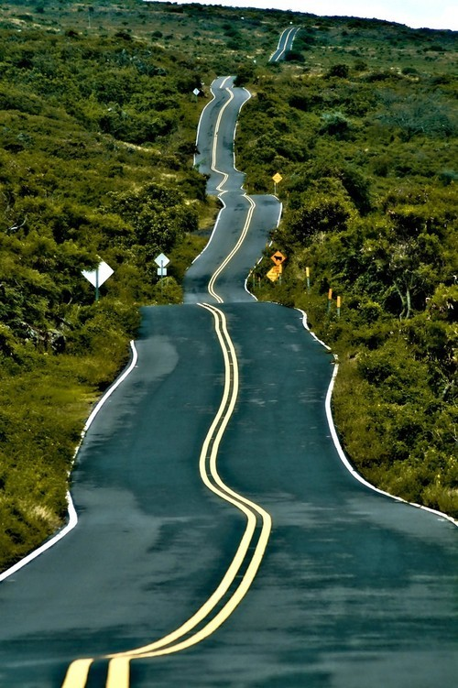
Here are a selection of pictures- choose one picture and use it to plan and write a creative piece of writing using knowledge that you have learnt this year. Use your imagination to write a short story of what you think could happen in the picture.
How would your journey end?
What would you be travelling in?
How would you feel travelling along here alone?
What can you hear?
see?
feel? Smell?
Where is this?
Where does this road lead to?

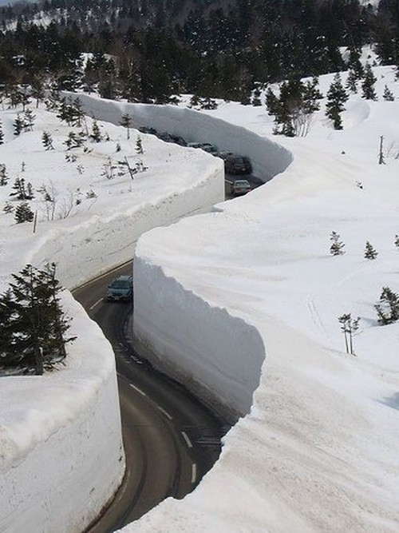

Here is a structure that you can use below to help you contrast an amazing piece of writing. Take your time throughout the week and use your imagination to gather together different ideas for a piece of creative writing. In addition, use the prompts that I have put around the first picture to get started with the other pictures too if you feel like this would help you.
- Adjectives/Adverbs
- Use similes and metaphors along with personification to describe how some of these paths 'move' across the landscape.
- Different sentence starters / Alan Peat sentences!
- Create a plan for your story

- Write your story

- Proofread

If you would like to send over any of your work or have any questions/ need help then please feel free to email.
david.tennant@kirkbyce.co.uk
Good luck and ENJOY!
Mr.Tennant

