Doubling
Task 1
Count how many spots there are on one side of the ladybird.
Double that number (add the same number on again). How many spots are there altogether?

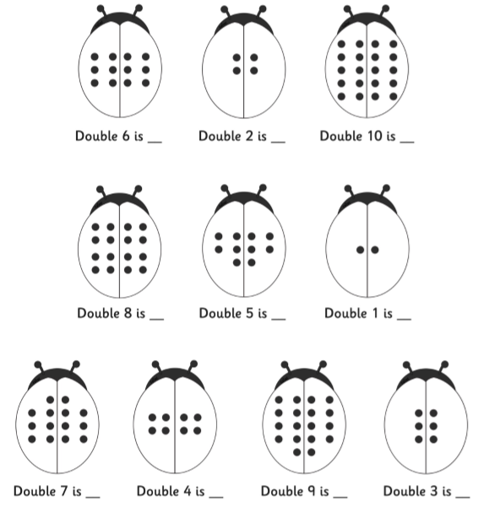

Task 2
Write a number sentence for each ladybird.
For example:- Double 6 is 12 would be 6 + 6 = 12 as a number sentence.

