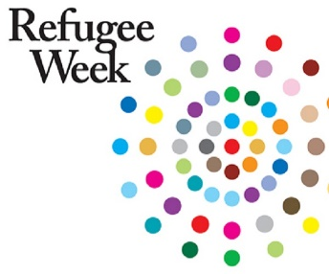
Refugee Week
This week it is Refugee week. Do you know what a refugee is? Do you know any famous refugees?
I would like you to create a poster that will explain to people what life is like as a refugee. I have attached a PowerPoint and video for you to use if you wish to. If you have completed this activity and would like an extra challenge then why don’t you see how many different ways there are to say ‘hello’ in countries all over the world!
https://www.bbc.co.uk/bitesize/clips/zbrd2hv
Mr Mawson

