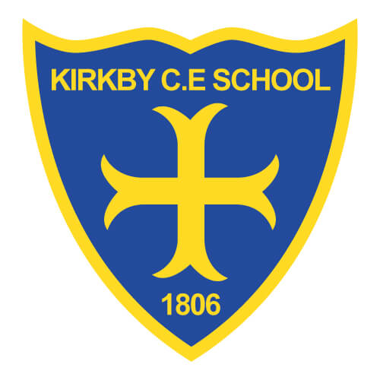Transition to School

2022

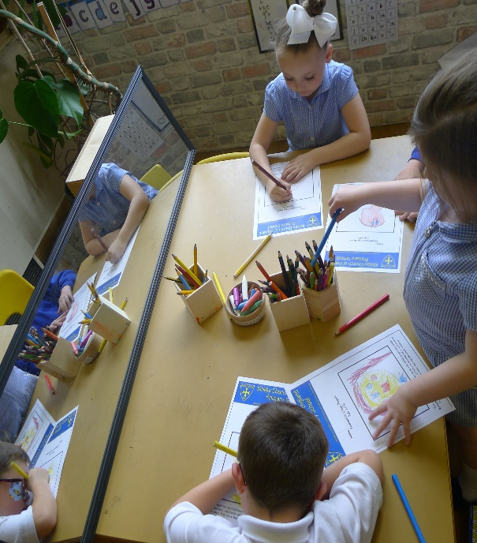

What do we do?

* In the summer term of Nursery, the daily routine becomes more in line with Reception. Allowing for a mix of large group work, independent ‘busy’ time and small group work.
* The environment is altered in correlation with the ages and stages of Reception.
* The children are familiar with the daily interactions at lunchtime and story times with new Teachers. If your child has already attended 30 hour provision at Kirkby CE, they will be aware of the daily routines.
* Becoming familiar with the wider school environment. Children have chance to eat their dinner in the school hall and visit the EYFS outdoor areas (woodlands etc).

At Kirkby C of E Primary School, we are dedicated to ensuring that all children have a smooth transition into school.

For children to succeed, it is crucial that they feel safe and happy in their new environment. By establishing positive relationships and promoting an exciting environment, it allows children the opportunity to develop confidence and independence.

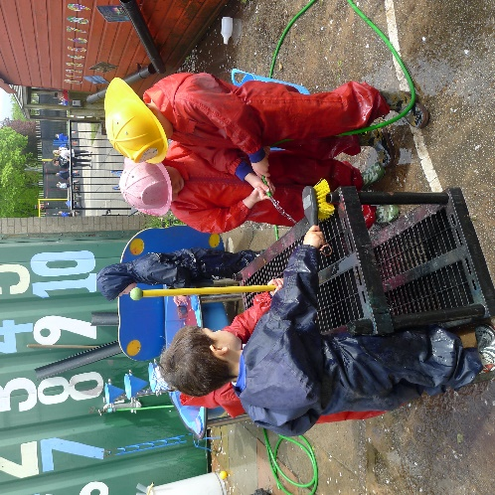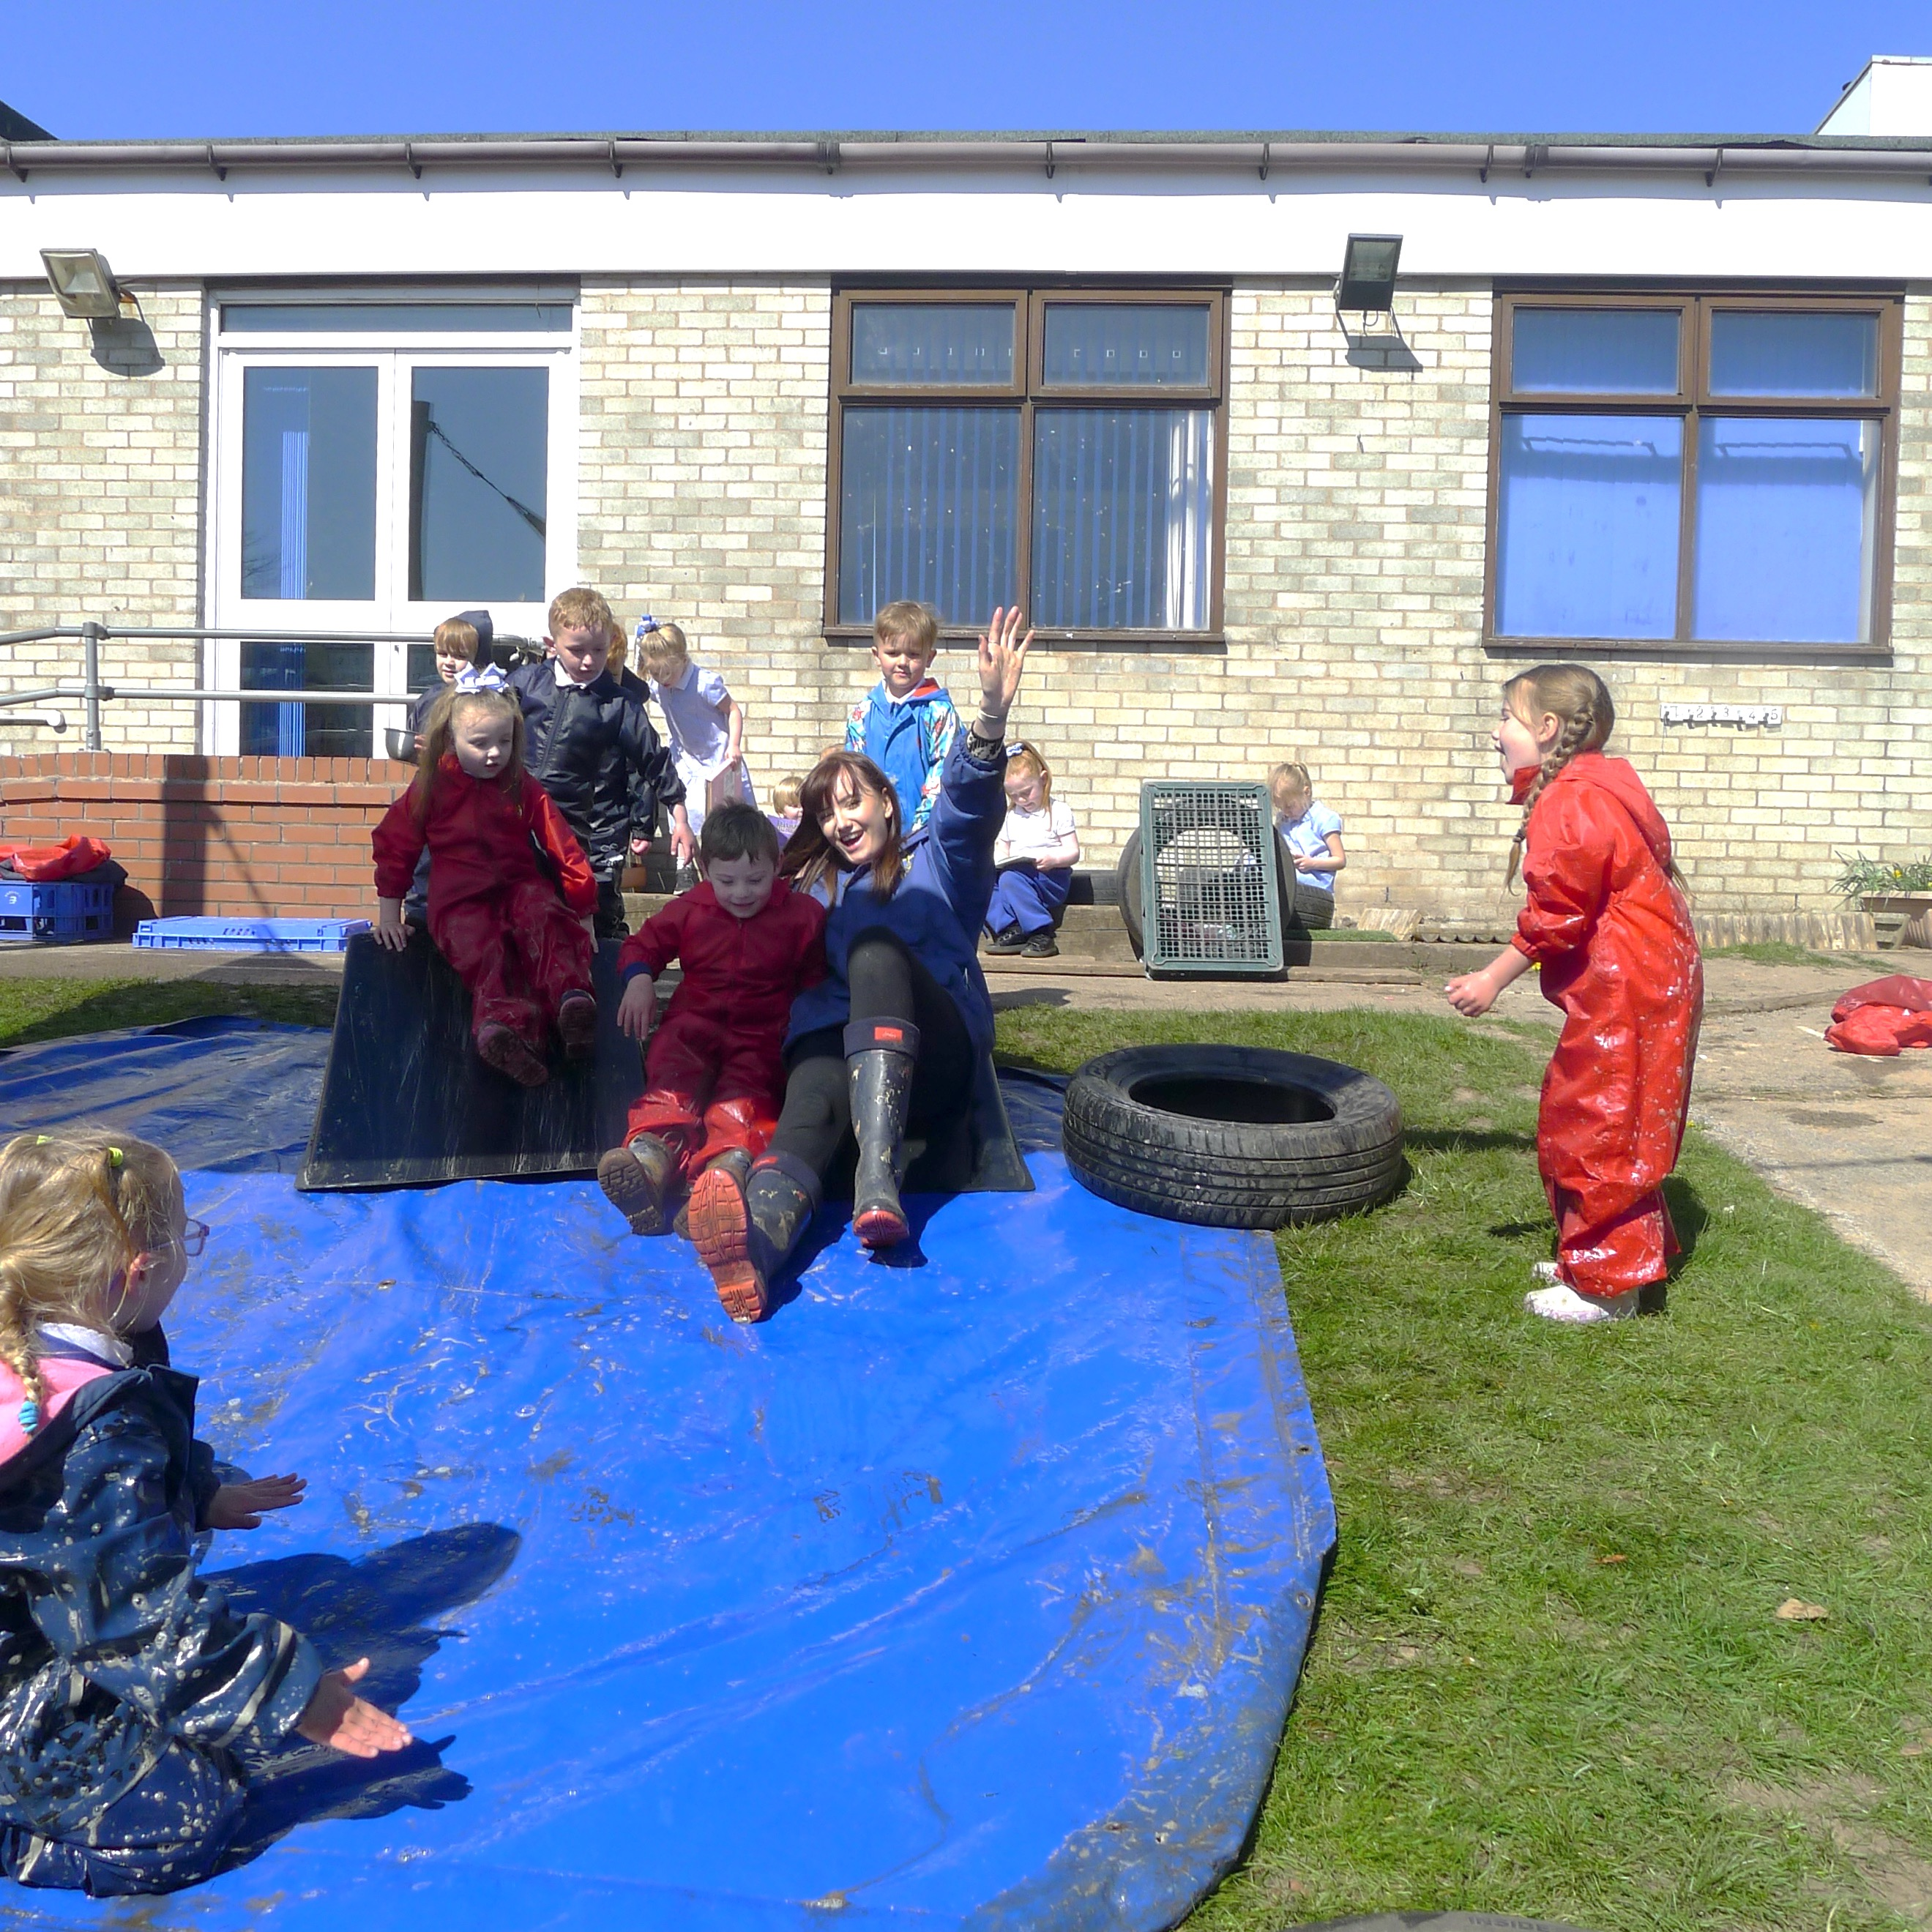

“The quality of a child’s early experience is vital for their future success”

Department for Education, 2014