Home Learning
Week Commencing 12/10/20

Phonics – Can you write your name? Use the letter formation on the sheet attached to help you form recognisable letters.

Maths – We are working with numbers 0 to 5. How many different ways can you make 5? Follow the link to take you to ‘White Rose Maths’. This corresponds with our number work in school.

https://whiterosemaths.com/homelearning/early-years/its-me-1-2-3-week-1/
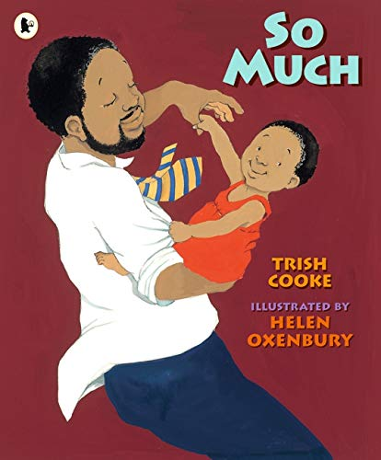
Power of Reading – We are currently reading ‘Too Much’ by Trish Cooke. Click on the link to watch it online – https://www.youtube.com/watch?v=A8GhmczYen0
Can you write an invitation for a party? Who is invited? Where will it be? When will it be? Draw who you would like at the party. Remember to write your own name at the bottom!

