Home Learning
Week Commencing 19/10/20

Phonics – Can you write your name? Use the letter formation on the sheet attached to help you form recognisable letters.
Can you write any initial letter sounds? Take a look around your house – what can you see? Can you draw a picture and write the first sound in the word you can hear?

Maths – We are working with numbers 0 to 5. How many different ways can you make 5? Follow the link to take you to ‘White Rose Maths’. This corresponds with our number work in school.

https://whiterosemaths.com/homelearning/early-years/its-me-1-2-3-week-1/
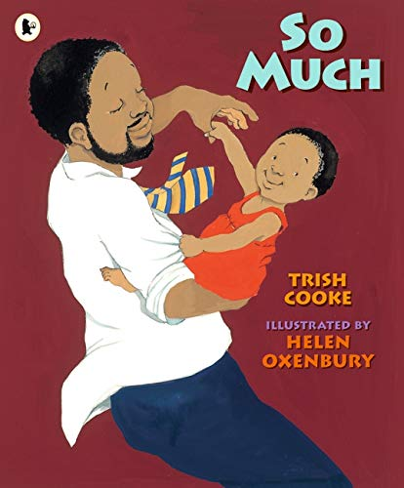
Power of Reading – We are currently reading ‘Too Much’ by Trish Cooke. Click on the link to watch it online – https://www.youtube.com/watch?v=A8GhmczYen0
Can you think of different ways to look after yourself and be happy? Draw different things that make you happy and discuss with your grown up.

Note for parents – Use open-ended questioning such as who/what/where/why/when/how questions to encourage communication and language skills.

Get Active! – Here are a selection of different ideas you could use to get active in your own garden!
https://www.ltl.org.uk/free-resources/
Click on the link for more ideas.
