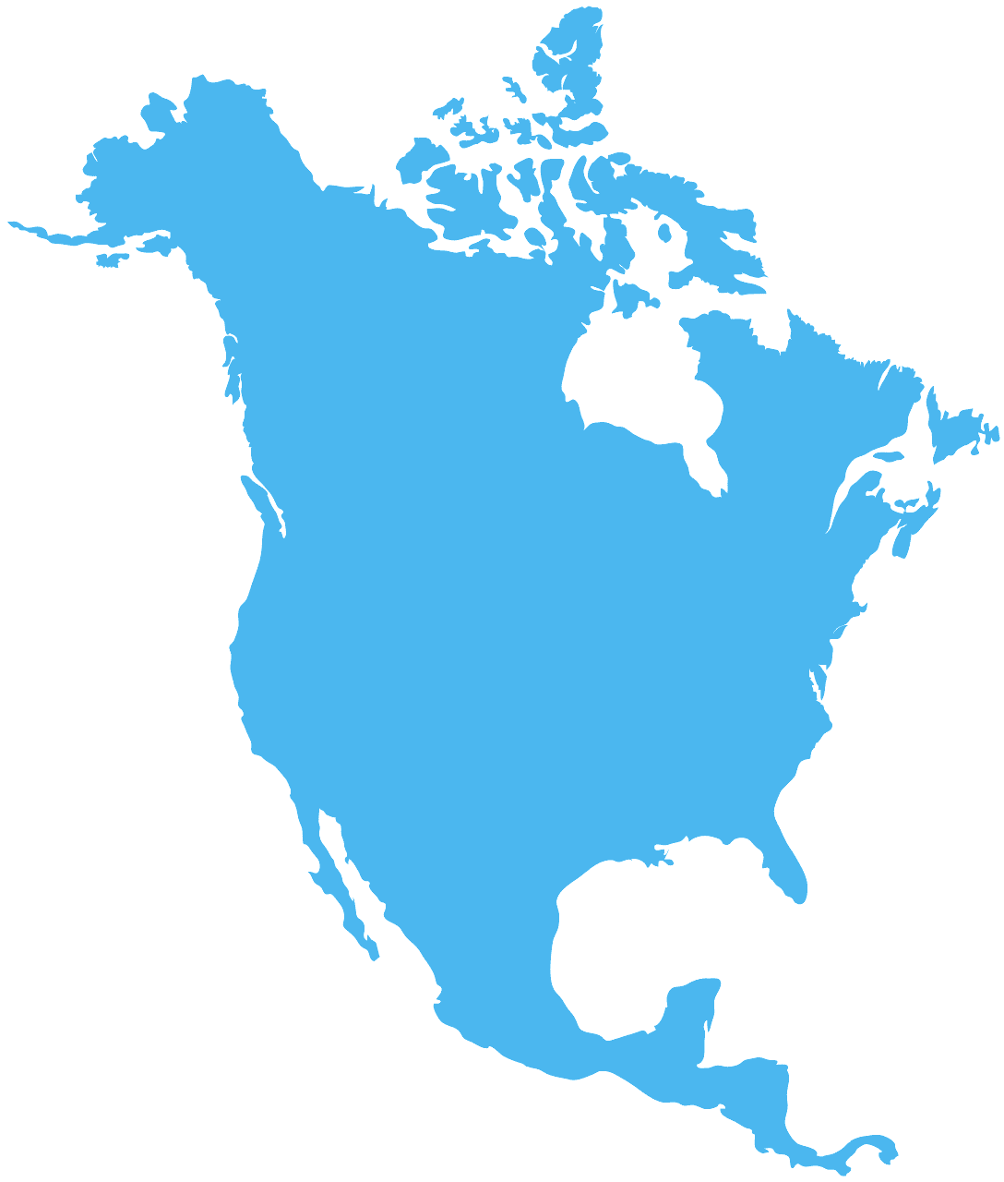
I can use my knowledge and resources to find out information about North and South America.
- Name the biggest and smallest country in North America.
Biggest:___________________
Smallest:__________________
- What sea borders the north of North America?
_______________________________________
- What is the longest river in North America?
_______________________________________
- Denali is the tallest mountain in North America. True or false?
____________
- In what sea would you find the countries of Cuba and Jamaica?
_______________________________________
- North America is located to the ____________ of Australia.
East, North-east or South-west.

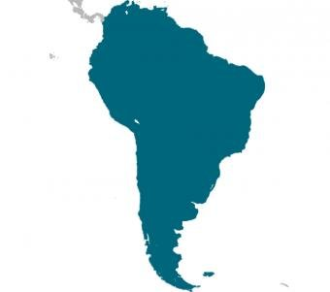

- What are the coordinates for Rio de Janeiro?
______________________ (Latitude, Longitude).
- What is the most spoken language in South America?
______________________________________________
- Name the biggest and smallest country in South America.
Biggest:___________________
Smallest:__________________
- Which is the biggest city in South America?
______________________________________________
- What is the capital city of Brazil?
______________________________________________
- Which country is at the northernmost point in South America?
___________________
Columbia, Brazil or Peru.
- Which country is at the southernmost point in South America?
___________________
Brazil, Peru or Chile.

Answers
1.) Biggest: Canada Smallest: St Kitts and Nevis
2.) Arctic Ocean
3.) Missouri River
4.) True
5.) Caribbean Sea
6.) North-east
7.) 22.9, 43, 1 (as close to 20, 40)
8.) Spanish
9.) Biggest: Brazil Smallest: Suriname
10.) Sao Luis
11.)Brasilia
12.) Columbia
13.) Chile

