Home Learning
Week Commencing 9/11/20

Phonics – We have been learning the sounds s, a, t and p. Can you draw any objects that begins with one of these sounds? Can you put any of the sounds together to make a word? (eg. at, as, pat, sat, tap). Can you write any rhyming words to sat/pat?

Maths – Can you find 5 objects around your house? How many different ways can you make 5? Write down the numbers (eg. 2+3 / 4+1 etc).
Can you sequence the story of Owl Babies? (first/then/next/after that/finally)
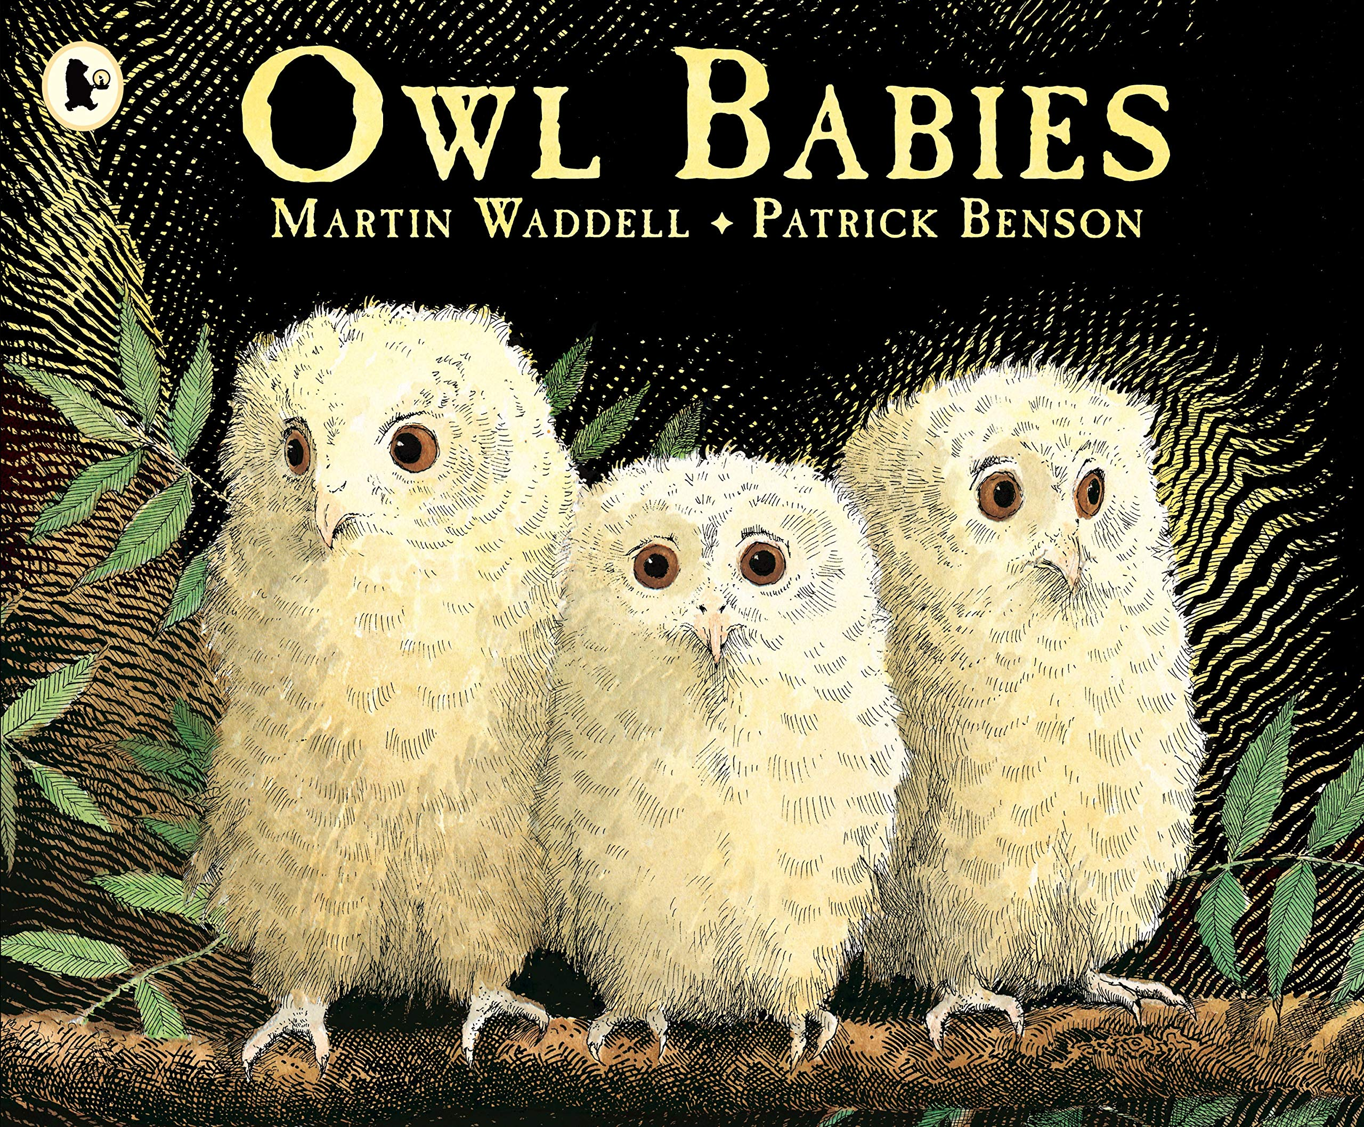
Power of Reading – We are currently reading the story ‘Owl Babies’. Can you write a letter to the mummy owl from the baby owls explaining why she should come back?
Can you find out anything about owls? What facts can you find out? What other animals are nocturnal? What does nocturnal mean?
Click on the link below to watch an online version of the story Owl Babies.

https://www.youtube.com/watch?v=TPQRiSTYFHo

