Home Learning
Week Commencing 16/11/20

Phonics – We have been learning the sounds i, n, m and d. Can you draw any objects that begins with one of these sounds? Can you put any of the sounds together to make a word? (eg. in, dim, mat, dad, nap). Can you write any rhyming words to dad/sad?

Maths – Can you find 5 small objects around your house and put in a bag. Take out a handful. Count them. How many left in bag? How do you know? Repeat to see how many different ways you can make 5.

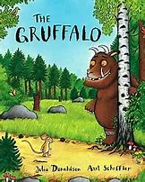Power of Reading – We are currently reading the story ‘The Gruffalo’. Read aloud the first three parts of the story, when the mouse meets the fox, snake and the owl. How do you think the mouse feels each time he first meets an animal? - Why does he talk about the Gruffalo like this? How do those descriptions make each of the animals feel? How does this change from when they first saw the mouse? What does the mouse want the animals to think? Why? - How do you think the mouse feels as he walks away each time?

Use the link below to watch an online version.

https://www.bbc.co.uk/iplayer/episode/b00pk64x/the-gruffalo

