Home Learning
Week Commencing 23/11/20

Phonics – We have been learning the sounds g, o, c and k. Can you draw any objects that begins with one of these sounds? Can you put any of the sounds together to make a word? (eg. cat, dog, kick, pig). Can you write any rhyming words to got/not?

Maths – Show the children activity mat of a part whole model (seperate pdf) with either one of the parts or whole missing. Children use objects to show diagram. Children explain how they know what is missing?

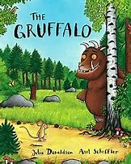Power of Reading – We are currently reading the story ‘The Gruffalo’. Re-read book. Encourage to join in with the repeated refrains e.g. “A Gruffalo? What’s a Gruffalo? A Gruffalo! Why, didn’t you know?”

Use the link below to watch an online version.

https://www.bbc.co.uk/iplayer/episode/b00pk64x/the-gruffalo

