Home Learning
Week Commencing 30/11/20

Phonics – We have been learning the sounds ck, e, h, b, f, l, u and r. Can you draw any objects that begins with one of these sounds? Can you put any of the sounds together to make a word? (eg. egg, clock, sun, rat). Can you write any rhyming words to sun/run?

Maths – Using two buckets, hide up to 5 pebbles or other objects in them. Ask children how many could be in each bucket? How do you know? If 3 in this bucket, how many in the other?

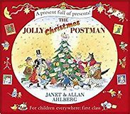Power of Reading – We are going to start the Jolly Christmas Postman. First we will be introducing a post office. Watch ‘Come Outside – A letter. What would it be like to be a postman? Can anyone think of a story with a post man in?

Use the link below to watch Come Outside.

https://www.youtube.com/watch?v=5580dxECAGg

