Home Learning
Week Commencing 7/12/20

Phonics – This week we will be learning the last of the phase 2 sounds (ff/l/ll/ss). Sounds with two letters are called ‘diagraphs’ and the children remember this by saying ‘two letters one sound’. They usually come at the end of words (eg. staff/full/pass). Can you think of any words with these sounds at the end? Can you add the sound buttons and bars? (eg. p a ss )

Maths – Have you got your Christmas tree up? Can you count the different coloured baubles on your tree? If you don’t have your tree up – use the picture of the tree attached. Can you find 1 more / 1 less?

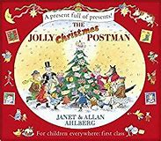Power of Reading – Can you write a letter to Santa using the sounds you know? Maybe you would like to write a letter to one of the characters in the story?
Can you draw a story map of all the different characters/places where the postman went to?

Picture for maths (if needed)
