English
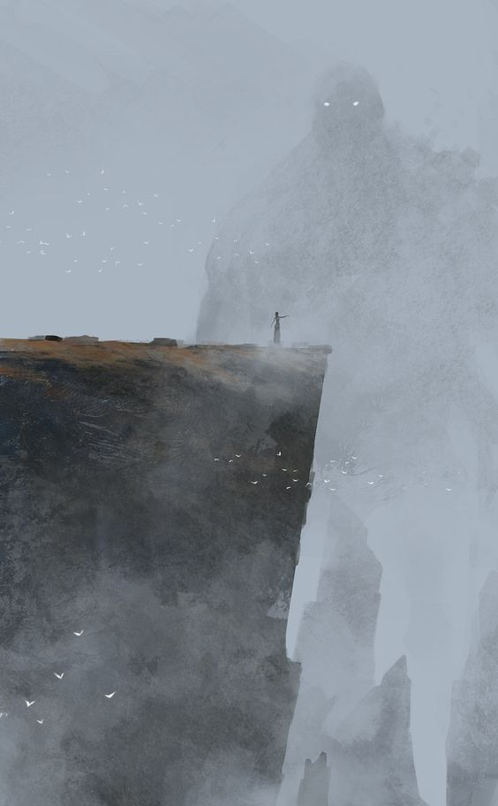
1) Interpreting a picture
Look at the picture and answer the questions below using lots of description.
- What can you see?
- What/who is the figure in the mist?
- How did it get there?
- What does it do?
- Are there more of them?
- Who is the person standing on the cliff top?
- What are they doing?
- What is their story?
- Where do you think this could be?
- What do you think the caption could be for this picture?

2) Time adverbials
Please use the powerpoint to help you refresh your memory of time adverbials and write sentences using a range of them to describe what could be happening in the picture. This will help you when completing the task below.
3) Diary entry
Once you have completed the activities above, use them to help you complete a diary entry. Imagine that you are the person standing on the top of the cliff and write a diary entry about this event. Find attached a powerpoint that will refresh your memory on what features to include in your diary entry.

