RE
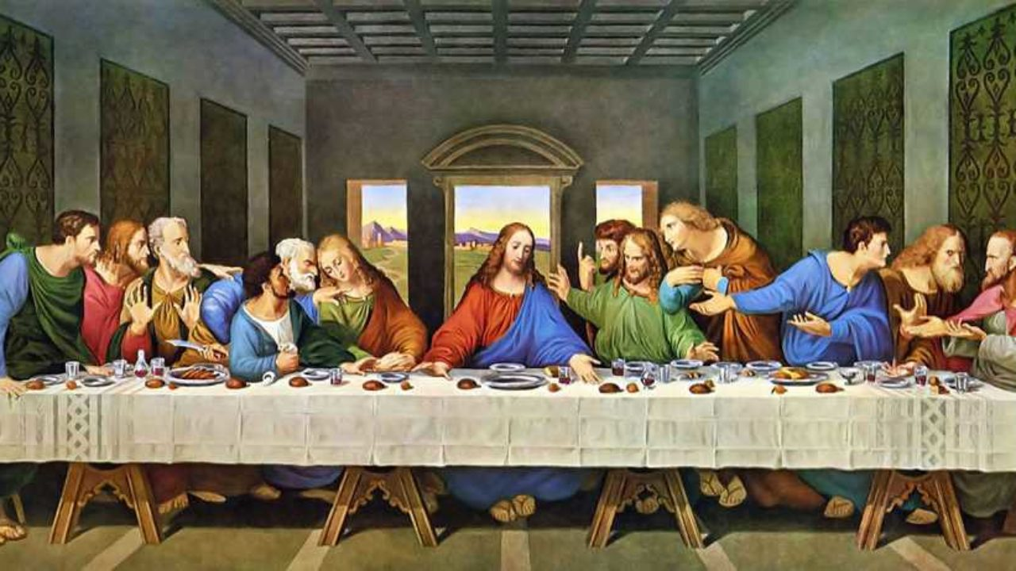
Look closely at the picture and answer these questions.
- What is this a picture of?
- Do you know who painted it?
- Who can you see in the painting? How many people are there? Which one is Jesus? How many feet can you see under the table? Does the number of feet match the number of people?
- What are they doing? What food and drink can you see on the table? Why are they eating and drinking together? Is it a special occasion?
- What do you know about the story that this scene is depicting? Where would you find the story?
- What details can you see in the painting? Can you spot anything that you think no one else has spotted?
Now copy the picture yourself. Remember to include the details you have identified. Take a photo of your picture and email it to your teacher.
Find out more information about the picture and the artist.
Clue: it’s called The Last Supper. Who painted it? Where would you go if you wanted to see it in real life? What other famous paintings did he paint?

