Bear and Cub
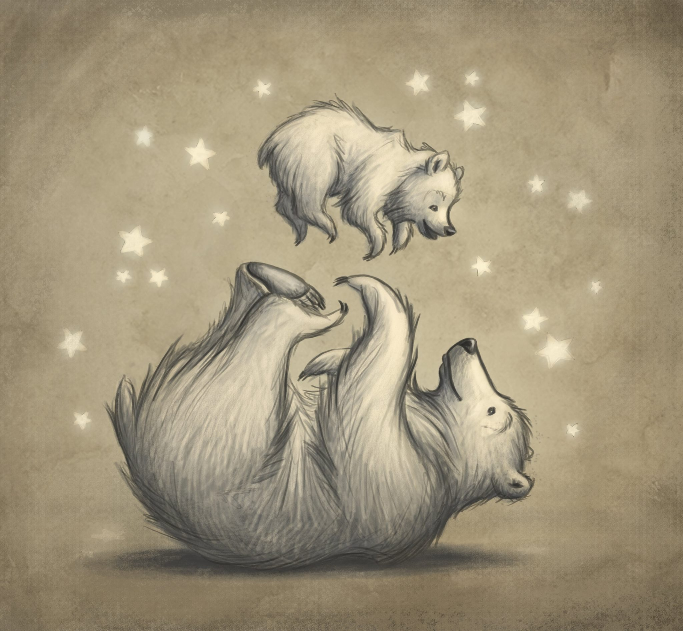
Look at the picture carefully.
Think about these questions and answer them in your workbooks.
Remember there are no right or wrong answers.
- How are the bears related?
- How old are they?
- What are their names?
- Where did they come from?
- What are they doing?
- How are they feeling?
Challenge (write in full sentences)
- Why are there stars around them?
- This looks like a special moment. Share a special memory between you and a parent/carer. Why do you think that time was special?
- Give the picture a new title. What would you call it?

