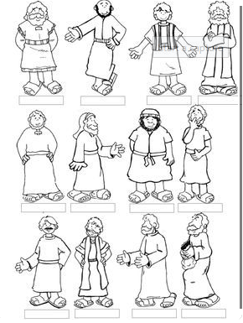

Draw or print and colour the disciples and give each one a name.
Thomas James Bartholomew Philip Andrew Judas
Judas Iscariot Simon Matthew Peter John James

