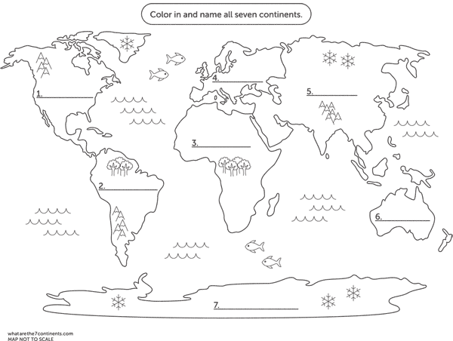

**Place the seven continents in the correct position:-**

**Africa**

**Antarctica**

**Asia**

**Australia**

**Europe**

**North America**

**South America**