Daily Stories – Parent feedback

“Hooray! What a great story Charlie loved it and so did we! Going to play the story out at home and each day have a new vegetable this week where Charlie has to find it in the fridge and help us cook it! See if works to try some new vegetables and tastes. I was impressed with how well Charlie knew his days of the week! He got a gold star off us ⭐️”

“Thank you Miss O'Nions, Mia has enjoyed
the story especially because I did not know
what Oliver would find!!

Thank you again”

“Lallarnie is working really hard
and has liked learning about penguins she
also loved story time so did I”

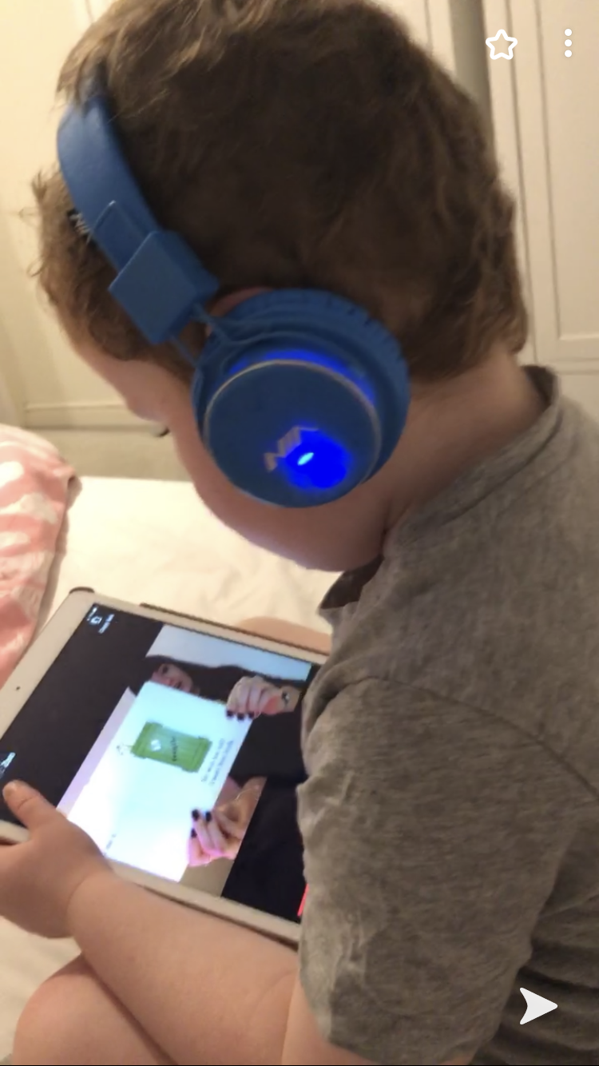

“Finley is really enjoying watching the stories at bedtime thank you”

“Hi Miss O’nions.
I hope you are well.
Jacob has loved listening to your stories. I think it is such a good idea because there is that link from school to home. We watched them all last night and he was mesmerised haha.
I think he thought it was FaceTime and was answering all your questions.
See you soon, stay safe”

Thank you for the daily story, Jessica was so pleased to see a familiar face and looks forward to seeing you everyday. We really do appreciate it.
Thank You,
Stay safe,

Harper has loved listening to your stories at bedtime, she has asked if you could read The Grufflo or The Grufflos Child please.

Thanks so much, take care

Your daily story time has been
really lovely it’s been great to introduce
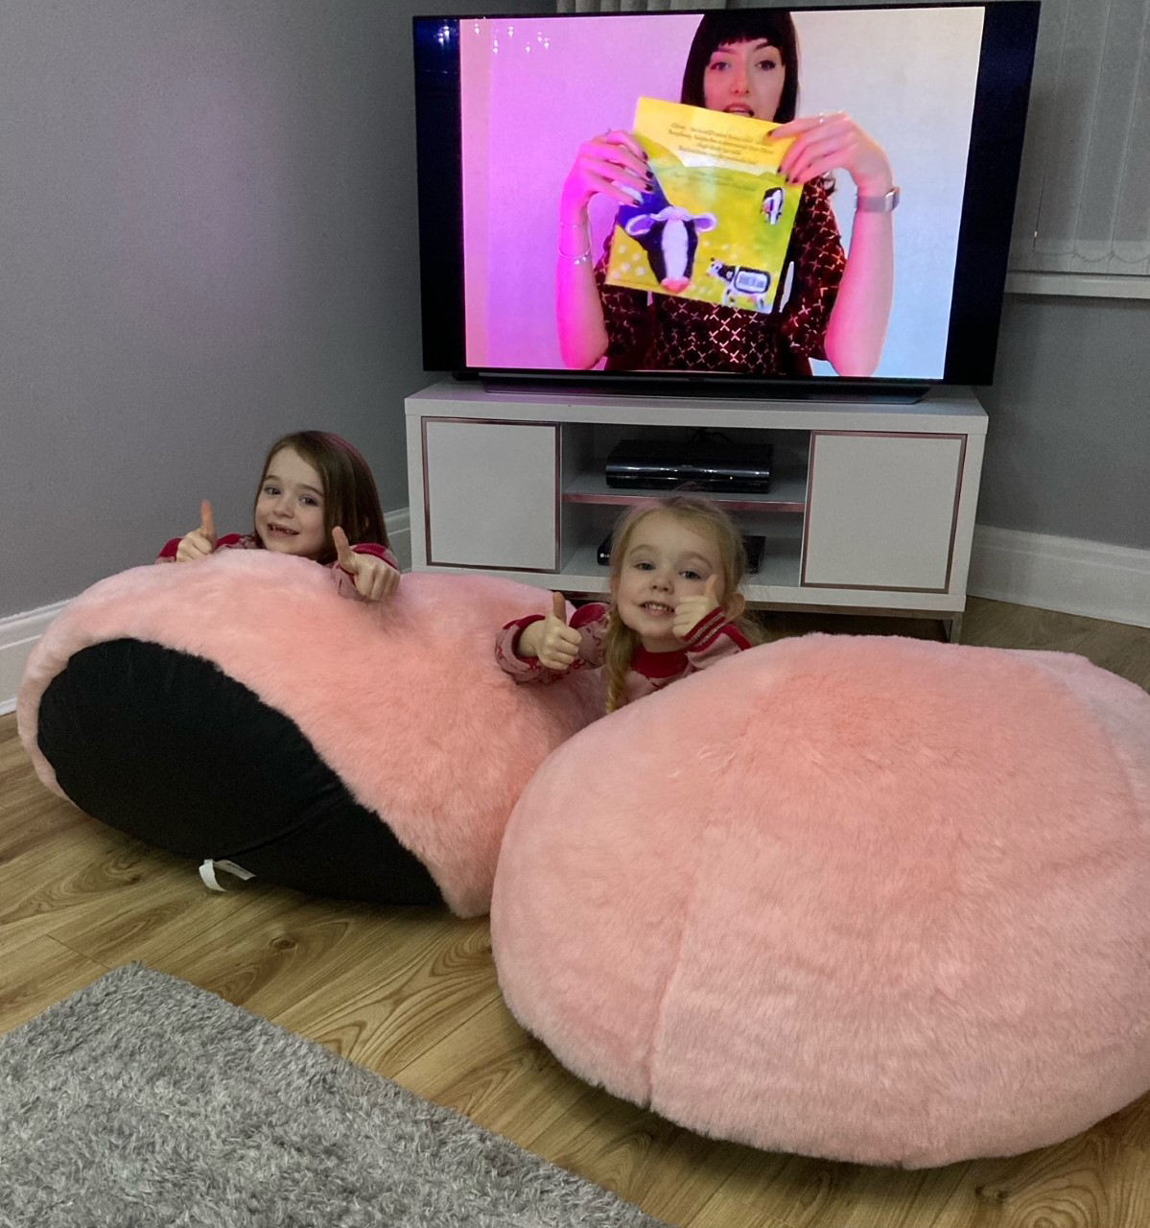
new stories for the girls and seeing some
old favourites again.

