There’s a Polar Bear in the Fridge!
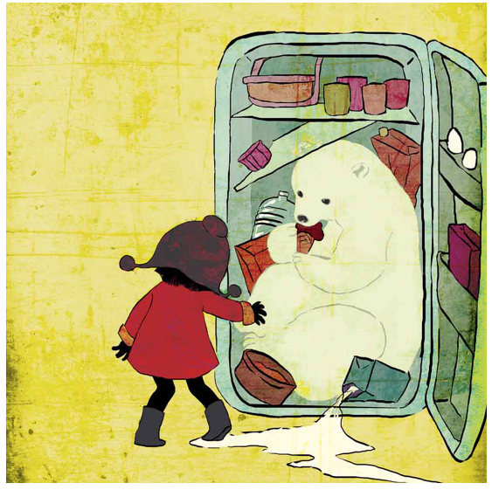
Look at the picture carefully.
Think about these questions and answer them in your workbooks.
Remember there are no right or wrong answers.
- Why is there a polar bear in the fridge?
- How did it get there?
- Where did it come from?
- What food and drink does the polar bear like?
- Why is it eating ice cream?
Challenge (write in full sentences)
- Did the girl help it get in there or has she only just discovered it?
- How will the girl’s family react? Do you think they will be angry?
- Draw a picture of the girl’s face, what emotion is she showing? Happy, surprised, scared?
- Give the picture a different title.

