How to make a Polar Bear
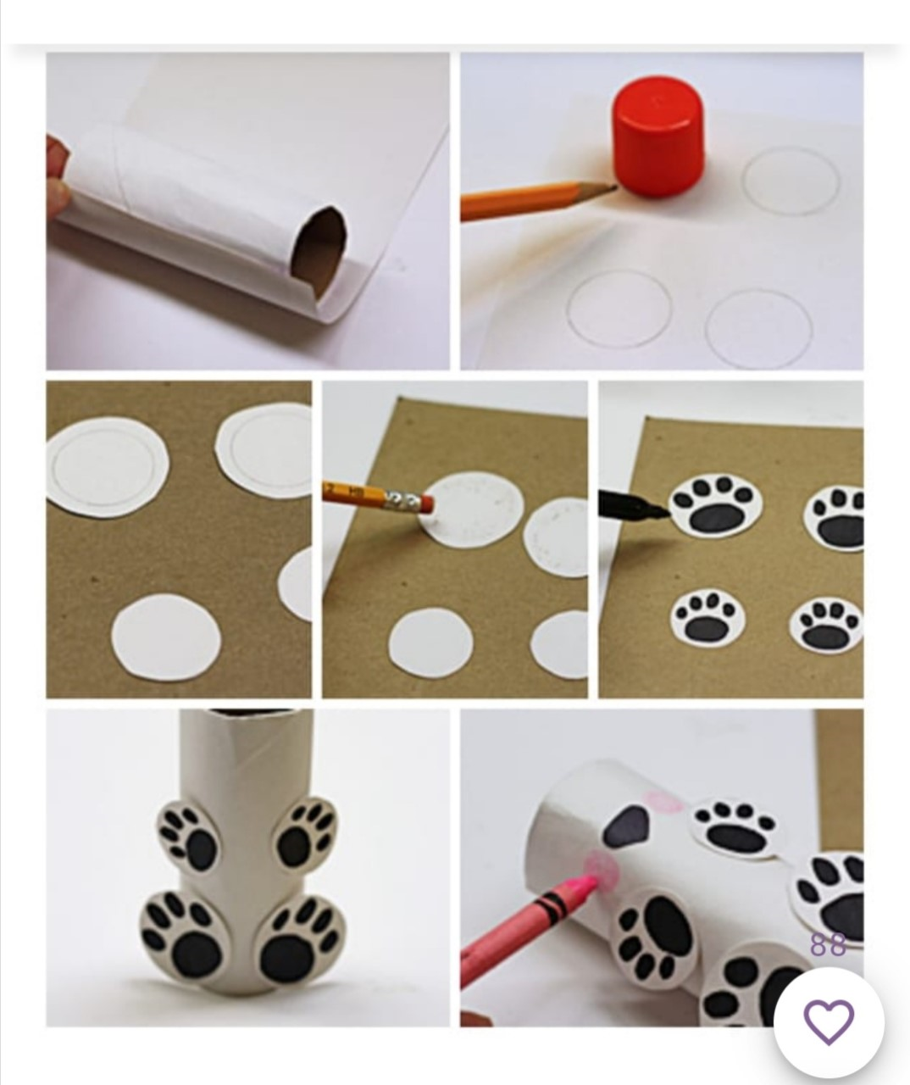

- Trim the white paper to fit around the cardboard tube. Stick it down so that your tube is now white.
- Draw four small circles, either draw freehand or draw around a small round object such as the lid from a glue stick. Two of the circles should be slightly smaller than the other two.
- Cut out the circles.
- Draw a paw print on all of the circles and colour them in using a black pen.
- Stick the four paws on to the tube, the larger circles should be at the bottom and the smaller circles towards the top.
- To finish, draw a nose, two eyes, a mouth and two pink cheeks.

