Take a Break!
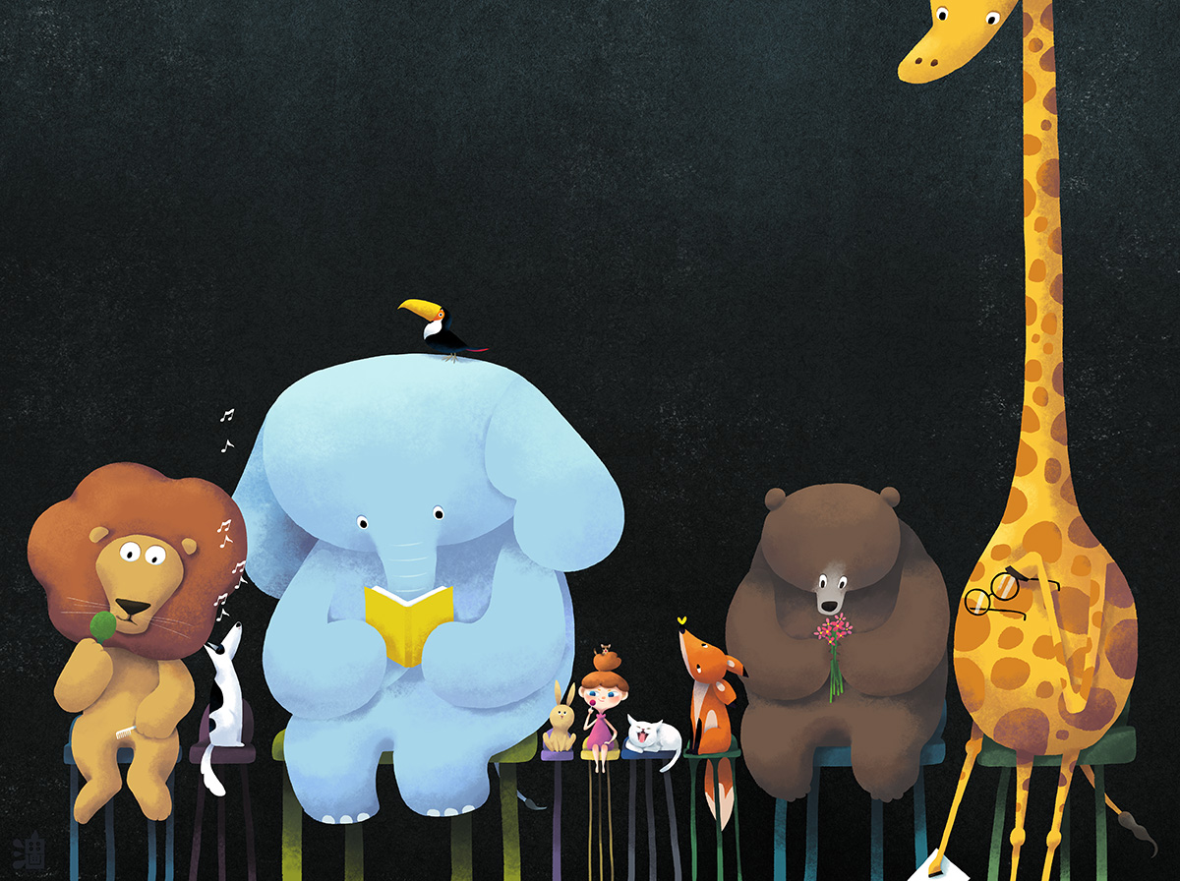
Look at the picture carefully.
Think about these questions and answer them in your workbooks.
Remember there are no right or wrong answers.
- What animals can you see? Write a list.
- What are the different animals doing?
- How is the bear feeling?
- Which animal do you think is the happiest? Why?
- The animals are taking a break. What do you like to do when you need a break from your work?
Challenge (write in full sentences)
- What do you think the animals were doing before this picture was taken?
- Who do the animals belong to?
- Give each animal a name. Try and use alliteration so that the animals name starts with the same letter as the animal, for example Leo the Lion.
- Write some of your own questions for this picture.

