Science
Everyday Materials – Umbrella Investigation
This week we would like you to do a simple test to find out which materials would be suitable to make an umbrella from.
Choose materials that you have around the house e. g kitchen roll, toilet roll, paper, cotton, foil, cling film etc
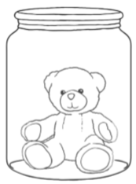 First put a small toy in a cup and make a lid with one of your materials. An elastic band would hold it in place.
Then drop a measured amount of water onto the lid.
Watch carefully to see what happens to the water, the material and the toy.
Would this material make a good umbrella?

Repeat this with the other materials.
To be a fair test, you must;
Use the same cup
Use the same toy
Use the same size of material
Use the same amount of water

For each material, record what happens.
Material | What happened? | Can this material be used for an umbrella?

Which material would be the best to use for an umbrella? Why?

