Morning Surprise!
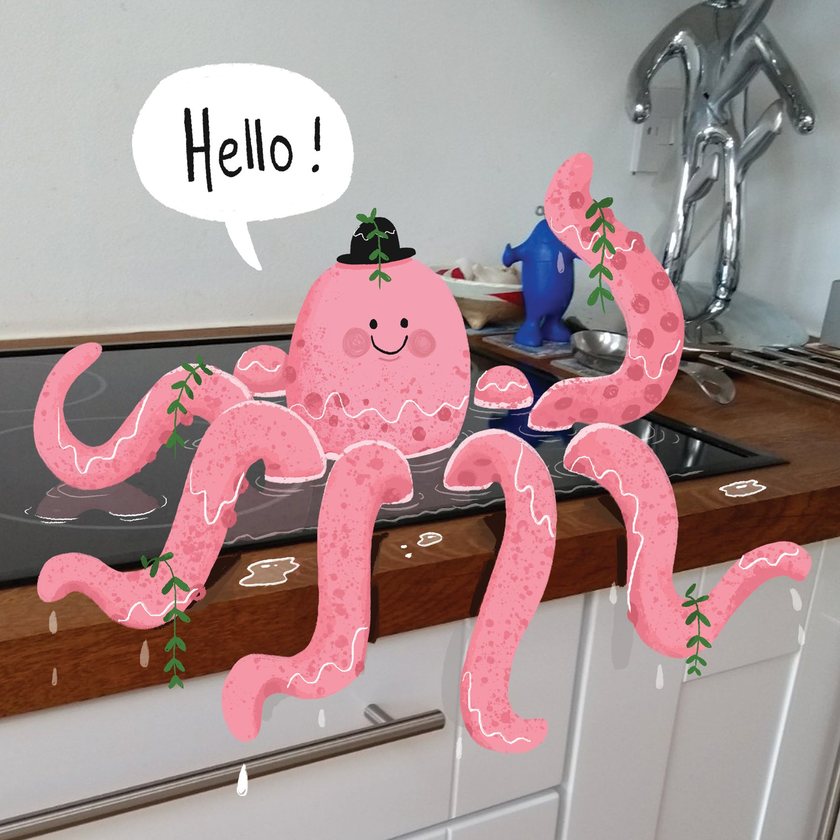
Look at the picture carefully.
Role Play the first three tasks then answer the questions in your workbook.
Role Play - Imagine that you have just walked into your kitchen to find this.

- Role play the conversation you might have with the octopus.
- Role play the telephone call you might have with a friend to tell them what you have found.
- Role play questions - You can only ask 3 questions to the octopus. What would you ask?

Now answer these questions in your book:
- How did the octopus get there? Why is it wearing a hat? Where did the plants come from?
- You decide to let the octopus stay here, but the next morning you come into your kitchen to find it joined by another creature. What might it be?
Challenge (write in full sentences)
- What happens next? Write down what you think might happen.
- Try to persuade the octopus to leave. What will you say?
- Draw your own octopus and give it a name.

