Moon Jellies!
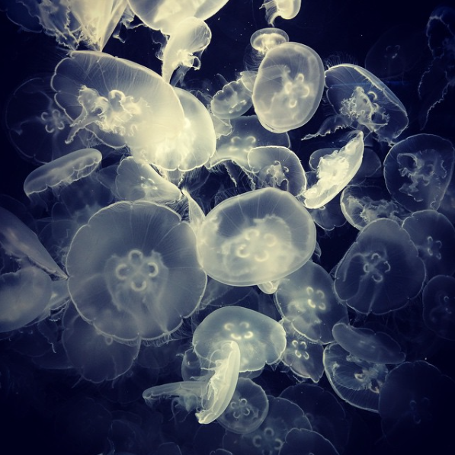
Look at the picture carefully.
Think about these questions and answer them in your workbooks.
- What are they?
- Where will you find them?
- Have you seen one of these before? Where was it?
Click here to find out some more information https://www.bbc.co.uk/bitesize/clips/zmxqxnb
- How do they move? Use some verbs to describe how they move.
- What other sea creatures did you see in the video? Name them and write them in a list.
Challenge (write in full sentences)
- Do jellyfish have brains?
- What do they eat?
- Find out a fact about jellyfish that you didn’t already know.
- Why do you think this picture is titled ‘Moon Jellies’? Give it a different title.

