English Activity – Inference Activity

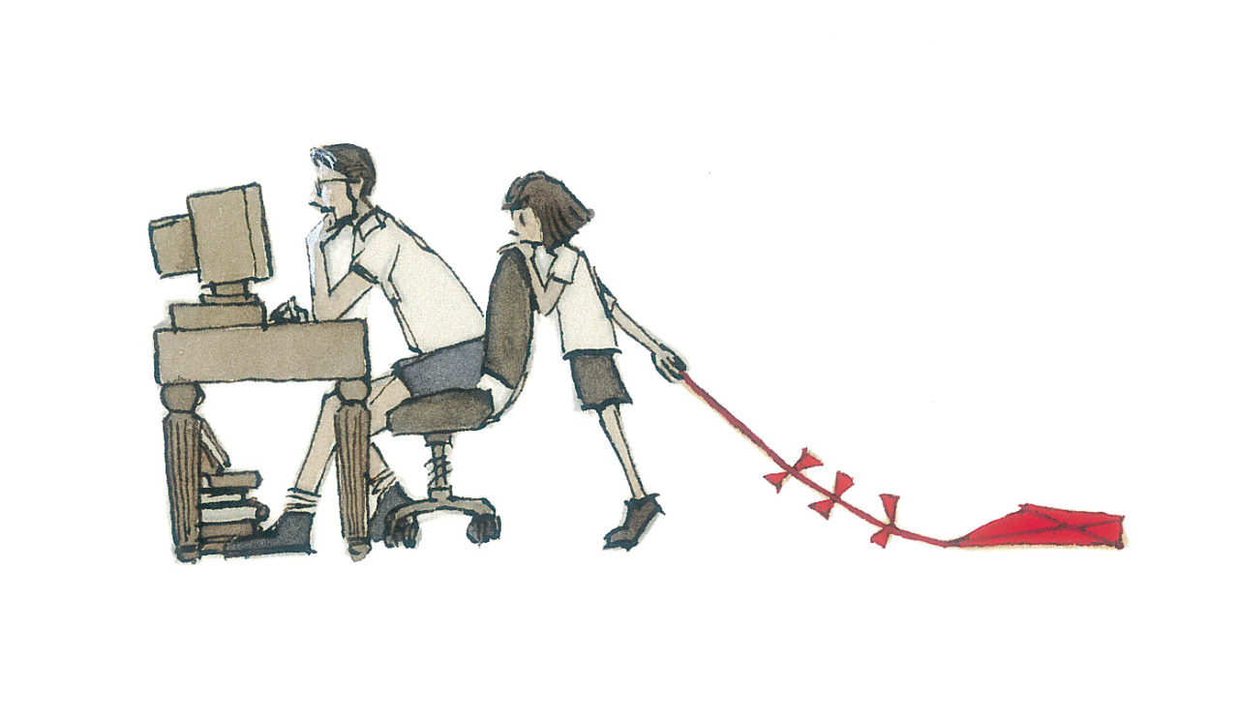
Look carefully at the picture below and then answer the questions below. Not all of the answers will be obvious from the picture. You will be required to use your inference skills.

What is the relationship between the two people pictured?

What is the person sitting down doing?

Why is the girl standing behind him?

Why is she dragging a kite on the floor?

Has she said anything to him? Does he know she’s there?

How is she feeling? What is she thinking?

Do you think this has happened before? Why/why not?

