Moon Jellies!
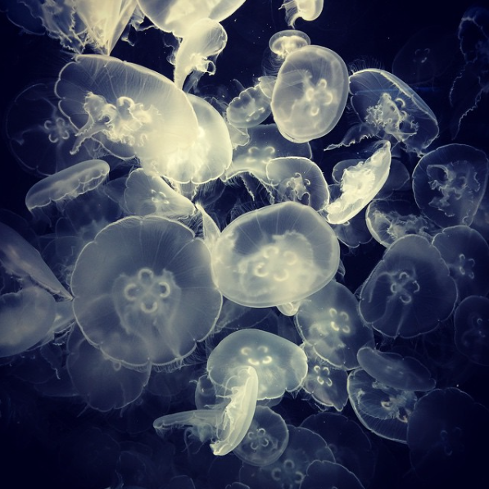
Look at the picture carefully.
Think about these questions and discuss with a grown up.
- What are they?
- Where will you find them?
- Have you seen one of these before? Where was it?
Click here to find out some more information
- How do they move? Use some verbs to describe how they move.
- What other sea creatures did you see in the video? Name them and write them in a list.
- Why do you think this picture is titled ‘Moon Jellies’? Give it a different title.
Challenge (write in full sentences)
- Find out a fact about jellyfish that you didn’t already know.

