Lesson 1
The Bible contains the following two passages which tell us a little bit about who Jesus was. Have a read of them and identify the words used to describe him. Do you know what they all mean? Look them up if you don’t.
Next, imagine you are living in Jesus’ lifetime and you actually meet him. What is he like? Write a descriptive narrative about him, detailing his looks as well as his personality and behaviour. Think about why he has been called the names he was in the Bible, and what he wanted people to think of him.
Start your writing like this: I met a man today. He was…
Isaiah 9: 6-7
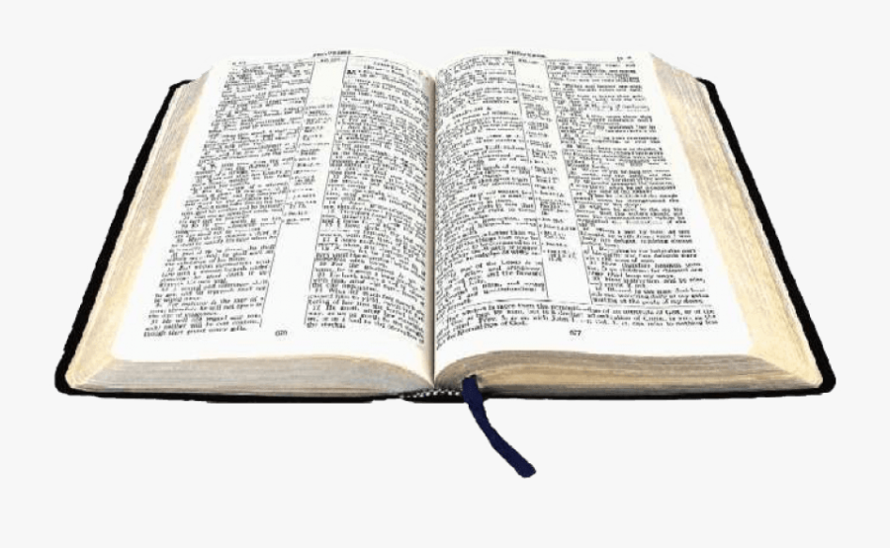
For to us a child is born,
to us a son is given,
and the government will be on his shoulders.
And he will be called
Wonderful Counselor, Mighty God,
Everlasting Father, Prince of Peace.
Of the greatness of his government and peace
there will be no end.
He will reign on David’s throne
and over his kingdom,
establishing and upholding it
with justice and righteousness
from that time on and forever.
The zeal of the Lord Almighty
will accomplish this.
Philippians 2: 6-11
Christ himself was like God in everything.
He was equal with God.
But he did not think that being equal with God was something to be held on to.
He gave up his place with God and made himself nothing.
He was born as a man
and became like a servant.
And when he was living as a man,
he humbled himself and was fully obedient to God.
He obeyed even when that caused his death—death on a cross.
So God raised Christ to the highest place.
God made the name of Christ greater than every other name.
God wants every knee to bow to Jesus—
everyone in heaven, on earth, and under the earth.
Everyone will say, “Jesus Christ is Lord”
and bring glory to God the Father.

