**Can you complete the number tracks?**

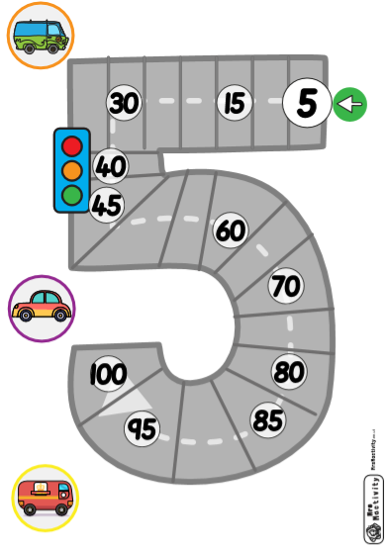**Count in 2’s and 5’s!**

