Design Technology

Vehicles

 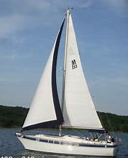 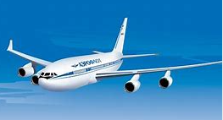

 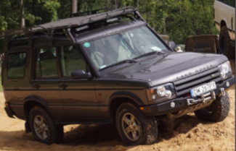 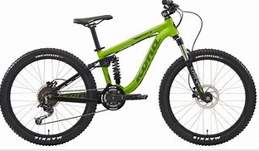

**You are going to design a vehicle!**

Design Criteria:

* Your vehicle must be a 3D model
* You must be able to put something in it or on it (for example a lego person or a small toy/teddy that will be transported in the vehicle)
* **Challenge** – Can you include a seat? Can you make a see through window?

**My Design!**

What will your vehicle look like?

Draw a labelled diagram of your model.

**Materials!**

List the different materials and equipment you will need to make your model.

**Finished Product!**

If you can, please attach a photograph here of your finished model (or bring it in to school when we return).

**Evaluation!**

After you have made your vehicle, think about your finished product.

Was your vehicle able to carry things? ……………………………….

Was it strong and sturdy?.................................................................

What did you like about your vehicle?..............................................

…………………………………………………………………………….

…………………………………………………………………………….

What could you improve? ……………………………………………..

…………………………………………………………………………….

…………………………………………………………………………….

Circle the number of stars out of five that you would give your vehicle.

