Lesson 2 - Names for Jesus
There is a significant list of the names people give Jesus in answer to the question of who he was.
Watch this video to find out some of them: https://youtu.be/5wVvAt7ToV8
Think about each of the following ‘titles’ and the questions raised by them:
Prince of Peace – Why? What did he do?
King of Kings – What kind of King was Jesus? Was he the sort of King the Jews were hoping for? Why not?
Jesus the King – What crown did he wear? Which robes did he wear? Where are his riches? Where is his Kingdom?
Lord, Saviour, Brother, Friend, Healer, Servant, Leader, Teacher, Rebel, Master and Son of God. How could Jesus be all these things?
What do you think is Jesus’ most important title?
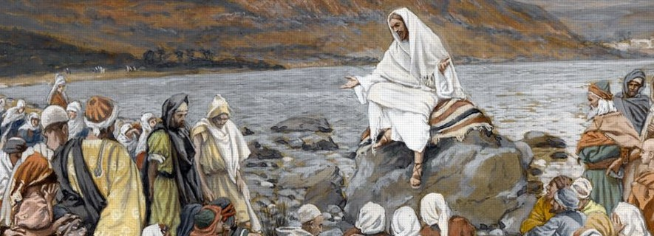

Complete the word search below of some of the titles Jesus was given.
